 **MINISTRY OF EDUCATION AND TRAINING**

| **FPT UNIVERSITY** |
| --- |
| InterdisciplinaryCapstone Project Document |
| Process of integrating eBanking  (Bank Statement, LockBox)  into SAP system |

| **GSP24SAP04** | |
| --- | --- |
| **Group Members** | Nguyễn Minh Huy - SE161323  Võ Thành Nam - SE150917  Vũ Mạnh Cường - SE151402  Nguyễn Minh Chiến - SS160573 |
| **Supervisor** | Ms. Nguyễn Hoàng Linh  Mr. Nguyễn Thế Hoàng |
| **Ext Supervisor** | Mr. Nguyễn Văn Long (FPT Software Functional Consultant ) |
| **Capstone Project code** | SP24SAP04 |

- Ho Chi Minh, April 2024 -

**Table of Contents**

Acknowledgments 3

Definition and Acronyms 4

I. Project Statements & Analysis 5

1. Project Introduction 5

1.1 Project Information 5

1.2 Project Team 5

a. Supervisors 5

b. Team Members 6

2. Product Analysis 6

2.1 Customer Definition 6

2.2 Current Processes and Limitations 6

2.3 Customer Requirements 8

3. Existing Systems 9

3.1 SAP Solution 9

3.2 Business Process 12

4. Project Scope & Limitations 20

4.1 Project Scope 20

4.1.1 In scope 20

4.1.2 Out of scope 20

5. Project Management Plan 20

5.1 Overview 20

5.1.1 Scope and Estimation 20

5.1.2 Project Objectives 24

5.1.3 Project Risks 24

5.2 Project Deliverables 24

5.3 Communication Plan 25

5.4 Training Plan 27

5.5 Project Management Plan 27

5.6 Handling Documents 29

II. SAP Configurations & Coding 29

1. System Infrastructure 29

1.1 System Landscape 29

1.2 Transport Request Management 30

2. SAP Configurations 31

2.1 Enterprise Structure 31

2.2 Process Configuration 48

2.2.1 Automatic Payment Configuration 49

2.2.2 Tax Configuration 52

2.2.3 Tolerance Groups 56

2.2.4 Other configurations 57

2.3 Master Data 60

2.3.1 G/L Master Data 60

2.3.2 Cost Center Master Data 62

2.3.2 BP Master Data 63

2.3.3 Bank Master Data 70

2.4 Electronic Banking Statement Configuration 72

2.5 Lockbox Configuration 77

2.6 DMEE Configuration 80

2.7 File Format Explanation 82

2.7.1 Bank Statement 82

2.7.2 Lockbox 85

2.7.3 DMEE 86

3. SAP Coding 88

3.1 Background 88

3.2 User Exit using in Bank Statement 88

3.2.1 Overview 90

3.2.2 Purpose/Background 90

3.2.3 Purpose/Background 90

3.2.4 Function Overview (Process Flow) 93

3.3 DMEE Enhancements by using Exit function 93

3.3.1 DMEE Overview 93

3.3.2 Purpose/Background 94

3.3.3 Operation Functional Requirements 94

General Requirements 94

Scenarios 94

Logic Execution 94

Scenario 1: Display Information about Charge 94

Scenario 2: Get Information about Country Tax Account 95

Scenario 3: Display Information about Payment Type 95

Scenario 4: Display Cost Center Category 96

3.3.4 Function Overview (Process Flow) 97

3.3.5 Function Overview (Program Flow) 98

3.3.6 DMEE Implementation 98

3.3.7 Table Name Structure 99

3.3.8 DMEE Tree Tags 99

3.6 Smartforms 101

3.6.1 Form Overview 101

3.6.2 ABAP Implementation 102

3.6.2.1 Form 102

3.6.2.2 Basic Design 103

3.6.2.3 Upload the company’s logo 108

3.6.2.4 Create Styles in Smartforms 109

3.6.2.5 Create a Smartform in SAP 110

3.6.2.6 Smartforms Initialization 111

3.6.2.7 Driver Program for Smartform 117

3.6.2.8 How the Form works 118

4. Set Up Batch for Automatic Clearing (F.13) 125

5. Authorization Settings 134

5.1 Role Matrix 134

5.2 Role Settings Process 137

5.3 Master Role Settings in SAP 138

5.4 FI Role Settings in SAP 138

Create role for FI Role Settings 142

5.5 GL Role Settings in SAP 143

Create new catalog for GL Role Settings 144

Add all tiles for GL Role Settings 144

Add to group for GL Role Settings 145

Create catalog apps based on roles for GL Role Settings 145

Add all relevant apps for GL Role Settings 146

Create role for GL Role Settings 146

5.6 AP Role Settings in SAP 148

Create new catalog for AP Role Settings 150

Add all tiles for AP Role Settings 150

Add to group for AP Role Settings 150

Create catalog apps based on roles for AP Role Settings 150

Add all relevant apps for AP Role Settings 151

Create role for AP Role Settings 151

5.7 AR Role Settings in SAP 153

Create new catalog for AR Role Settings 153

Add all tiles for AR Role Settings 154

Add to group for AR Role Settings 154

Create catalog apps based on roles for AR Role Settings 154

Add all relevant apps for AR Role Settings 154

Create role for AR Role Settings 155

III. Implementation & Testing 156

1. Implementation 156

1.1 SAP Process Execution 156

1.2 Installation Guides 158

1.3 Installation Instruction 159

1.4 User Manual 166

Workflow 1: Maintain Business Partner 166

Workflow 2: Create DMEE Files 169

Workflow 3: Bank Statement 186

Workflow 4: Lockbox 211

Workflow 5: Cash in Bank Book Report 233

2. Test Plan 235

2.1 Human Resources 235

2.2 Test Environment 236

2.2 System Test Scenario 236

2.2.1 Maintain Business Partner Process 237

2.2.2 DMEE Process 237

2.2.3 Bank Statement Process 238

2.2.4 LockBox Process 239

2.2.5 Cash in Bank Form 240

2.3 Test Reports 241

# Acknowledgments

Dear esteemed instructors and colleagues,

First of all, I would like to take this moment to extend our heartfelt gratitude to Mr. Nguyen Van Long for his assistance and guidance throughout the duration of our graduation thesis. His contributions have played a pivotal role in shaping the success and quality of our endeavour.

Our special thanks extend to Ms. Nguyen Hoang Linh and Mr. Nguyen The Hoang for their support, encouragement and for offering invaluable insights.

We would like to sincerely thank FPT Software for their support in providing the SAP System to this semester’s graduation thesis, allowing us to use the SAP System to get the final answers we would love to find.

We are also grateful and want to say profound thanks to each individual in this graduation thesis group. Besides that, each of the members of our project has provided a big effort, their time, their enthusiasm, and for the most is the experience of working in a group.

We acknowledge that, given our limited experience and the complexity of the technologies involved, there may have been some errors or challenges along the way. We hope for your understanding and forgiveness for any shortcomings that may have arisen during the project’s execution.

Our gratitude extends to our families and friends, whose unwavering support served as a constant source of motivation and encouragement, helping us complete this project successfully.

Best regards,

GSP24SAP04 Team

# 

# Definition and Acronyms

| **Acronym** | **Definition** |
| --- | --- |
| G/L | General Ledger |
| FI | Financial Accounting Module |
| CO | Controlling Module |
| DR | Debit |
| CR | Credit |
| AP | Accounts Payable |
| AR | Accounts Receivable |
| GR | Goods Receipt |
| IR | Invoice Receipt |
| ERP | Enterprise Resource Planning |
| QA | Quality Assurance |
| SIT | System Integration Testing |
| UAT | User Acceptance Testing |
| TMS | Transport Management System |
| TRs | Workbench Requests |
| K/TRs | Customizing Requests |
| DEV | Development Environment |
| QAS | Quality Assurance Environment |
| PRO | Production Environment |
| BAdIs | Business Add-Ins |
| BP | Business partner |
| DME | Data Medium Exchange |

# I. Project Statements & Analysis

## 1. Project Introduction

### 1.1 Project Information

* Project name: ***Process of integrating eBanking (Bank Statement, LockBox) into SAP system***
* Vietnamese name: ***Quy trình tích hợp ngân hàng điện tử vào hệ thống SAP (Bank statement, LockBox)***
* Topic code: ***SP24SAP04***
* Group code: ***GSP24SAP04***
* Software type: ***SAP S/4HANA***

### 1.2 Project Team

#### Supervisors

| **Full Name** | **Role** | **Email** | **Mobile** |
| --- | --- | --- | --- |
| Nguyễn Thế Hoàng | Lecturer | hoangnt20@fe.edu.vn | 0986628525 |
| Nguyễn Hoàng Linh | Lecturer | linhnh55@fe.edu.vn | 0919307719 |
| Nguyễn Văn Long | Mentor | longnv37@fpt.com | 0978551247 |

#### Team Members

| **Full Name** | **Role** | **Email** | **Mobile** |
| --- | --- | --- | --- |
| Nguyễn Minh Huy | Member | huynmse161323@fpt.edu.vn | 0833060802 |
| Võ Thành Nam | Member | namvtse150917@fpt.edu.vn | 0945644435 |
| Vũ Mạnh Cường | Member | cuongvmse151402@fpt.edu.vn | 0888358309 |
| Nguyễn Minh Chiến | Member | chiennmss160573@fpt.edu.vn | 0911326932 |

## 2. Product Analysis

### 2.1 Customer Definition

ABC Company, a global manufacturer specializing in power tools and DIY equipment for the construction and woodworking industries, operates manufacturing facilities in the United States of America. With a diverse product range, ABC Company recognizes the need to address its unique financial and accounting challenges with precision.

Recognizing the intricacies of its expansive operations and diverse product offerings, ABC Company is keenly aware of its unique financial and accounting challenges. The dynamic nature of the manufacturing industry, coupled with global operations, necessitates a meticulous approach to financial management. ABC Company understands the importance of precision in addressing these challenges and is committed to implementing strategic solutions that align with its overarching business objectives.

In an industry where accuracy and efficiency are paramount, ABC Company acknowledges the critical role that financial and accounting processes play in sustaining its success. The company is poised to leverage its industry expertise and technological advancements to streamline financial operations and ensure compliance with global standards. With an unwavering commitment to excellence, ABC Company embraces the need for tailored financial solutions that will not only enhance its operational efficiency but also contribute to its sustained growth and success in the competitive market.

### 2.2 Current Processes and Limitations

Currently leveraging SAP S/4HANA Finance for its financial operations, ABC Company has identified a specific challenge in the daily processing of bank transactions. The existing manual process involves financial transactions originating from source documents like invoices and receipts. Accountants manually record these transactions in specialized journals, such as sales and purchases, before entering them into the general ledger. This data is then summarised and prepared for crucial financial reports, including the Income Statement and Balance Sheet. However, this process entails saving transactions locally and subsequently posting them to the general ledger, leading to time-consuming processes and potential errors during reconciliation.

ABC Company faces significant challenges with manual banking transactions, imposing pressure on accounting staff to process numerous transactions manually. This manual approach leads to issues like human errors, increased time and resource consumption, reduced overall productivity and efficiency, and escalating financial costs. Moreover, manual processes result in delays and discrepancies in financial data, affecting real-time visibility, cash flow forecasting, liquidity management, and overall financial decision-making. Therefore, the implementation of SAP FI eBanking and LockBox is necessary to surmount the mentioned challenges. This software optimizes banking integration and transaction processes, ensuring real-time synchronization within SAP systems. This strategic upgrade is vital for addressing manual process challenges, maintaining accuracy, ensuring compliance, and mitigating associated risks.

**BF01: Current Incoming Payment Process**

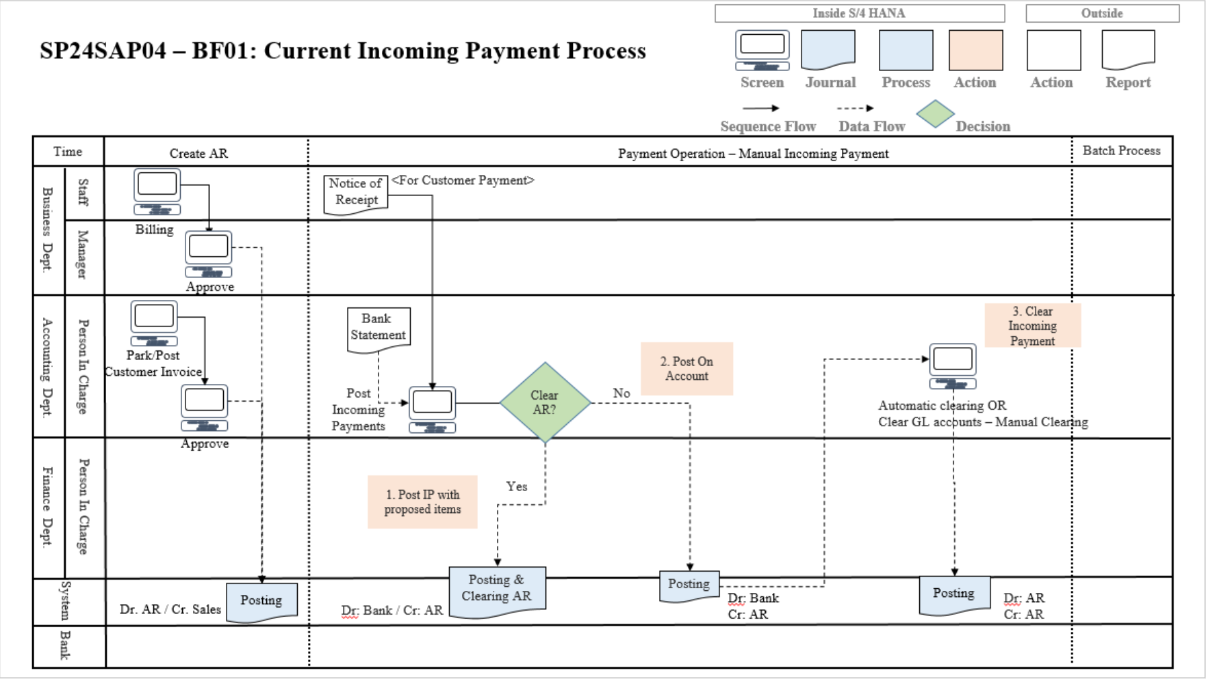

**BF02: Current Outgoing Payment Process**

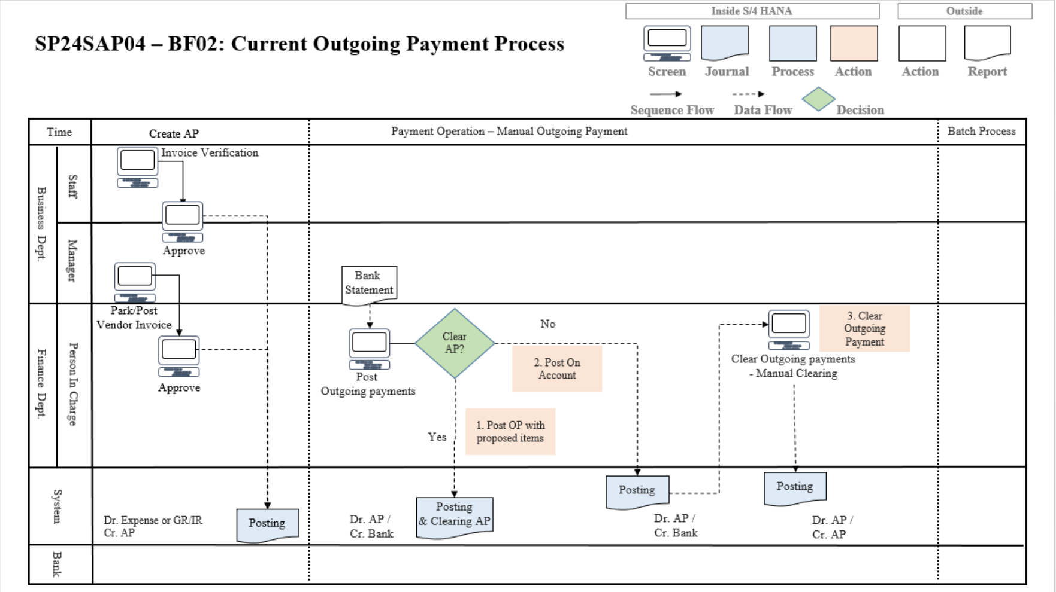

### 2.3 Customer Requirements

ABC Company has clearly outlined specific requirements to tackle ongoing challenges in their bank reconciliation processes. They are actively seeking a solution that can optimize and automate this process, thereby reducing manual workload and processing time. The adoption of SAP S/4HANA Finance is instrumental in achieving these goals.

The implementation of enhanced Bank Statement functionality within SAP S/4HANA Finance is poised to revolutionize ABC Company's reconciliation procedures. This innovation streamlines the reconciliation process by automating the matching of internal records with bank transactions. The result is a substantial reduction in the time required for manual data entry, leading to a marked improvement in overall efficiency.

ABC Company is particularly focused on minimizing the risk of errors in reconciling bank transactions, aiming to enhance the accuracy of its financial reporting. SAP S/4HANA Finance offers a robust platform equipped with automated reconciliation algorithms. This not only reduces the likelihood of discrepancies between recorded amounts in the system and actual bank statements but also fortifies the integrity of financial data. The outcome is more reliable reporting and informed decision-making.

Seamless integration with their existing SAP S/4HANA Finance system is a critical requirement for ABC Company, especially concerning eBanking functionalities. The proposed solution involves configuring bank master and house bank settings within SAP to establish a cohesive and integrated financial management process. The integration of eBanking, encompassing Bank Statement and Lockbox functionalities, is pivotal in meeting this requirement. The real-time visibility afforded by this integration into the company's financial position underscores its effectiveness.

By leveraging SAP's capabilities, ABC Company is poised to achieve a unified and synchronized bank reconciliation process. This not only minimizes discrepancies but also ensures accurate financial records, empowering the company with a foundation for sound financial management and reporting.

## 3. Existing Systems

### 3.1 SAP Solution

eBanking Integration in SAP (Bank Statements & LockBox) boosts efficiency and accuracy, saving time, minimizing errors, and giving real-time financial insights - both for users and the entire organization. It's automation at its finest, driving better decisions and a competitive edge.

In SAP Financial Accounting Module, it offers a comprehensive solution to meet ABC Company's requirements, promising efficiency, accuracy, and improved workflow continuity. Customization needs, integration of Bank Statements, implementation of Lockbox Functionality, and the relevance and benefits of SAP FI features for the company will be systematically analysed. This integration increases employee efficiency and streamlines the company's bank reconciliation process as well as reduces the risk of errors. Businesses can monitor transactions in real-time, which will allow the company to clearly and accurately understand its financial situation and make business decisions.

To embark on this transformative journey, SAP FI will undergo a meticulous analysis of ABC Company's specific requirements. Customization, a cornerstone of SAP FI, will be intricately aligned with the unique needs and intricacies of ABC Company's financial landscape. This tailored approach ensures that the solution seamlessly integrates into the existing framework, optimizing processes and addressing specific pain points.

A pivotal aspect of this integration is the incorporation of Bank Statement functionality. This feature promises to revolutionize the way ABC Company manages its financial transactions. By facilitating the real-time integration of Bank Statements into the SAP system, the solution not only expedites the reconciliation process but also significantly reduces the likelihood of errors. The result is a more agile and responsive financial system, where data accuracy is paramount.

The implementation of Lockbox functionality further enhances the capabilities of SAP FI for ABC Company. This feature streamlines and automates the handling of incoming payments, contributing to a more efficient cash management system. ABC Company can expect accelerated processing times, reduced manual intervention, and an overall improvement in the accuracy and timeliness of revenue recognition.

Integrating eBanking functionalities like Bank Statements and Lockbox isn't just an option, it's a crucial step for several reasons:

* In today's fast-paced business environment, eBanking integration is becoming the standard for efficient financial operations.
* Companies are moving towards automation and digitalization, and integrating eBanking is a key step in this direction.

Integrating eBanking functionalities like Bank Statement and Lockbox is necessary:

**Increased Efficiency and Productivity:**

*Automates data entry:* Bank statements and Lockbox data seamlessly flow into SAP, eliminating manual data entry and saving you time and effort.

*Reduces errors:* Automatic processing minimizes data entry errors, leading to more accurate financial records and reporting.

*Improved cash flow visibility:* Timely updates on incoming and outgoing payments provide real-time cash flow visibility, enabling better financial decision-making.

**Enhanced Accuracy and Control:**

*Reduced risk of fraud:* Automatic matching and validation procedures help identify potential discrepancies and fraudulent activities early on.

*Better compliance:* Streamlined processes ensure adherence to financial regulations and accounting standards.

**Strategic Benefits:**

*Improved customer satisfaction:* Faster payment processing and accurate customer account updates lead to improved customer satisfaction.

*Reduced operating costs:* Increased efficiency and automation lead to lower operating costs in the long run.

As SAP FI seamlessly weaves itself into ABC Company's financial fabric, the relevance and benefits of its features become increasingly apparent. The solution offers real-time transaction monitoring, providing ABC Company with a comprehensive and up-to-the-minute understanding of its financial standing. Armed with this real-time visibility, the company gains the agility to make informed and strategic business decisions, responding promptly to market dynamics and opportunities.

**Bank Integration with File Interface – Outgoing Integration**

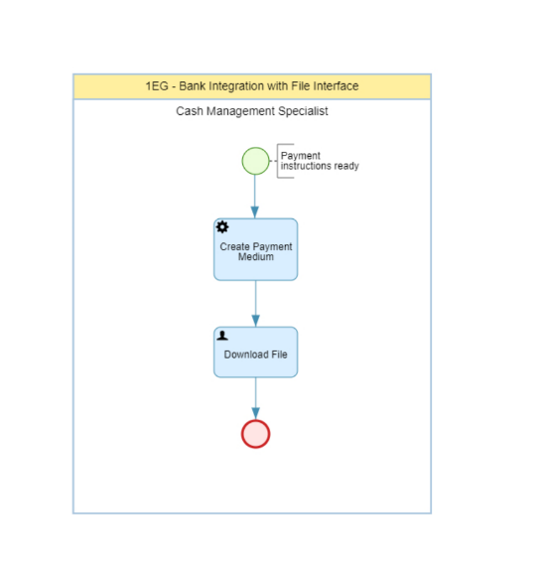

**Bank Integration with File Interface – Incoming Integration**

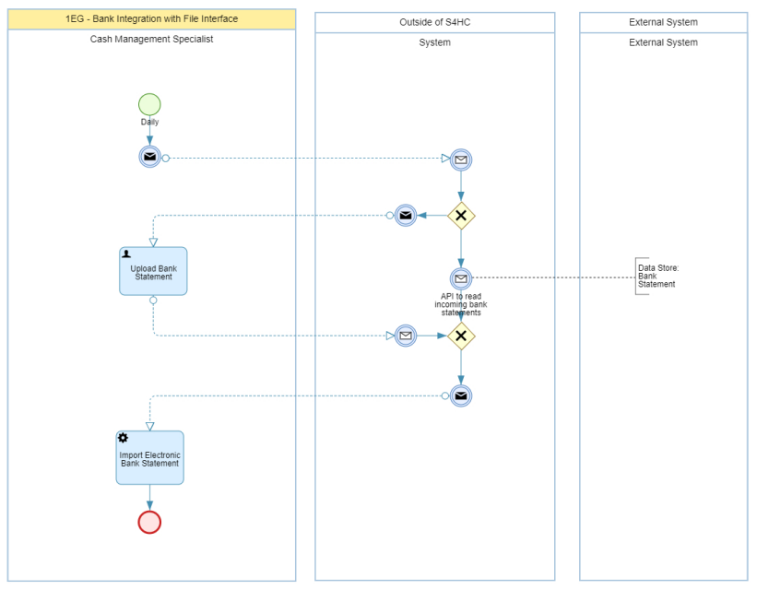

**Import Bank Statement**

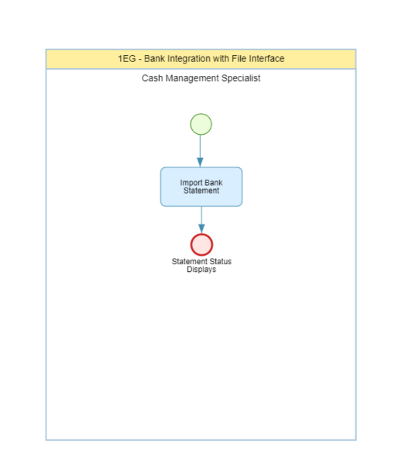

### 3.2 Business Process

**BF03: Incoming Payment with Electronic Bank Statement**

Within the context of this procedure, the Manual Incoming Payment process will be omitted and supplanted by an immediate Bank Statement process. This entails that subsequent to the acquisition of the Bank Statement from the financial institution, the system will autonomously locate the relevant Customer Invoice within the SAP system and perform an automatic mapping. Subsequently, the balance tracking will be conducted through the Bank Sub Incoming G/L Account.

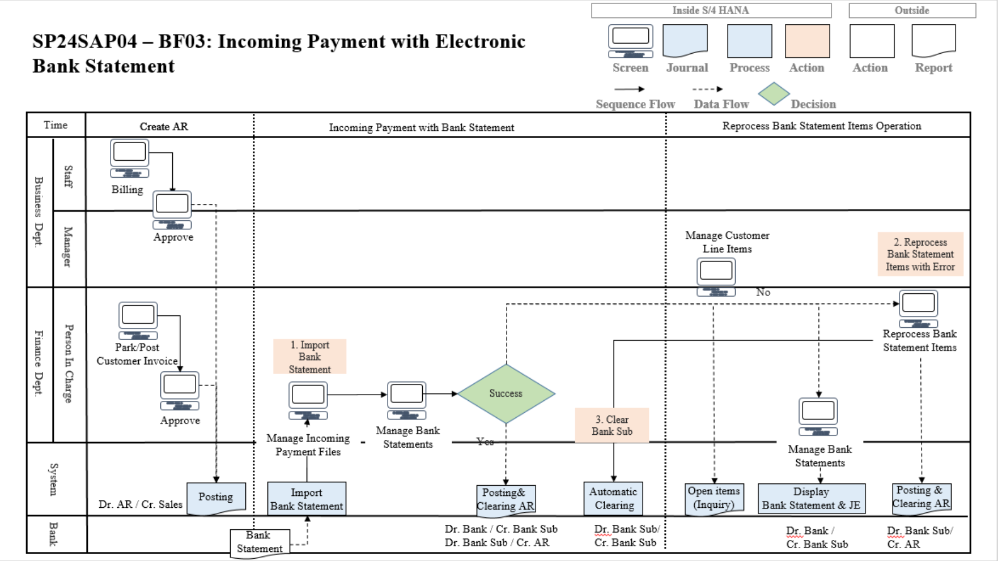

| **Step** | **Step Name** | **Detailed Description** | **Role** |
| --- | --- | --- | --- |
| 1 | Import Bank Statement | Bank Statement is sent from the sending bank into the SAP system for processing. Users have to import files to the SAP system. There are many formats of Bank Statement like MT940, CAMT053, …  Fiori Application  **F1680 - Manage Incoming Payment Files**  At this point, users are available to check for their status of Bank Statement, If Status is “Completed”, it means Bank Statement can be processed successfully and users can refer to related Journal Entries. Otherwise, status is “Not Complete”, user have to reprocess through Reprocess Bank Statement Items (Step 2)  Fiori Application  **F1564 - Manage Bank Statements** | Finance Department |
| 2 | Reprocess Bank Statement Items with Error | When the error occurred, to which extent may be caused by not matching the exact customer’s invoice, wrong characteristics, etc … Users need to clear open Items if necessary before proceeding further, the taken approach can be listed as: system logs, error messages, or manual review of the bank statement item. Then, again manage and organize Bank Statements as required for processing, which includes several types of solution for realizing the cause of the error and taking corrective action. After everything is done, review and post journal entry.  Fiori Application  **F1520 - Reprocess Bank Statement Items** | Finance Department |
| 3 | Clear Bank Sub | After all the successful process of the Bank Statement in the making, users reconcile Bank Sub Incoming Items are cleared, giving its balance back to zero.  With the process can be managed by batch operation.  Fiori Application  **F.13 - Clear G/L Accounts** | G/L Accountant |

**BF04: Outgoing Payment with Electronic Bank Statement**

In the process of outgoing payment, we are incorporating the Bank Statement alongside integration with the Automatic Payment system, aiming to establish a holistic framework for this procedure.

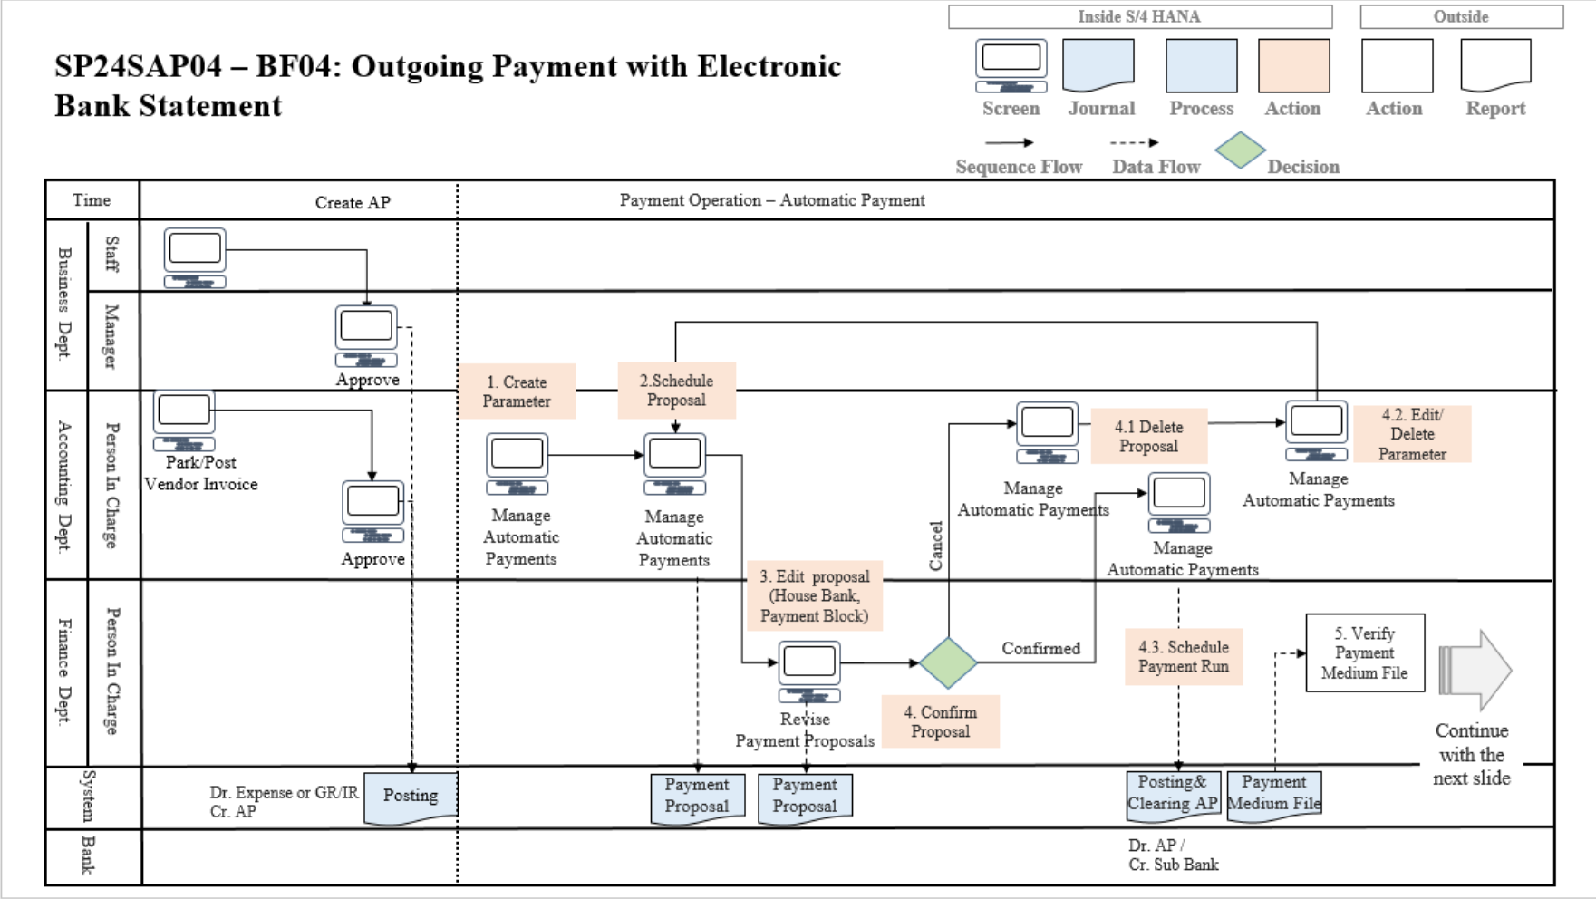

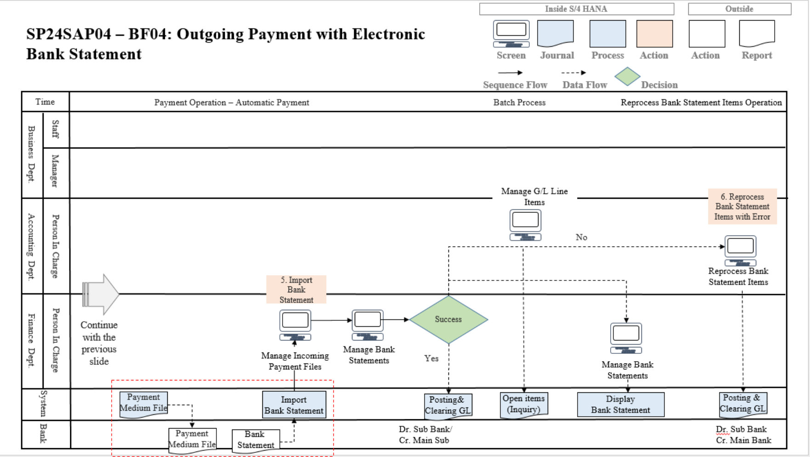

| **Step** | **Step Name** | **Detailed Description** | **Role** |
| --- | --- | --- | --- |
| 1 | Create Parameters | Users can create parameters according to their requirements which govern aspects such as payment terms, document types, and validation rules Fiori Application  **F0770 - Manage Automatic Payments** | Account Payable Accountant |
| 2 | Schedule Payment Proposal | Payment proposals are scheduled to initiate the payment process for vendor invoices or other outgoing payments. Users can set up the parameters for the payment run, including the selection criteria for invoices, payment methods, and scheduling options by using this app Fiori Application  **F0770 - Manage Automatic Payments** | Account Payable Accountant |
| 3 | Edit Proposal | After scheduling the payment proposal, users may need to make adjustments or corrections to the proposed payments which allows users to review and modify the proposed payment list, such as adding or removing invoices, changing payment amounts, or adjusting payment dates by using this app Fiori Application  **F0770 - Manage Automatic Payments** | Account Payable Accountant |
| 4 | Confirm Proposal and Schedule Payment Run | Once the payment proposal is finalized, users confirm the proposal to lock in the selected invoices and payment details. This app initiates the payment run process, generating payment documents and executing the actual payments according to the scheduled parameters Fiori Application  **F0770 - Manage Automatic Payments** | Account Payable Accountant |
| 5 | Verify Payment Medium File | After running the payment process, the system will output a Payment Medium File. The bank will read and analyse this DMEE file and then output a Bank Statement file  Fiori Application  **F1868 - Manage Payment Media** | Account Payable Accountant |
| 6 | Import Bank Statement | Bank Statement is sent from the sending bank into the SAP system for processing. Users have to import files to the SAP system. There are many formats of Bank Statement like MT940, CAMT053, …  Fiori Application  **F1680 - Manage Incoming Payment Files**  At this point, users are available to check for their status of Bank Statement, If Status is “Completed”, it means Bank Statement can be processed successfully and users can refer to related Journal Entries. Otherwise, status is “Not Complete”, user have to reprocess through Reprocess Bank Statement Items (Step 6)  Fiori Application  **F1564 - Manage Bank Statements** | Finance Department |
| 7 | Reprocess Bank Statement Items with Error | When the error occurred, to which extent may be caused by not matching the exact Vendor Paying document, wrong characteristics, etc … Users need to clear open Items if necessary before proceeding further, the taken approach can be listed as: system logs, error messages, or manual review of the bank statement item. Then, again manage and organize Bank Statements as required for processing, which includes several types of solution for realizing the cause of the error and taking corrective action. After everything is done, review and post journal entry  Fiori Application  **F1520 - Reprocess Bank Statement Items** | Finance Department |

**BF05: Lockbox Integration**

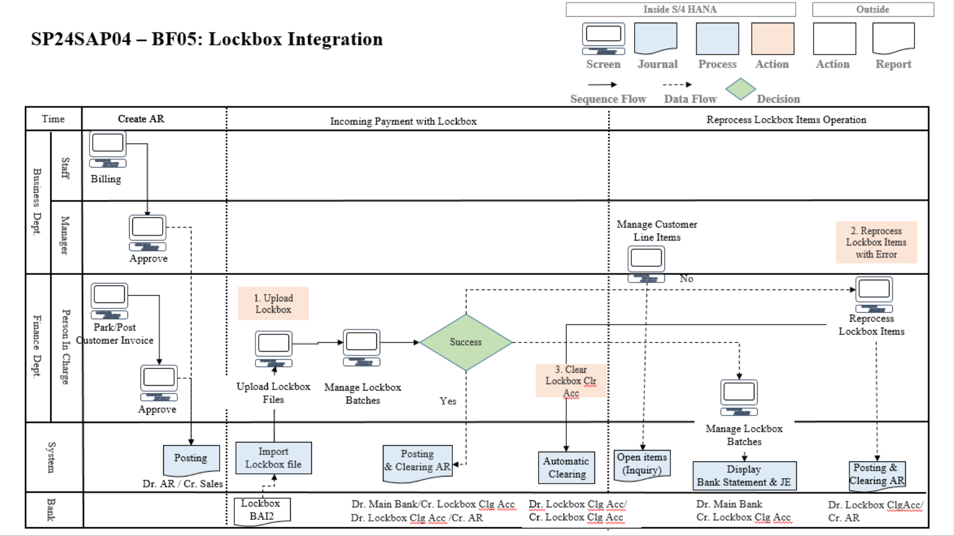

| **Step** | **Step Name** | **Detailed Description** | **Role** |
| --- | --- | --- | --- |
| 1 | Upload Lockbox | After the transactions made by the customer are transferred to the company's account, the bank will collect them into a Lockbox file (BAI2 format) and send them to the business. User will import the Lockbox data into the main program for processing  Fiori Application  **FBL2 - Upload Lockbox Files**  At this point, users are available to check for their status of Lockbox File. If Status is “Completed”, it means Lockbox can be processed successfully and users can refer to related Journal Entries. Otherwise, status is “Not Complete”, user have to reprocess through Reprocess Lockbox Items (Step 2)  Fiori Application  **F1681 - Manage Lockbox Batches** | Finance Department |
| 2 | Reprocess Lockbox Items with Errors | When the error occurred, to which extent may be caused by not matching the exact customer’s invoice, wrong characteristics, etc … Users need to clear open Items if necessary before proceeding further, the taken approach can be listed as: system logs, error messages, or manual review of the lockbox item. Then, again manage and organize Lockbox Batches as required for processing, which includes several types of solution for realizing the cause of the error and taking corrective action. After everything is done, review and post journal entry  Fiori Application  **F3398 - Reprocess Lockbox Items** | Finance Department |
| 3 | Clear Lockbox Clearing Account | After all the successful process of the Lockbox in the making, users reconcile Bank Sub Incoming Items are cleared, giving its balance back to zero.  With the process can be managed by batch operation.  Fiori Application  **F.13 - Clear G/L Accounts** | G/L Accountant |

## 4. Project Scope & Limitations

### 4.1 Project Scope

#### 4.1.1 In scope

The ABC Company project focuses on seamlessly integrating eBanking functionalities—Bank Statement and Lockbox—into their existing SAP S/4HANA Finance system. With the goal of streamlining bank reconciliation, the project aims to automate processes, optimize efficiency, and reduce manual efforts. Leveraging SAP's advanced Bank Statement functionality, the project targets the automation of internal record matching, ensuring quicker and more accurate reconciliation.

A key objective is error mitigation in bank transaction reconciliation. The integrated eBanking solution utilizes SAP S/4HANA Finance's robust reconciliation algorithms, minimizing discrepancies and enhancing accuracy in financial reporting and decision-making. Additionally, the project prioritizes real-time financial visibility, configuring settings within SAP to provide immediate insights into the company's financial position.

Ultimately, the overarching goal is a unified bank reconciliation process tailored to ABC Company's needs. This involves the seamless integration of Bank Statement and Lockbox functionalities into SAP S/4HANA Finance, minimizing discrepancies, ensuring accurate financial records, and contributing to overall financial management efficiency.

#### 4.1.2 Out of scope

Besides the goals stated above, ABC company's project also outlines points beyond the scope of the research:

Eliminate Manual Processes:

- Aim to eliminate most of the manual processes involved.

- Automate and reduce manual processes for accountants.

- Make work easier and more accurate.

The processes related to Multi-Bank Connectivity are things that will not be mentioned within the scope of this project. Because it is beyond the requirements of the business, it will also be a goal to aim for in the future.

## 5. Project Management Plan

### 5.1 Overview

#### 5.1.1 Scope and Estimation

| # | WBS Item | Complexity | Est. Effort (in days) |
| --- | --- | --- | --- |
| **1** | **Project Plan** |  | **38.5** |
| 1.1 | **Knowledge Transfer** | Medium | 15 |
| 1.1 | **Process Adoption** | Medium | 7 |
| 1.2 | Project Kick-off | Medium | 0.5 |
| 1.3 | Define problem statement (Customer Definition,  Current Processes and Limitations) | Medium | 2 |
| 1.4 | Define Requirement Analysis (Customer Requirements, SAP Solution) | Medium | 10 |
| 1.5 | Write a preliminary report on topic thesis "Process of integrating Bank Statement, LockBox" (based on the suggested Mentor template) | Medium | 4 |
| **2** | **Processes Finalization** |  | **26** |
| 2.1 | Draw Business Process for Outgoing Bank Integration | Medium | 5 |
| 2.2 | Draw Business Process for Incoming Bank Integration | Medium | 5 |
| 2.3 | Draw Business Process for Import Bank Statement | Medium | 5 |
| 2.4 | Draw business process for Incoming Payment with Electronic Bank Statement | Medium | 5 |
| 2.5 | Draw business process for LockBox Integration | Medium | 6 |
| **3** | **Project Scopes** |  | **4** |
| 3.1 | Define project scope & limitations | Medium | 2 |
| 3.2 | Finish Report 1 | Simple | 2 |
| **4** | **Define System Infrastructure** |  | **13** |
| 4.1 | Define System Landscape | Medium | 7 |
| 4.2 | Define Transport Request Management | Medium | 6 |
| 5 | **Realization** |  | 34 |
| 5.1 | SAP Configuration (Master Data Configuration, Electronic Bank Statement Configuration, LockBox Configuration,…) | Medium | 12 |
| 5.2 | Authorizations/ Roles Configuration | Medium | 5 |
| 5.3 | User guide | Medium | 10 |
| 5.4 | Finish Report 2 | Medium | 7 |
| **6** | **Coding** |  | **25** |
| 6.1 | User Exit for Processing Bank Statement | Medium | 2 |
| 6.2 | Enhance Exit Function in DMEE (Data Medium Exchange Engine) File | Medium | 5 |
| 6.3 | Smartforms (Cash in Bank Detail Book Design) | Medium | 6 |
| 6.4 | Set Up Batch Job for Automatic Clearing (F.13) | Medium | 7 |
| 6.7 | Finish Report 3 | Medium | 5 |
| **7** | **Final Preparation** |  | **13** |
| 7.3 | Define Test Environment | Medium | 5 |
| 7.1 | Define Test Cases | Medium | 6 |
| 7.2 | Define Test Reports | Simple | 2 |
| 8 | **Go-live** |  | 6 |
| 8.1 | Moving Transport Request to PRD | Medium | 6 |
| 8.1 | **Finish Report 4** | Medium | 6 |

**Total Estimated Effort (days): 192,5**

#### 

#### 

#### 5.1.2 Project Objectives

| **#** | **Quality Stage** | **No. of Defects** | **% Of Defect** | **Notes** |
| --- | --- | --- | --- | --- |
| 1 | Reviewing | 6 | 20 |  |
| 2 | Unit Test | 4 | 14 |  |
| 3 | System Test | 2 | 9 |  |

#### 

#### 5.1.3 Project Risks

| **#** | **Risk Description** | **Impact** | **Possibility** | **Response Plans** |
| --- | --- | --- | --- | --- |
| 1 | Not understanding requirements. | High | Medium | Develop a prototype and review this with supervisors. |
| 2 | Conflicts between team members. | High | Medium | Creating a meeting to share uncomfortable things. |
| 3 | Lack of experience and knowledge. | High | Medium | All members should support each other. |
| 4 | Personal problems of some members. | High | Medium | All members should support each other. |

### 5.2 Project Deliverables

| **#** | **Deliverable** | **Due Date** | **Notes** |
| --- | --- | --- | --- |
| 1 | Project Plan | 2/1/2024 | Make project goal plan |
| 2 | Report 1: Project Introduction | 30/1/2024 | Project Introduction |
| 3 | Report 2: Configuration and Coding | 12/3/2024 | Configuration for Bank Statement & Lockbox |
| 4 | Report 3: Software Requirement Specifications | 15/3/2024 | Create specifications for Software Requirements |
| 5 | Configuration Guide | 10/4/2024 | Create and Edit Configuration Checklist on Excel NoteBook for 60 sequences |
| 7 | Testing Reports | 12/04/2024 | System testing according to test case |
| 6 | Final Report: Interdisciplinary Project Report | 14/4/2024 | Finish the final report |

### 

### 5.3 Communication Plan

| **Communication Item** | **Who/ Target** | **Purpose** | **When, Frequency** | **Type, Tool, Method(s)** |
| --- | --- | --- | --- | --- |
| Online Meeting | Mentor,  Supervisor,  Team member | ● Report about the progress.  ● Raise and handle the problems.  ● Review task.  ● Review and test the app. | Every Tuesday, Thursday of a week | Google Meet |
| Offline Meeting | Team Member | ● Working together in the same place to solve problems quickly.  ● Generate and handle problems.  ● Discuss requirements and business analysis.  ● Ask and answer each other's questions.  ● Inform the team about important project news and events. | Usually | The coffee shop |
| Chatting | Team Member | ● Discuss about the project  ● Talk and report the working progress | Always | Zalo |
| Meeting supervisor | Mentor,  Supervisor,  Team member | ● Review working progress  ● Review project report  ● Review project report  ● Answer question | Sometimes | FPT Software  Ftown-3 |

### 

### 5.4 Training Plan

| **Training area** | **Participants** | **When, Duration** |
| --- | --- | --- |
| Business Process in Financial Accounting in SAP S4/HANA | All members | 09/01/2024 - 30/01/2024 |
| Bank Accounting, Cash Journal and Bank Reconciliation | All members | 30/01/2024 - 10/02/2024 |
| Bank Statement Configuration | Mạnh Cường, Minh Chiến | 11/02/2024 - 25/03/2024 |
| LockBox Configuration | Minh Huy, Thành Nam | 11/02/2024 - 25/03/2024 |
| Authorization Settings | Minh Huy, Minh Chiến | 25/3/2024 - 10/4/2024 |
| SAP Process Configuration | All members | 10/01/2024 - 20/04/2024 |
| Business Process Configuration | All members | 20/04/2024 - 23/4/2024 |
| ABAP Coding - Enhance Exit Function in DMEE File | Minh Huy | 10/05/2024 - 23/05/2024 |
| ABAP Coding - User Exit for Processing Bank Statement | Mạnh Cường | 10/05/2024 - 23/05/2024 |
| ABAP Coding - Smartforms | Thành Nam | 10/05/2024 - 23/05/2024 |

### 5.5 Project Management Plan

| **Start date** | **End date** | **Project Member** | **Task** | **Project Deliverable** |
| --- | --- | --- | --- | --- |
| 09/01/2024 | 15/01/2024 | All members | Write a preliminary report on topic thesis "Process of integrating Bank Statement, LockBox" (based on the suggested Mentor template) |  |
|
|
|
|
| 16/01/2024 | 20/01/2024 | Nguyễn Minh Huy | Draw Workflow for the Current Incoming Payment Process | Section 2.2, diagram BF01 |
| 16/01/2024 | 20/01/2024 | Võ Thành Nam | Draw Workflow for the Current Outgoing Payment Process | Section 2.2, diagram BF02 |
| 16/01/2024 | 20/01/2024 | Vũ Mạnh Cường | Draw Workflow for the Current Incoming Payment Process | Section 2.2, diagram BF03 |
| 21/01/2024 | 30/01/2024 | Nguyễn Minh Chiến, Vũ Mạnh Cường | Draw Workflow for the Current Incoming Payment Process | Section 3.2, diagram BF03 |
| 21/01/2024 | 30/01/2024 | Nguyễn Minh Chiến, Vũ Mạnh Cường | Draw Workflow for the Incoming Payment with Electronic Bank Statement | Section 3.2, diagram BF03 |
| 21/01/2024 | 30/01/2024 | Nguyễn Minh Chiến, Vũ Mạnh Cường | Draw Workflow for the Outgoing Payment with Electronic Bank Statement | Section 3.2, diagram BF04 |
| 21/01/2024 | 30/01/2024 | Nguyễn Minh Huy, Võ Thành Nam | Draw Workflow for the LockBox Integration | Section 3.2, diagram BF05 |
| 10/05/2024 | 11/05/2024 | Nguyễn Minh Chiến | Testing Maintain Business Partner functionality |  |
| 11/05/2024 | 12/05/2024 | Nguyễn Minh Chiến | Test the DMEE file generation functionality |  |
| 09/05/2024 | 14/05/2024 | Nguyễn Minh Chiến | Testing Bank Statement Functionality |  |
| 12/05/2024 | 14/05/2024 | Nguyễn Minh Chiến | Testing Lockbox Functionality |  |
| 15/05/2024 | 15/05/2024 | Nguyễn Minh Chiến | Testing Authorization |  |

### 5.6 Handling Documents

Save the document, report, diagram, picture, and notes using Google Drive, then place them in the appropriate category folder. Google Drive enables file version management.

# II. SAP Configurations & Coding

## 1. System Infrastructure

### 1.1 System Landscape

SAP, a leading player in enterprise resource planning (ERP) systems, operates within a complex system landscape of interconnected environments. This ecosystem facilitates the development and deployment of SAP applications. Transport requests play a crucial role in this landscape, enabling controlled migration of changes across environments while maintaining integrity and consistency.

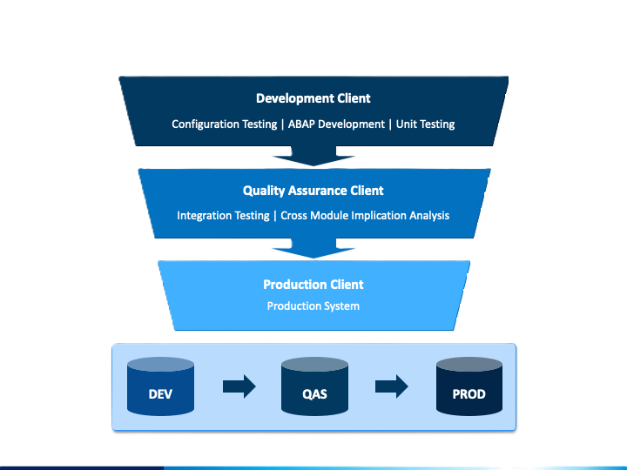

In the development environment, developers innovate by crafting and enhancing SAP applications to meet specific business needs. New functionalities are developed and rigorously tested here to ensure quality before progressing. This environment serves as a playground for experimentation, where developers refine existing functionalities and ensure they meet quality standards.

Once changes are approved in development, they undergo rigorous testing in the quality assurance (QA) environment. Here, changes are subjected to system integration testing (SIT) and user acceptance testing (UAT) to validate their functionality and ensure they align with business requirements. System integration testing (SIT) is conducted in a separate client, where the integrated system functionalities are thoroughly tested to verify that they interact correctly with one another and with external systems. This ensures the seamless integration of the developed functionalities into the existing system architecture. On the other hand, user acceptance testing (UAT) is performed in another client, allowing end-users to validate the changes against their specific business needs and workflows. This phase ensures that the implemented changes meet user expectations and are intuitive to use in real-world scenarios. Performance testing is also conducted in the QA environment to assess system response under varying loads, ensuring stability before deployment.

The production environment hosts real business transactions and is meticulously maintained for optimal performance and reliability. It is in this stable environment that approved changes are deployed, ensuring that business operations run smoothly without disruptions.

### 1.2 Transport Request Management

Transport requests serve as containers facilitating the controlled migration of changes across SAP systems. These requests are governed by a stringent approval process and are orchestrated by the Transport Management System (TMS) for orderly deployment. By encapsulating changes within transport requests, SAP ensures integrity and consistency across environments, minimizing disruptions and maintaining stability.

SAP offers two primary transport requests to cater to change management needs: Workbench Requests (TRs) for transporting repository objects like programs and function modules, and Customizing Requests (K/TRs) for transporting configuration changes made within the SAP system. By categorizing changes into these types, SAP provides a structured approach to managing and deploying modifications across environments, ensuring consistency and reliability in the SAP landscape.

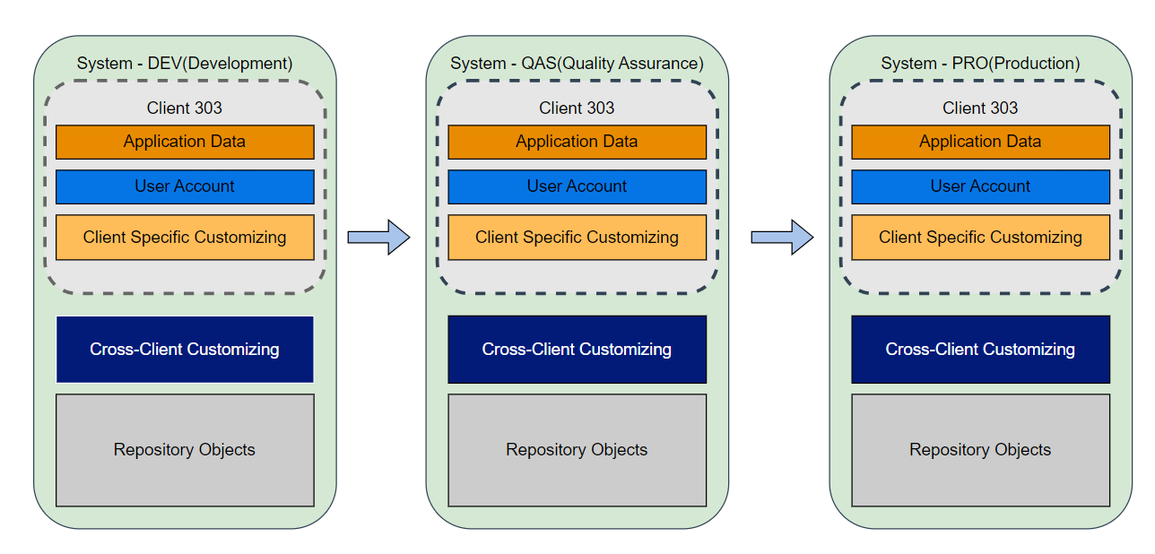

For this project, we will use three system environments which are Development (DEV), Quality Assurance (QAS), and Production (PRO), and have the same client 303, the quality assurance environment in client 303. We will use Workbench Requests for transporting enhancements of user exit to other environments and Customizing Requests for transporting configuration to the other.

## 2. SAP Configurations

### 2.1 Enterprise Structure

To construct the enterprise framework, we shall diligently rely upon the extant datasets within SAP, encompassing integral components such as the company code, the designated business area, the designated controlling area, credit control mechanisms, the specified field status, as well as the comprehensive ledger system found within the realms of Financial Accounting (FI) and Controlling (CO). Following the acquisition and analysis of these elements, we will proceed to the meticulous construction of an intricate network, establishing a coherent mapping that interlinks each aspect to its counterparts, thereby ensuring a robust and well-orchestrated enterprise structure.

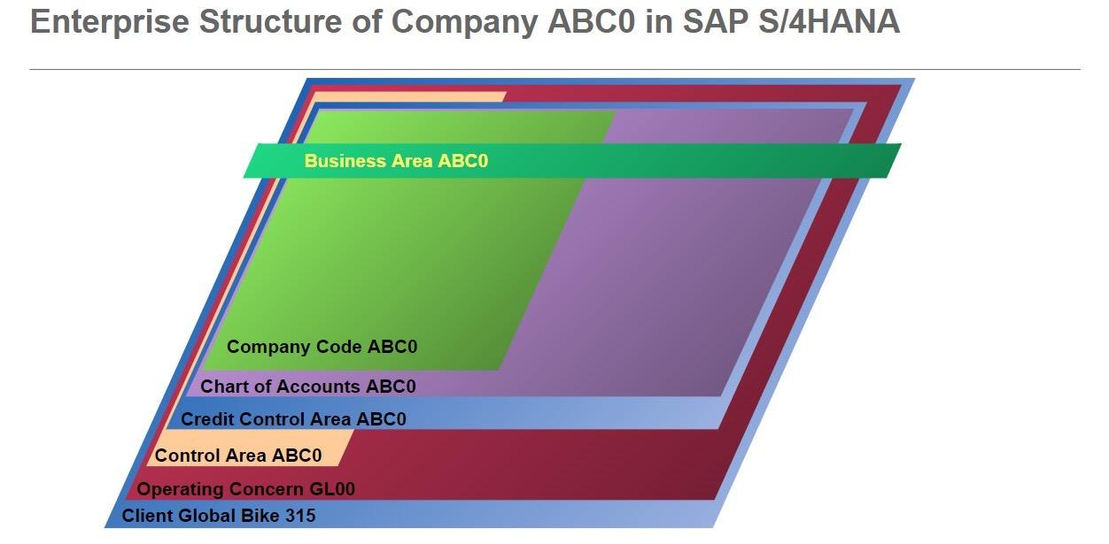

**Define Company Code**

*SAP Customizing Implementation Guide ► Enterprise Structure ► Definition ► Financial Accounting ► Edit, Copy, Delete, Check Company Code*

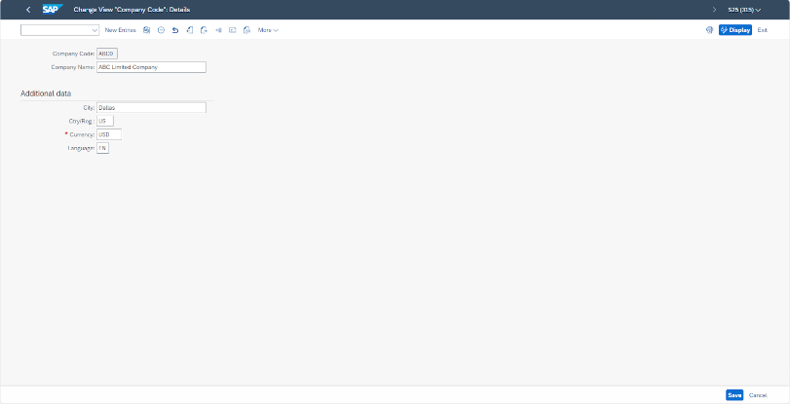

Edit Detail of Address Data in Company Code

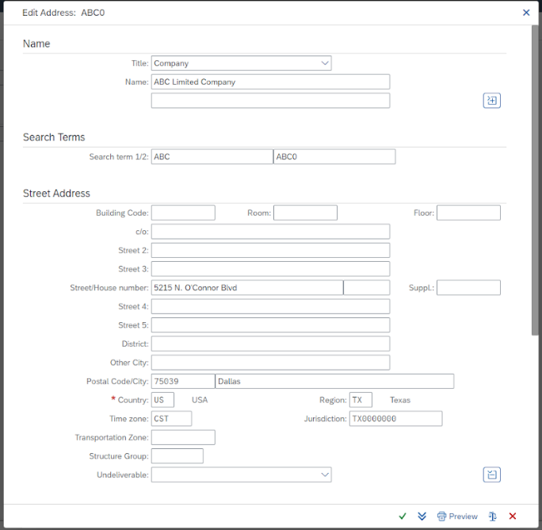

**Define Business Area**

*SAP Customizing Implementation Guide ► Enterprise Structure ► Definition ► Financial Accounting ► Define Business Area*

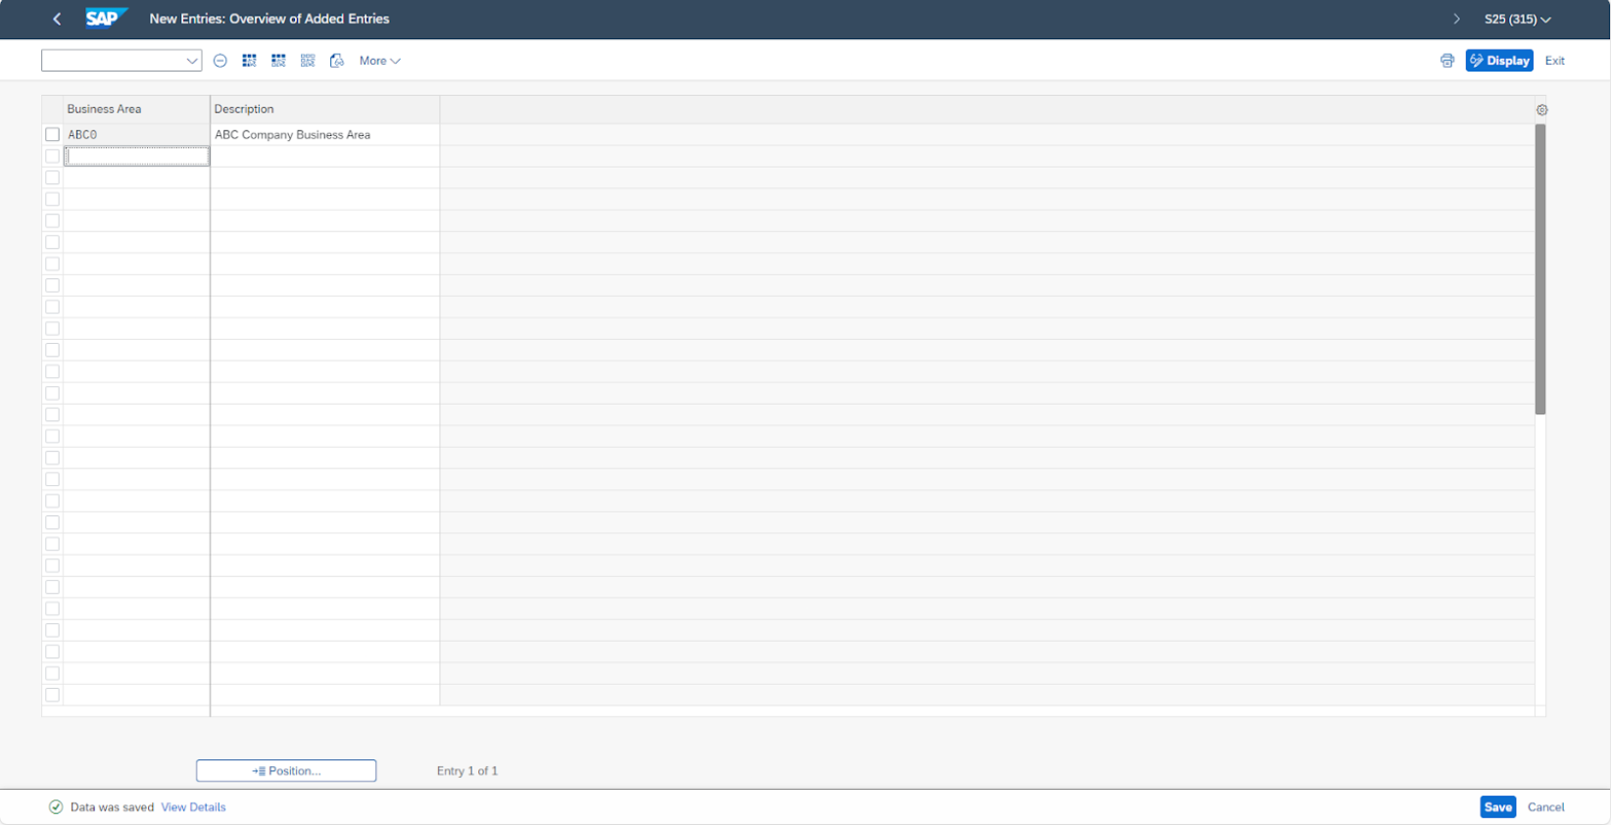

**Define Empty Chart of Accounts**

*SAP Customizing Implementation Guide ► Financial Accounting ► General Ledger Accounting ► Master Data ► G/L Accounts ► Preparations ►Edit Chart of Accounts List*

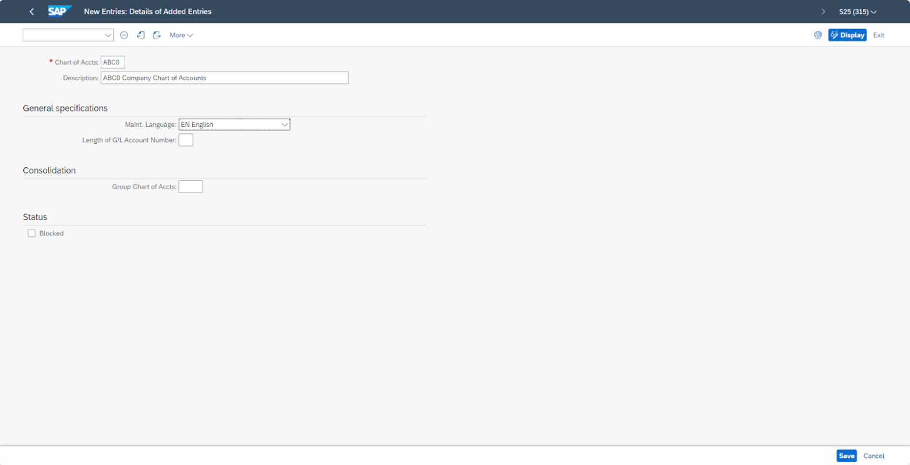

**Define Controlling Area**

*SAP Customizing Implementation Guide ► Enterprise Structure ► Definition ► Controlling ► Maintain Controlling Area*

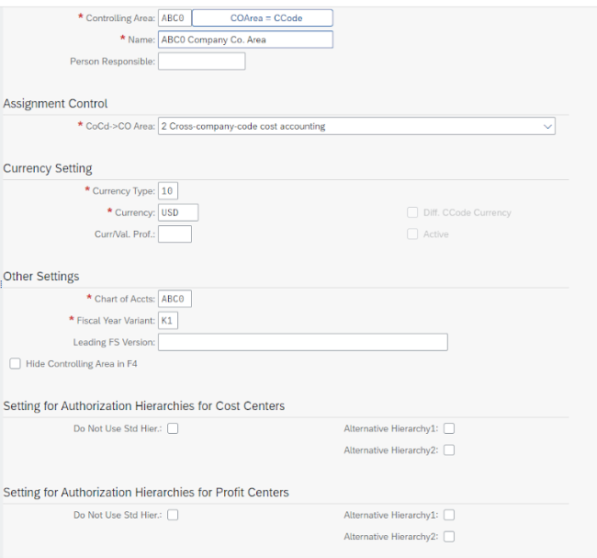

**Define Credit Control Area**

*SAP Customizing Implementation Guide ► Enterprise Structure ► Definition ► Financial Accounting ► Define Credit Control Area*

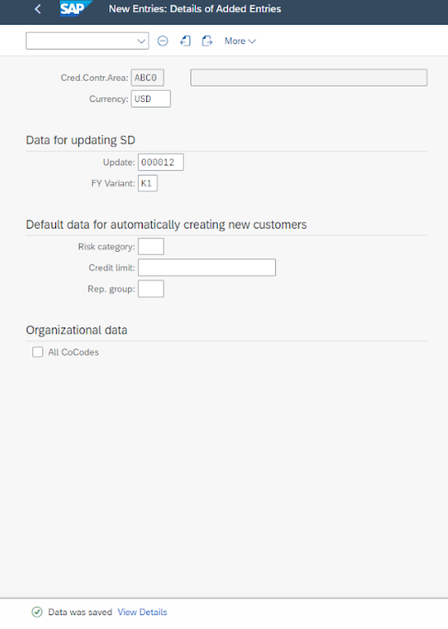

**Define Posting Period Variants**

*SAP Customizing Implementation Guide ► Financial Accounting ► Financial Accounting Global Settings ► Ledgers ► Fiscal Year and Posting Periods ► Posting Periods ► Define Variants for Open Posting Periods*

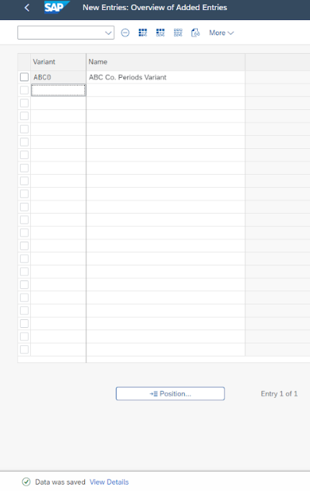

**Define Field Status Variant**

*SAP Customizing Implementation Guide ► Financial Accounting ► Financial Accounting Global Settings ► Ledgers ► Fields ► Define Field Status Variants*

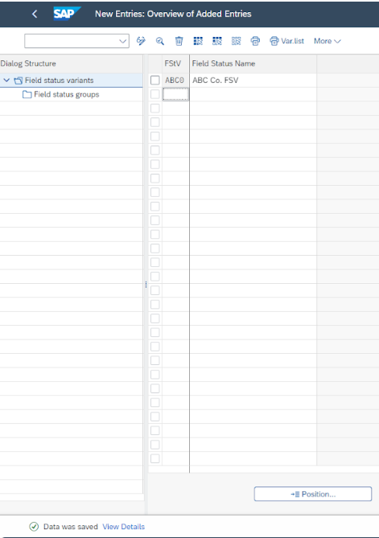

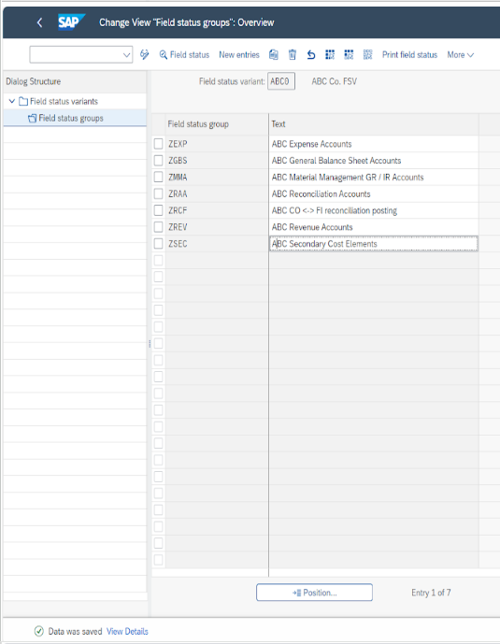

**Enter Global Parameters for a Company Code**

*SAP Customizing Implementation Guide ► Financial Accounting ► Financial Accounting Global Settings ► Global Parameters for Company Code ► Enter Global Parameters*

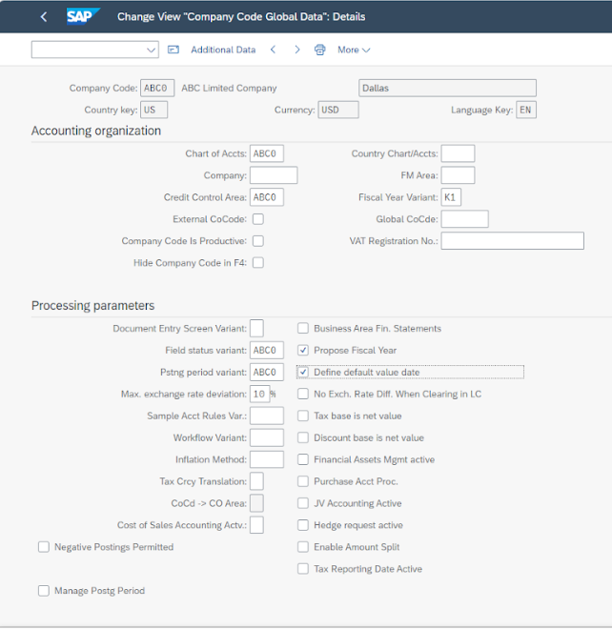

**Assign Company Code to Controlling Area**

*SAP Customizing Implementation Guide ► Enterprise Structure ► Assignment ► Controlling ► Assign company code to controlling area*

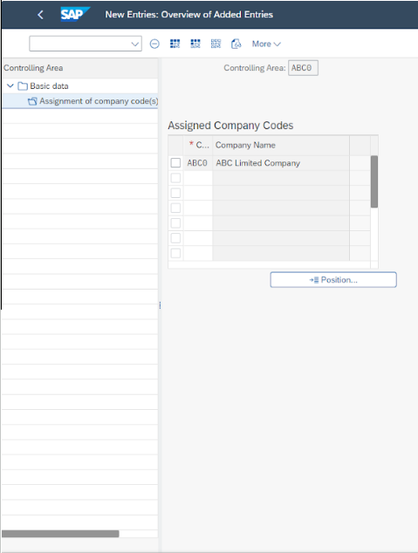

**Assign Controlling Area to Operating Concern**

*SAP Customizing Implementation Guide ► Enterprise Structure ► Assignment ► Controlling ► Assign controlling area to operation concern*

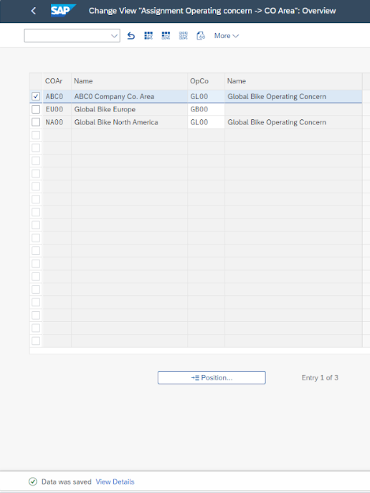

**Assign Credit Control Area to Company Code**

*SAP Customizing Implementation Guide ► Financial Supply Chain Management ► Credit Management ► Integration with Accounts Receivable Accounting and Sales and Distribution ► Integration with Accounts Receivable Accounting ► Assign Permitted Credit Control Areas to Company Code*

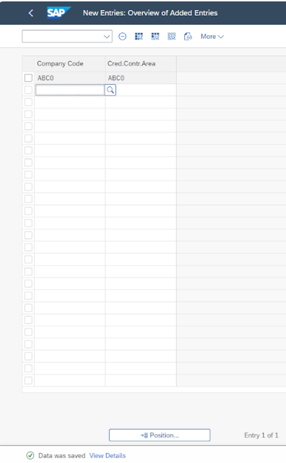

**Assign Company Code to Ledger**

*SAP Customizing Implementation Guide ► Financial Accounting ► Financial Accounting Global Settings ► Ledgers ► Ledger ► Define Settings for Ledgers and Currency Types*

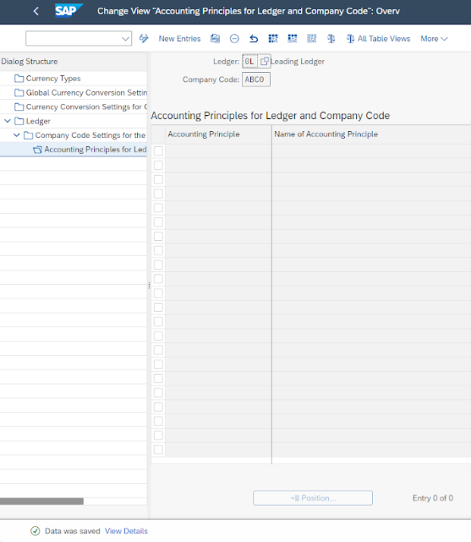

**Define Default Values for Postings in Controlling**

*SAP Customizing Implementation Guide ► Financial Accounting ► Financial Accounting Global Settings ► Ledgers ► Integration of Controlling with Financial Accounting ► Check and Define Default Values for Postings in Controlling*

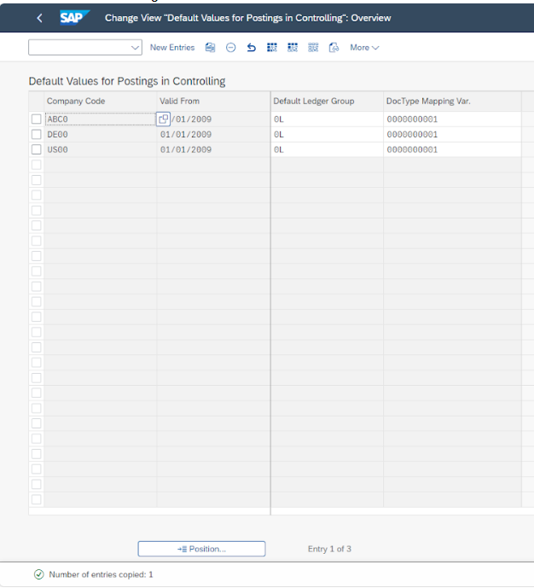

**Define Ledger for CO Version**

*SAP Customizing Implementation Guide ► Financial Accounting ► Financial Accounting Global Settings ► Ledgers ► Integration of Controlling with Financial Accounting ► Define Ledger for CO Version*

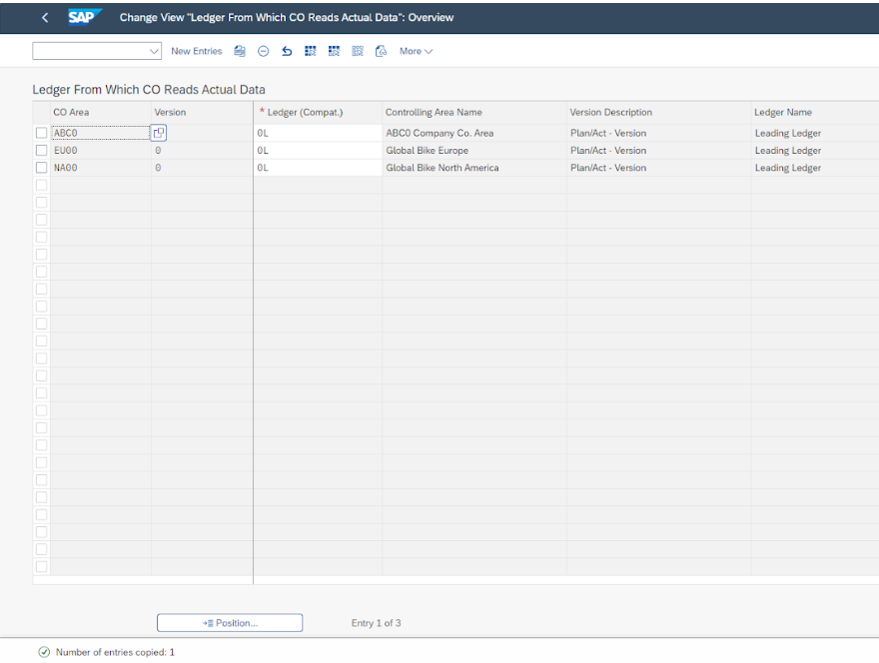

**Enter Global Parameters for a Controlling Area**

*SAP Customizing Implementation Guide ► Controlling ► General Controlling ► Organization ► Maintain Controlling Area*

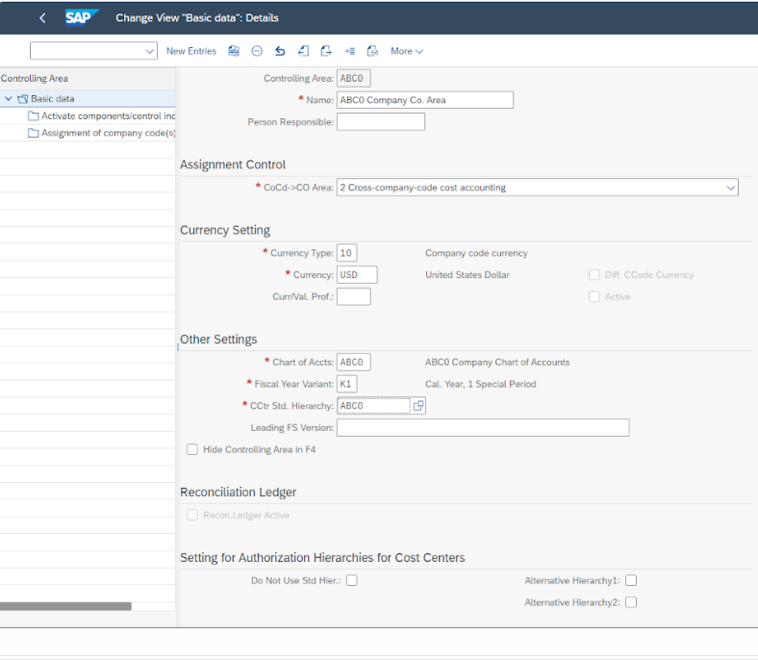

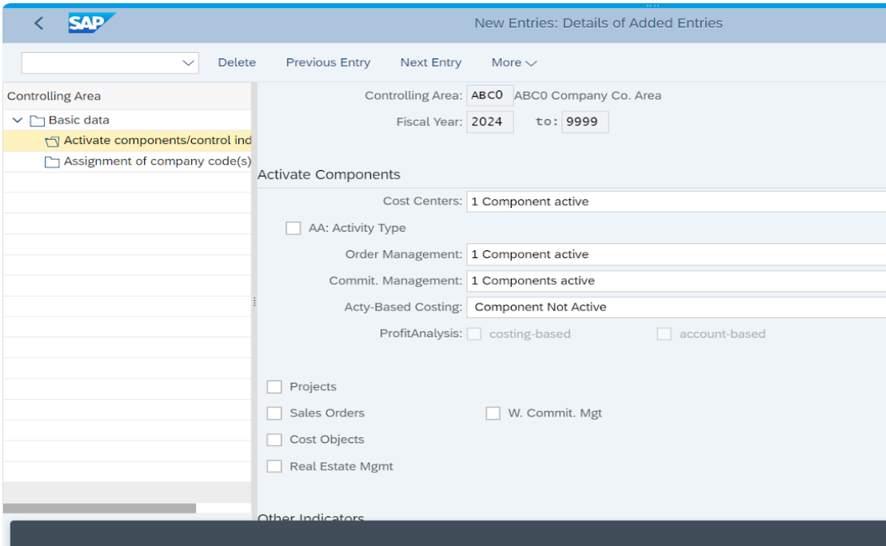

**Initialize the Posting Period**

*SAP Customizing Implementation Guide ► Logistics - General ► Material Master ► Basic Settings ► Maintain Company Codes for Materials Management*

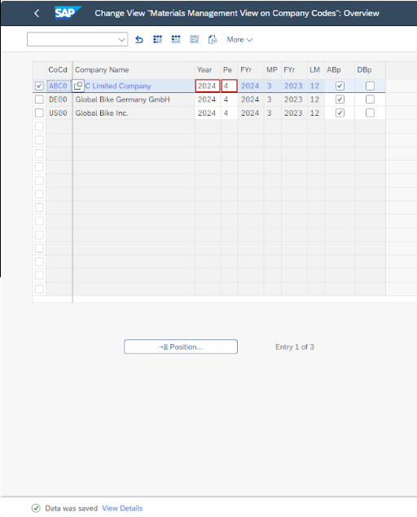

### 2.2 Process Configuration

In the process of configuring our financial systems, we have adopted a methodology that aligns with the SAP standard framework to facilitate the deployment of processes related to accounts receivable and accounts payable. This adherence to established protocols ensures consistency and leverages proven practices within the industry. Additionally, as a measure to enhance financial controls and mitigate risks associated with transactional activities, we have instituted a policy that specifies a maximum allowable amount for each transaction. These limitations are strategically set to maintain financial integrity and prevent the occurrence of errors or fraudulent activities within our transactional operations.

#### 2.2.1 Automatic Payment Configuration

**Set Up Company Code for Payment Transactions**

*SAP Customizing Implementation Guide ► Financial Accounting ► Accounts Receivable and Accounts Payable ► Business Transactions ► Outgoing Payments ► Automatic Outgoing Payments ► Payment Method/Bank Selection for Payment Program ► Set Up All Company Codes for Payment Transactions*

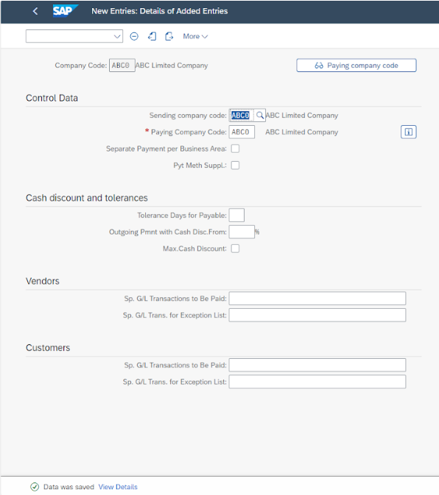

**Set up Paying Company Code**

*SAP Customizing Implementation Guide ► Financial Accounting ► Accounts Receivable and Accounts Payable ► Business Transactions ► Outgoing Payments ► Automatic Outgoing Payments ► Payment Method/Bank Selection for Payment Program ► Set Up All Company Codes for Payment Transactions*

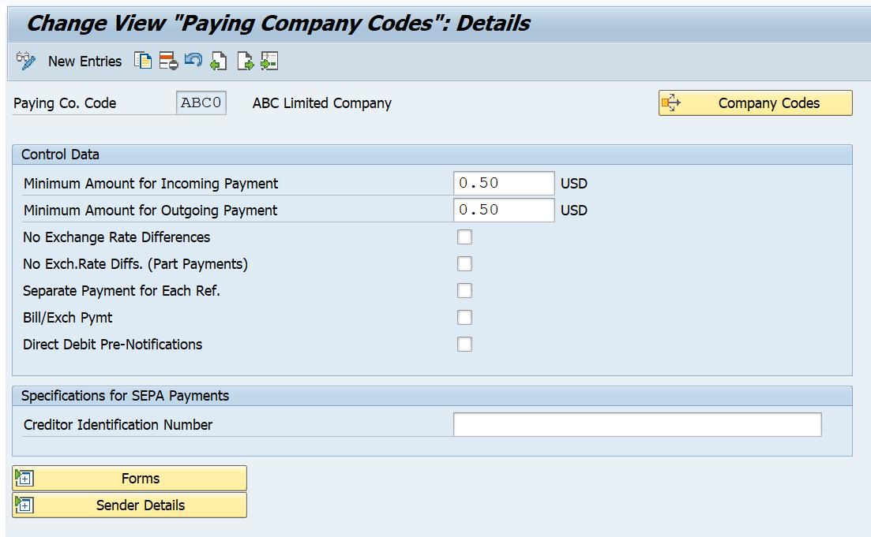

**Set up Payment Method in Country**

*SAP Customizing Implementation Guide ► Financial Accounting ► Accounts Receivable and Accounts Payable ► Business Transactions ► Outgoing Payments ► Automatic Outgoing Payments ► Payment Method/Bank Selection for Payment Program ► Set Up All Company Codes for Payment Transactions*

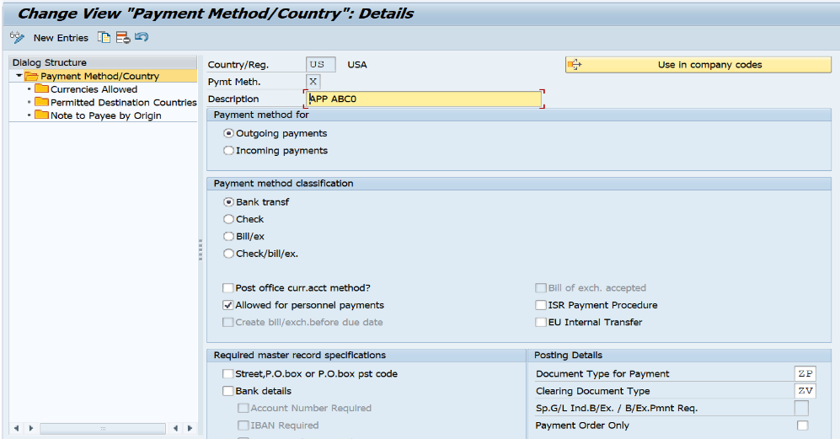

**Set up Payment Method in Company Code**

*SAP Customizing Implementation Guide ► Financial Accounting ► Accounts Receivable and Accounts Payable ► Business Transactions ► Outgoing Payments ► Automatic Outgoing Payments ► Payment Method/Bank Selection for Payment Program ► Set Up All Company Codes for Payment Transactions*

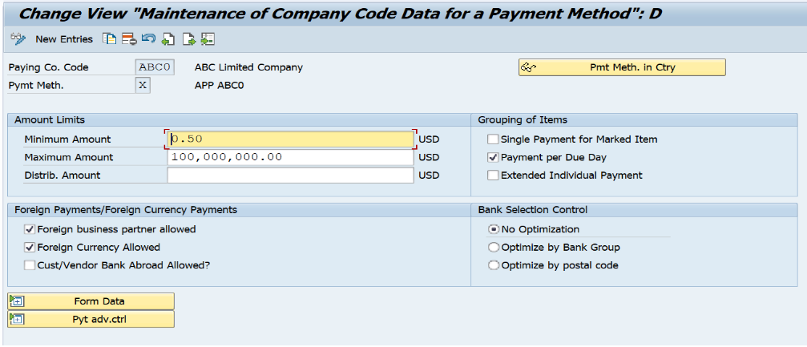

**Bank Determination**

*SAP Customizing Implementation Guide ► Financial Accounting ► Accounts Receivable and Accounts Payable ► Business Transactions ► Outgoing Payments ► Automatic Outgoing Payments ► Payment Method/Bank Selection for Payment Program ► Set Up All Company Codes for Payment Transactions*

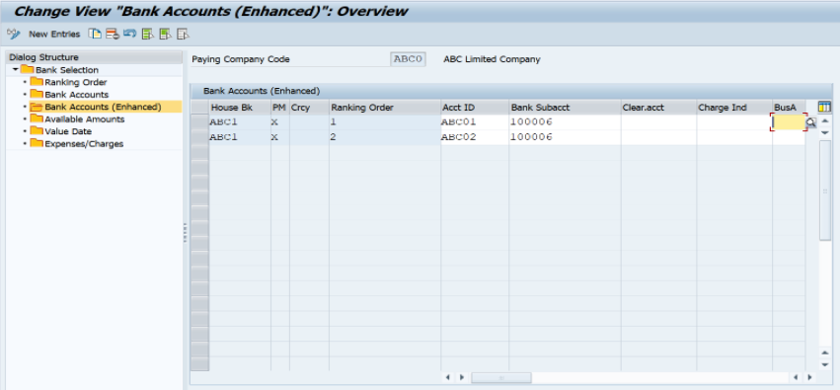

### 

#### 2.2.2 Tax Configuration

**Check Tax Procedure**

*SAP Customizing Implementation Guide ► Financial Accounting ► Financial Accounting Global Settings ►Tax on Sales/Purchases ►Basis Setting ►Check Calculation Procedure*

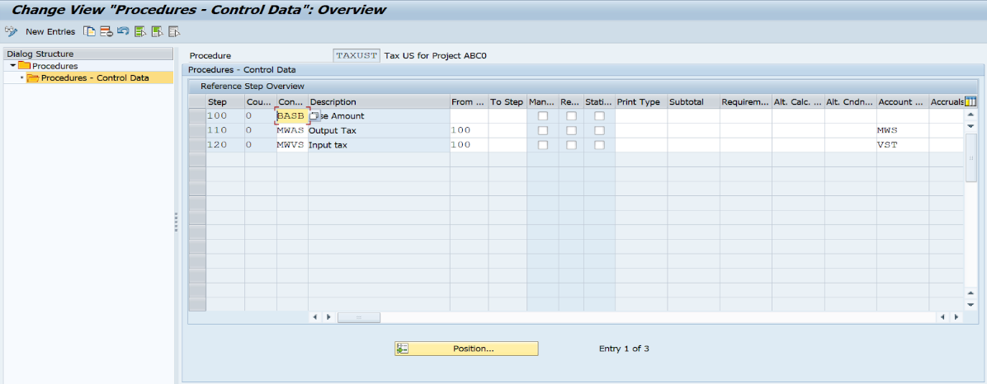

**Assign Country to Calculation Procedure**

*SAP Customizing Implementation Guide ► Financial Accounting ► Financial Accounting Global Settings ►Tax on Sales/Purchases ►Basis Setting ►Assign Country to Calculation Procedure*

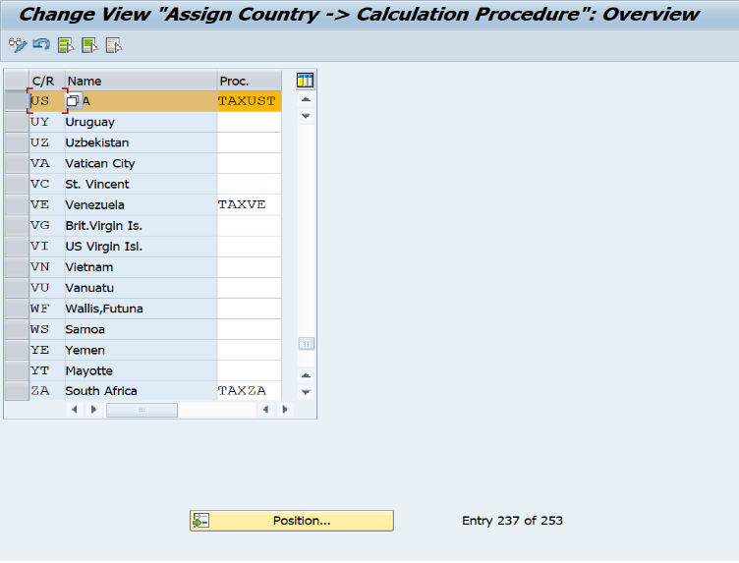

**Define Tax Codes for Sales and Purchases**

*SAP Customizing Implementation Guide ► Financial Accounting ► Financial Accounting Global Settings ►Tax on Sales/Purchases ► Calculation ►Define Tax Codes for Sales and Purchases*

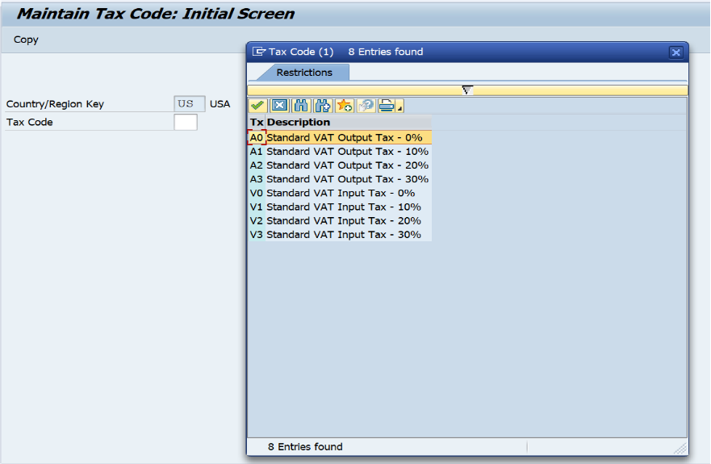

**Define Tax Accounts**

*SAP Customizing Implementation Guide ► Financial Accounting ► Financial Accounting Global Settings ►Tax on Sales/Purchases ► Posting ►Define Tax Accounts*

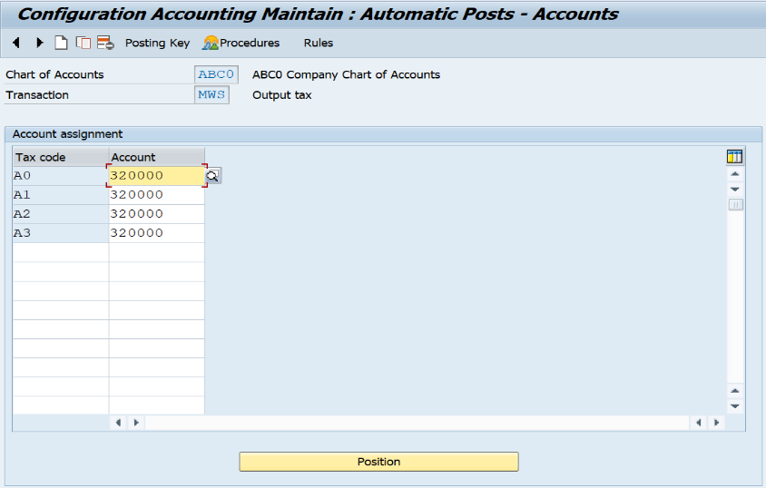

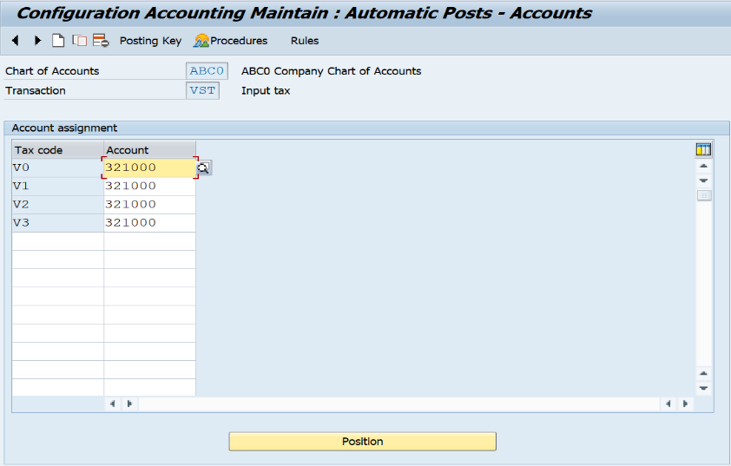

**Assign Tax Code for Non-taxable Transactions**

*SAP Customizing Implementation Guide ► Financial Accounting ► Financial Accounting Global Settings ►Tax on Sales/Purchases ► Posting ►Assign Tax Code for Non-taxable Transactions*

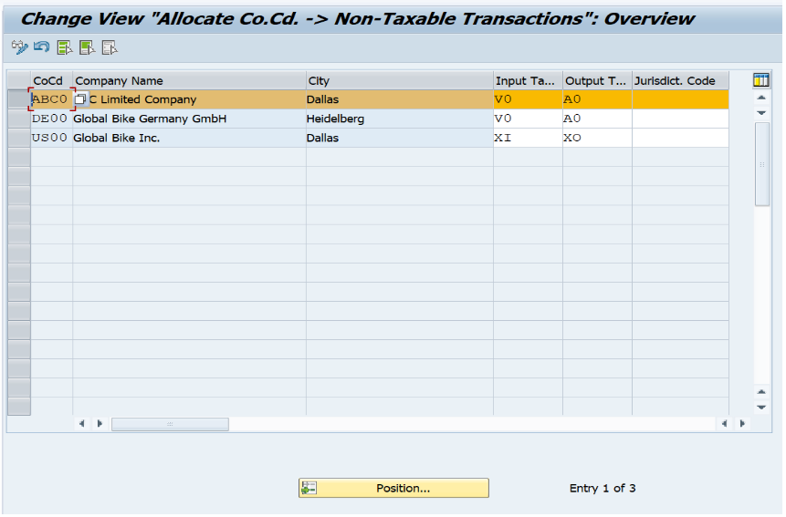

#### 2.2.3 Tolerance Groups

**Define Tolerance Groups for Employees**

*SAP Customizing Implementation Guide ► Financial Accounting ► Financial Accounting Global Settings ► Document ► Tolerance Groups ► Define Tolerance Groups for Employees*

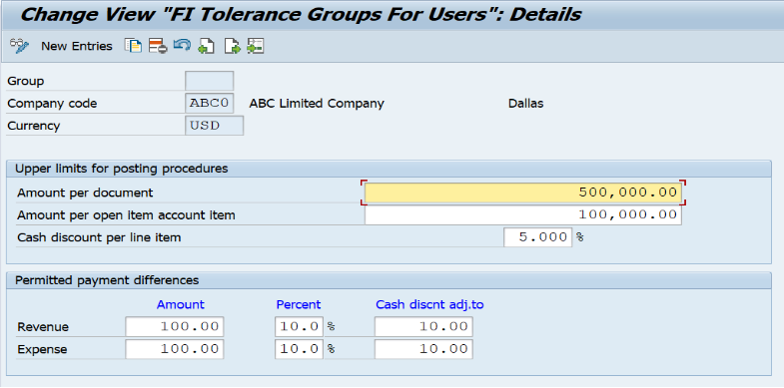

**Define Tolerance Groups for G/L Account**

*SAP Customizing Implementation Guide ► Financial Accounting ► General Ledger Accounting ► Business Transaction ► Open Item Clearing ► Clearing Differences ► Define Tolerance Groups for G/L Accounts*

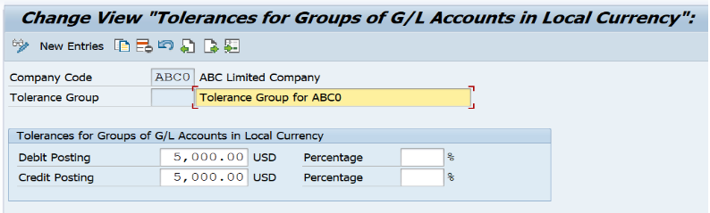

**Define Tolerance Groups Customer/Vendor**

*SAP Customizing Implementation Guide ► Financial Accounting ► Account Receivable and Account Payable ► Business Transaction ► Open Item Clearing ► Clearing Differences ► Define Tolerance Groups for Customers and Suppliers*

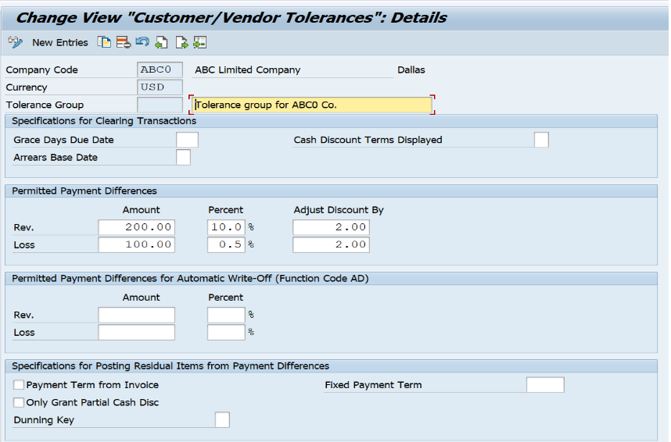

#### 2.2.4 Other configurations

**Exchange Rate Differences**

*SAP Customizing Implementation Guide ► Financial Accounting ► General Ledger Accounting ► Periodic Processing ► Evaluate ► Foreign Currency Valuation ► Prepare Automatic Postings for Foreign Currency Valuation*

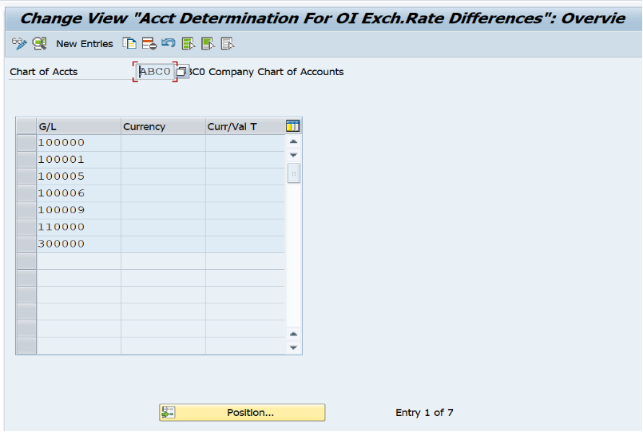

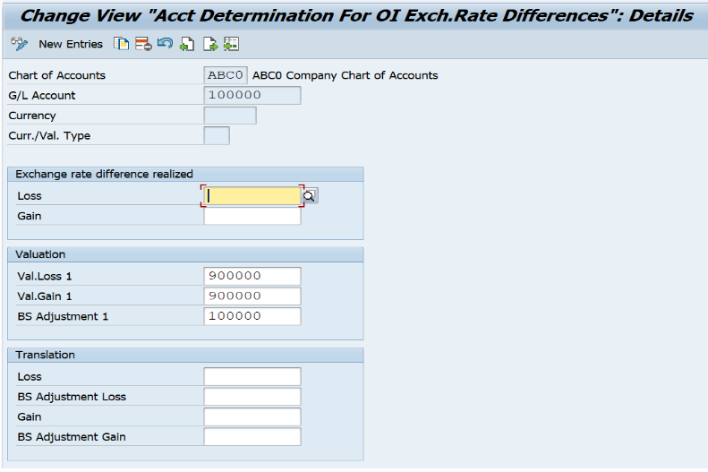

**Define Account Groups**

*SAP Customizing Implementation Guide ► Financial Accounting ► General Ledger Accounting ► Master Data ► G/L Accounts ► Preparations ► Define Account Group*

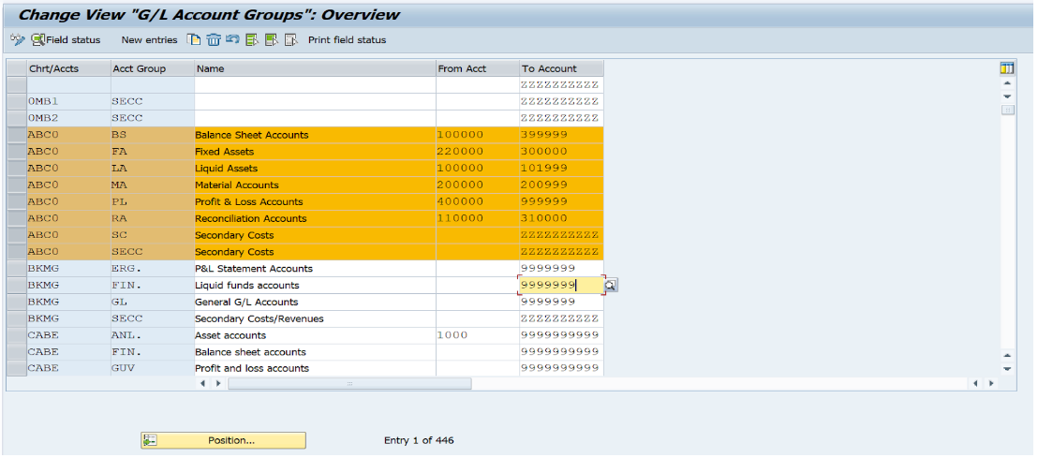

**Create Document Number Ranges for Financial Accounting**

*SAP Customizing Implementation Guide ► Financial Accounting ► Financial Accounting Global Settings ► Document ► Document Number Ranges ► Copy to Company Code*

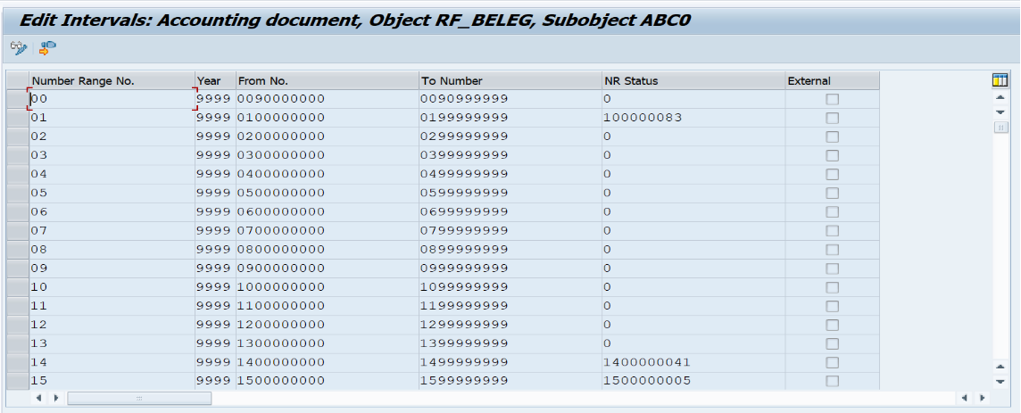

**Create Document Number Ranges for Controlling**

*SAP Customizing Implementation Guide ► Controlling ► General Controlling ► Organization ► Maintain Number Ranges for Controlling Documents*

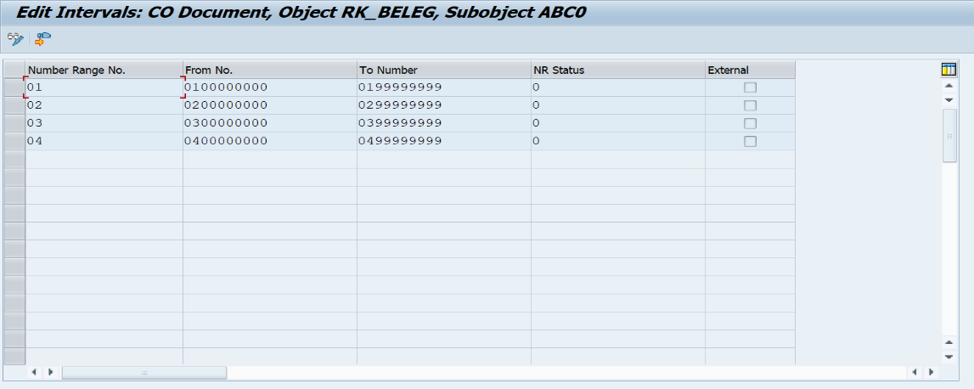

### 2.3 Master Data

#### 2.3.1 G/L Master Data

In the context of configuring the enterprise structure on SAP and creating General Ledger (G/L) master data, we primarily initiate the process by duplicating G/L master records from a template company, often identified as GL00. This template company is typically a reference company code that holds a standard set of G/L accounts, which are commonly used across the organization in various business transactions.

The act of copying G/L master data from GL00 serves as a starting point for ensuring consistency and efficiency since it reduces redundant efforts in creating common G/L accounts from scratch. The G/L master records generally encompass information such as the account number, account name, account group, and the operational chart of accounts, among others.

Once we have established a base by copying these G/L accounts, we proceed to tailor the G/L master data to fit specific requirements of individual company codes within the enterprise structure. This includes adding unique G/L accounts that are necessary to capture special transactions which are not covered by the standard template from GL00. These unique G/L accounts might relate to speciialized financial events such as customized revenue streams, company-specific expenses, or unique asset classes that pertain to particular operational nuances of a subsidiary or division.

**Define Retained Earning Account:**

*SAP Customizing Implementation Guide ► Financial Accounting ► General Ledger Accounting ► Master Data ► G/L Accounts ► G/L Account Creation and Processing ► Create G/L Accounts with Reference*

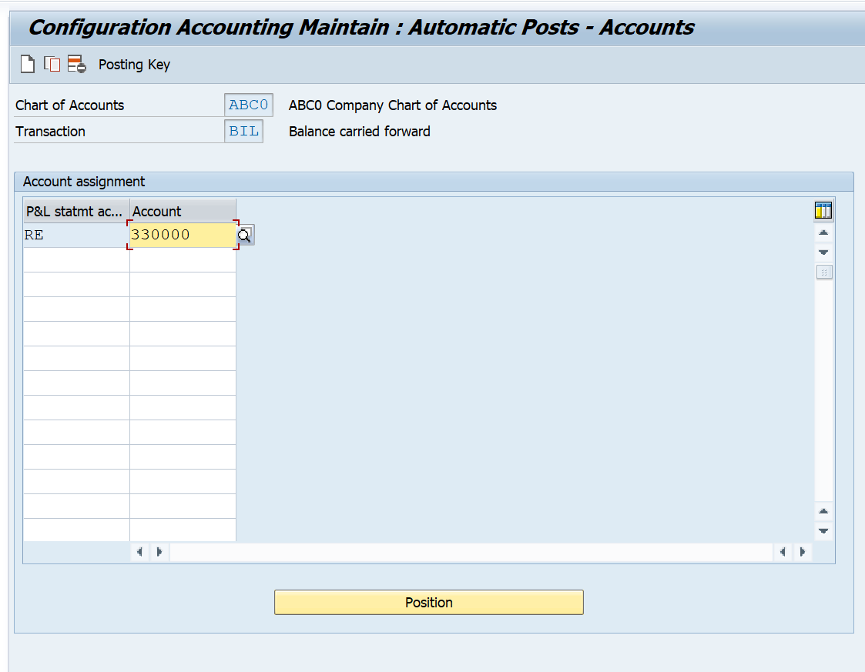

**Create Balance Sheet G/L Accounts:**

*SAP Customizing Implementation Guide ► Financial Accounting ► General Ledger Accounting ► Master Data ► G/L Accounts ► G/L Account Creation and Processing ► Create G/L Accounts with Reference*

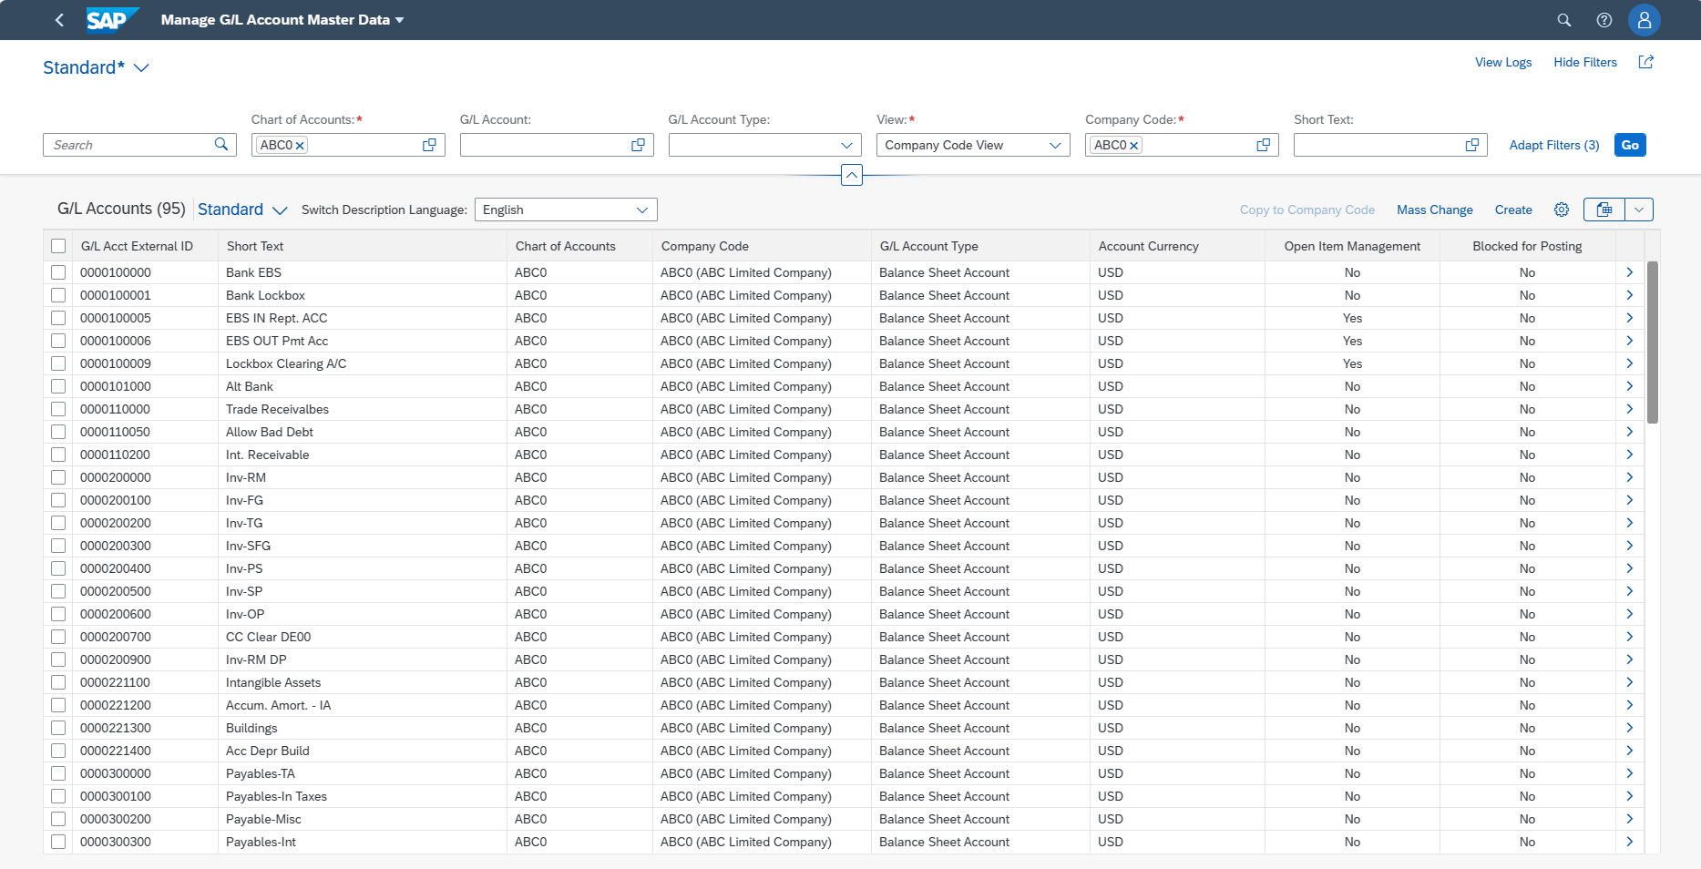

#### 2.3.2 Cost Center Master Data

**Create Standard Hierarchy**

*SAP Customizing Implementation Guide ► Controlling ► Cost Center Accounting ► Master Data ► Cost Centers ► Define Cost Center Groups*

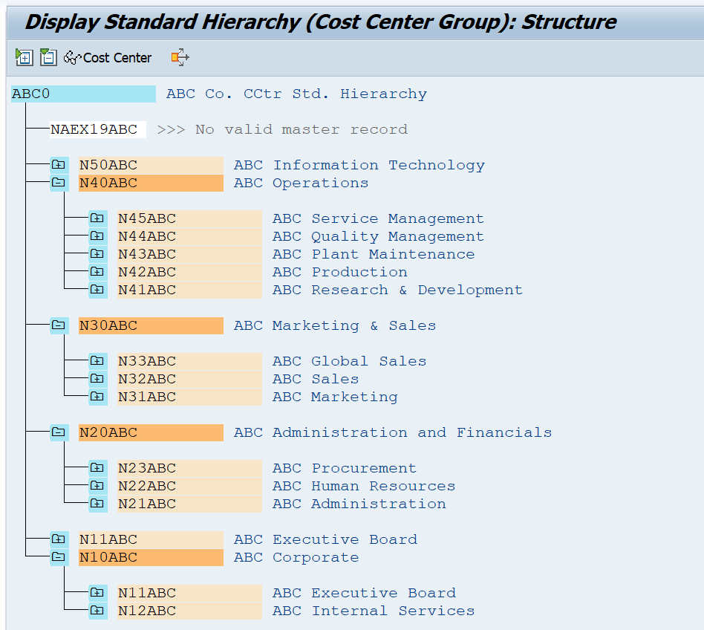

**Create Cost Element Groups**

*SAP Customizing Implementation Guide ► Controlling ► Cost Element Accounting ► Master Data ► Cost Elements ► Create Cost Element Groups*

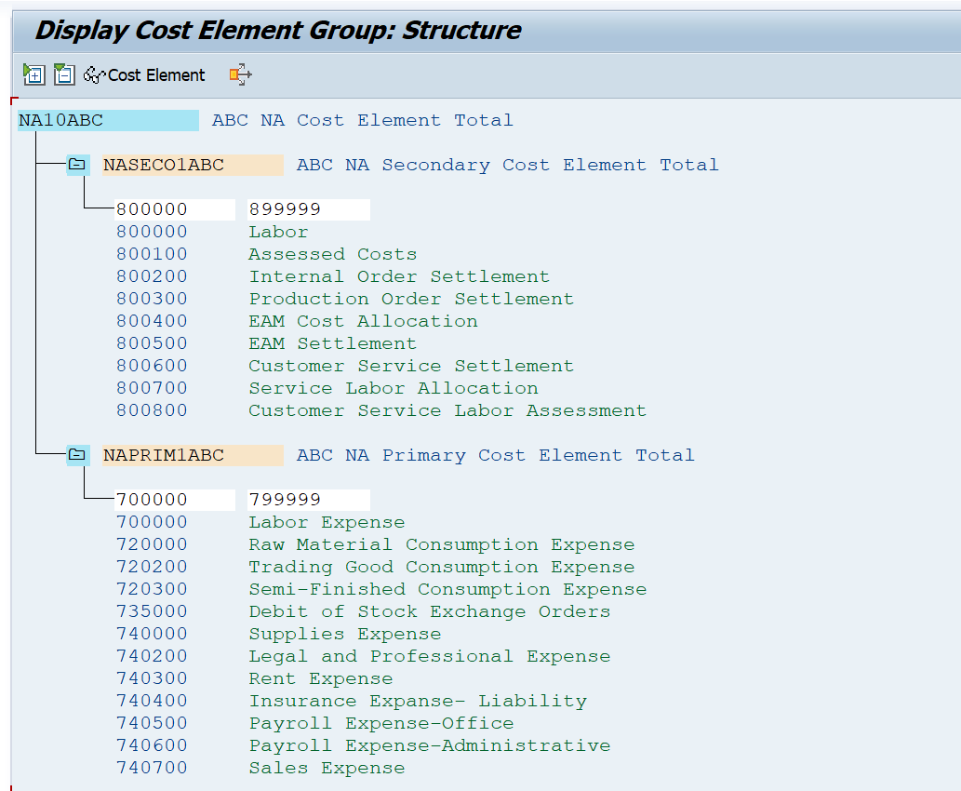

#### 2.3.2 BP Master Data

In the framework of SAP S4HANA, entities commonly recognized as customers and vendors are consolidated under the collective term "Business Partner." This particular aggregation requires a supplementary set of configurations to adequately support the enhanced functionalities associated with this integrated module. In practice, the corporate structure has partitioned these business partners into three specific groupings, each with respective attributes. These groupings comprise local, or domestic entities, foreign entities, reflecting the international participants, and those categorized for single transactions, reflecting infrequent interactions with the enterprise.

Correspondingly, each of these groupings possesses a distinct numerical range that serves as an identification mechanism, streamlining the classification process for organizational efficiency. This methodical structuring allows for more refined data management and reporting processes, aligning with the enhanced capabilities that SAP S4HANA brings to enterprise resource planning.

To operationalize this categorization, the current operational policy mandates the creation of at least one customer or vendor profile within each group. These profiles are intended to serve as exemplars or prototypes for the respective group, adhering to the specific configurations and number ranges that have been predetermined for that classification. This approach not only harmonizes with the overarching framework of "Business Partner" within the system but also provides a structured foundation for future business interactions and expansions within the enterprise’s operational environment.

**Define Account Groups with Screen Layout (Customers)**

*SAP Customizing Implementation Guide ► Financial Accounting ► Accounts Receivable and Accounts Payable ► Customer Accounts ► Master Data ► Preparations for Creating Customer Master Data ► Define Account Groups with Screen Layout (Customers)*

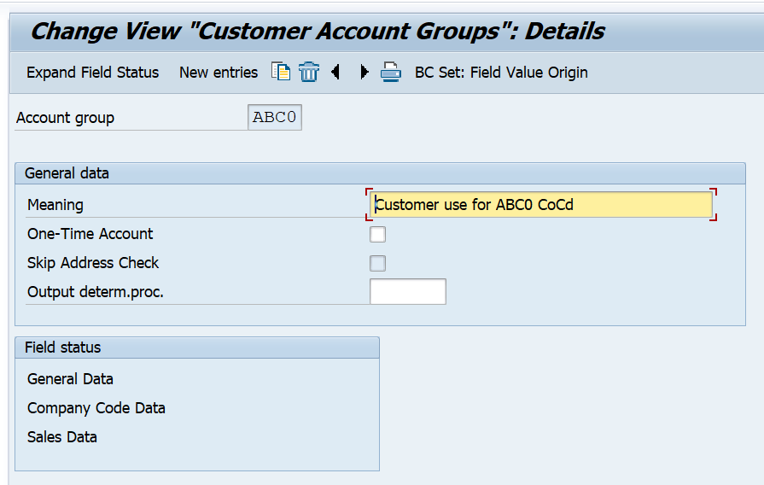

**Create Number Ranges for Customer Accounts**

*SAP Customizing Implementation Guide ► Financial Accounting ► Accounts Receivable and Accounts Payable ► Customer Accounts ► Master Data ► Preparations for Creating Customer Master Data ► Create Number Ranges for Customer Accounts*

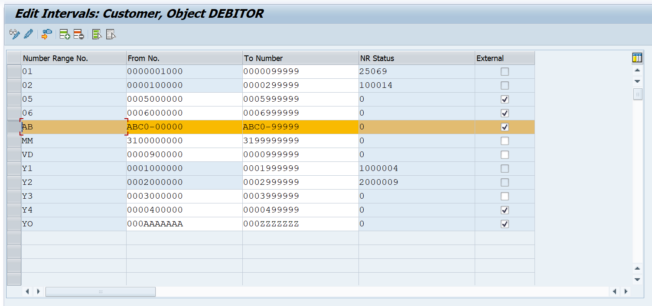

**Assign Number Ranges to Customer Account Groups**

*SAP Customizing Implementation Guide ► Financial Accounting ► Accounts Receivable and Accounts Payable ► Customer Accounts ► Master Data ► Preparations for Creating Customer Master Data ► Assign Number Ranges to Customer Account Groups*

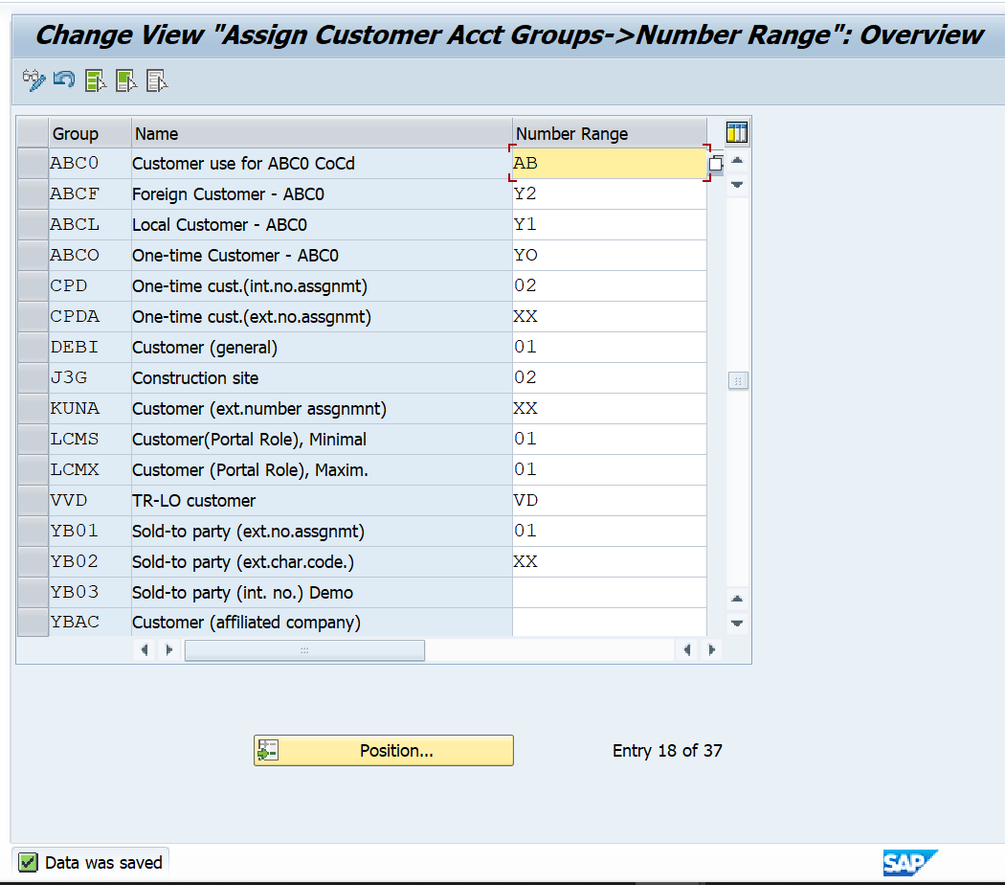

**Define Account Groups with Screen Layout (Vendors)**

*SAP Customizing Implementation Guide ► Financial Accounting ► Accounts Receivable and Accounts Payable ► Vendor Accounts ► Master Data ► Preparations for Creating Vendor Master Data ► Define Account Groups with Screen Layout (Vendors)*

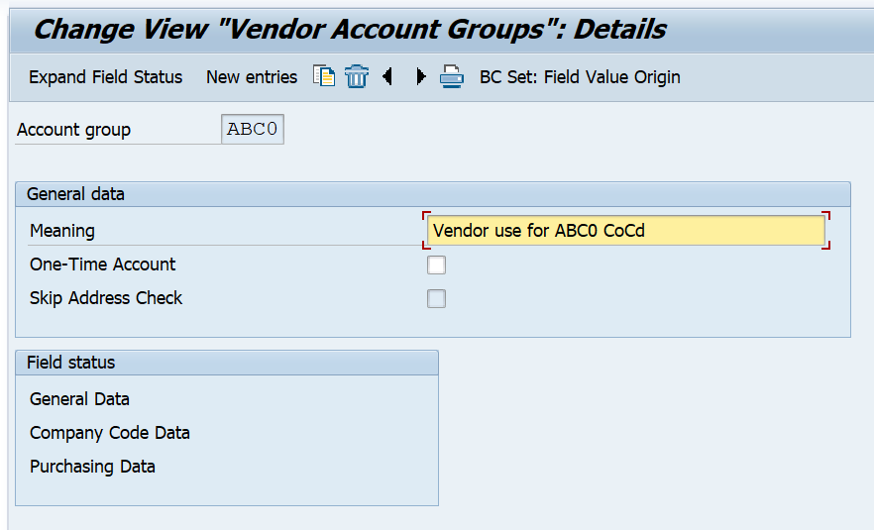

**Create Number Ranges for Vendor Accounts**

*SAP Customizing Implementation Guide ► Financial Accounting ► Accounts Receivable and Accounts Payable ► Vendor Accounts ► Master Data ► Preparations for Creating Vendor Master Data ► Create Number Ranges for Vendor Accounts*

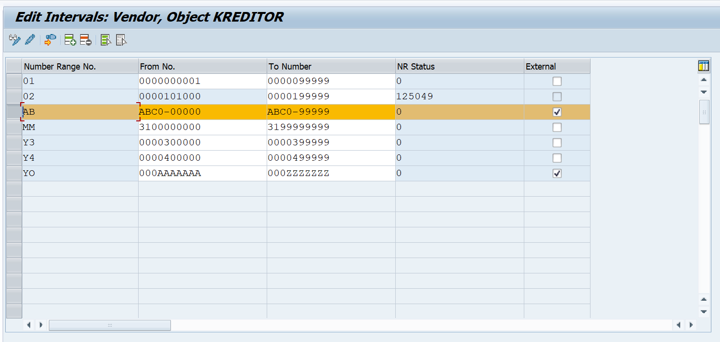

**Assign Number Ranges to Vendor Account Groups**

*SAP Customizing Implementation Guide ► Financial Accounting ► Accounts Receivable and Accounts Payable ► Vendor Accounts ► Master Data ► Preparations for Creating Vendor Master Data ► Assign Number Ranges to Vendor Account Groups*

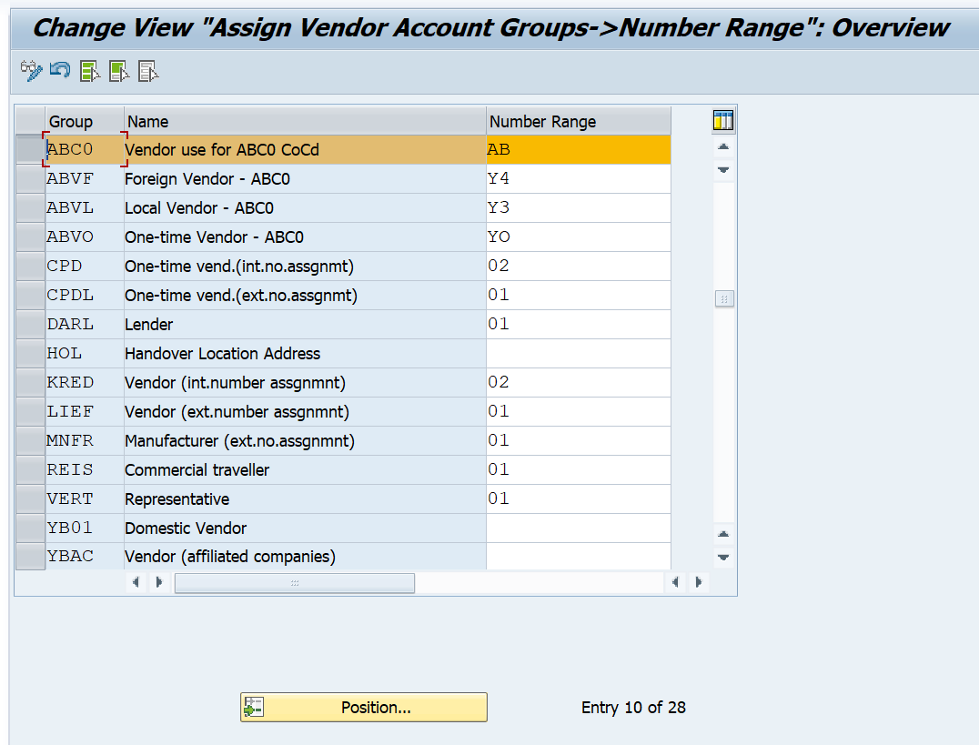

**Define Number Ranges for BP**

*SAP Customizing Implementation Guide ► SAP Business Partner ► Basic Settings ► Define Number Ranges for BP*

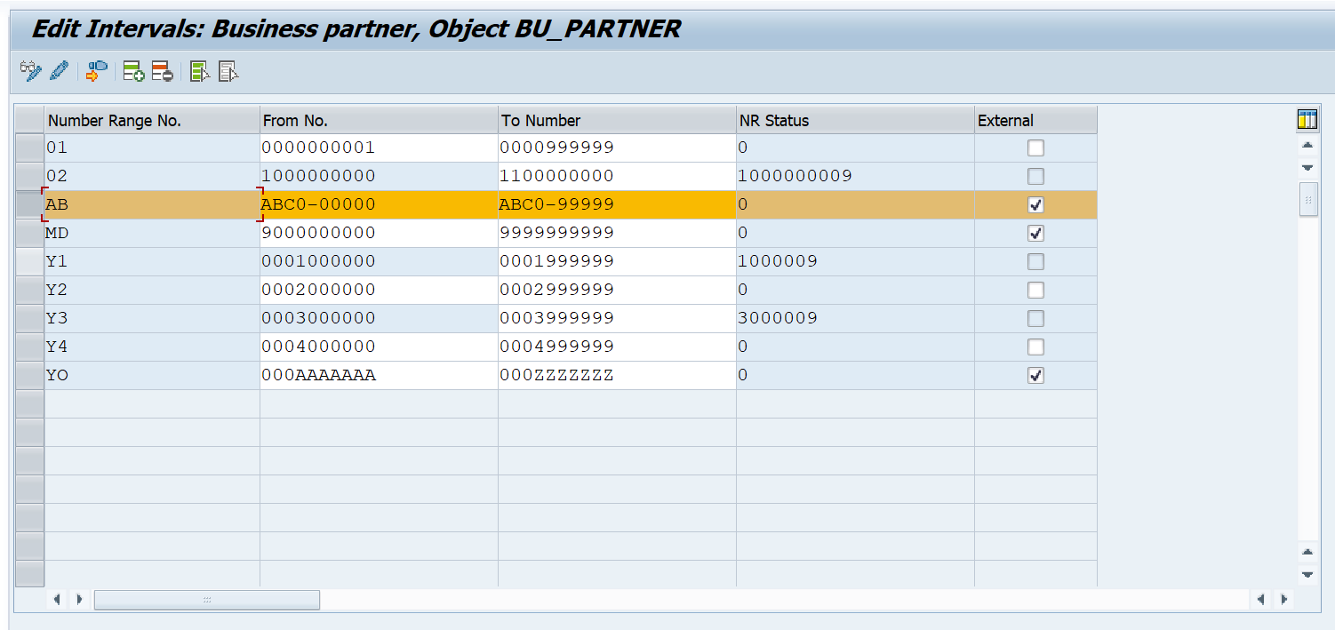

**Define Groupings and Assign Number Ranges**

*SAP Customizing Implementation Guide ► Cross Application Components ► SAP Business Partner ► Business Partner ► Basic Settings ► Number Ranges and Groupings ► Define Groupings and Assign Number Ranges*

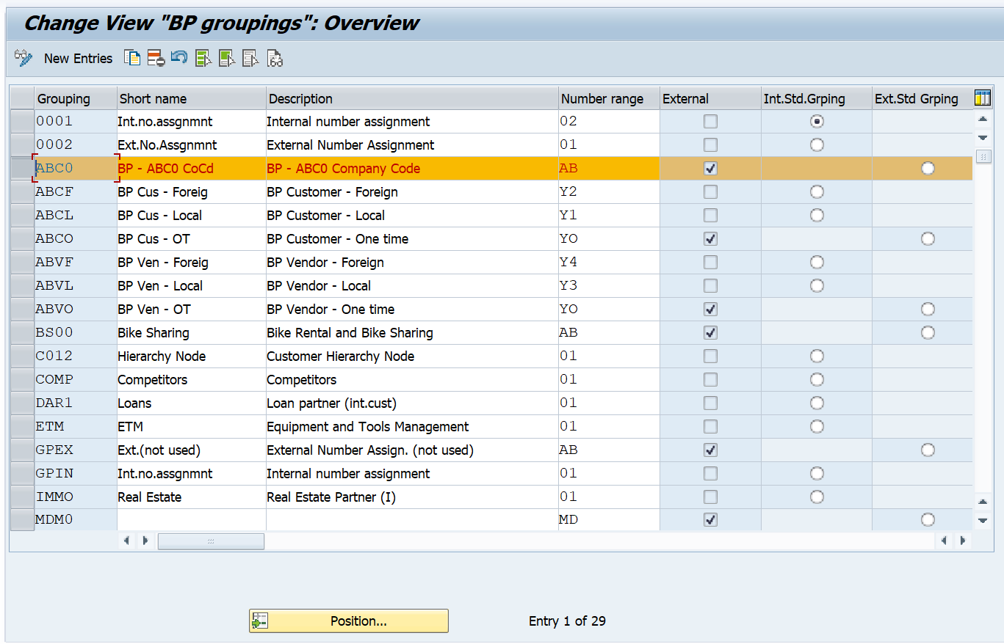

**Define Number Assignment for Direction BP to Customer**

*SAP Customizing Implementation Guide ► SPRO ►Cross Application Components ► Master data Synchronization ► Customer/Vendor integration ► Business partner settings ►Settings for customer integration► Field Assignment for customer integration ►Assign Keys ►Define number assignment for direction BP to Customer*

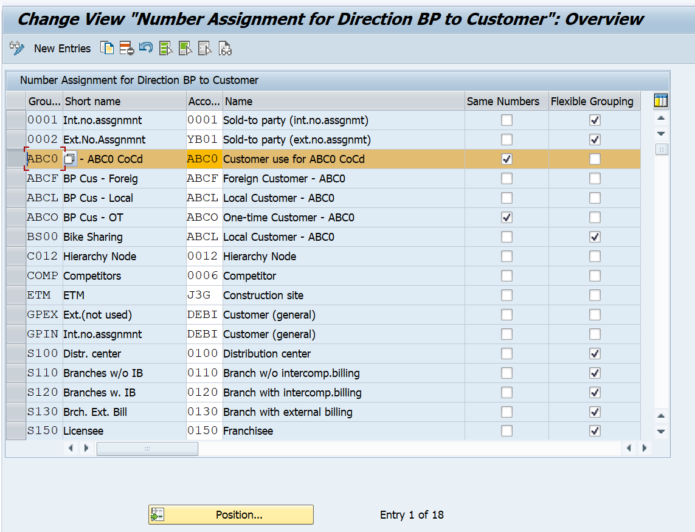

**Define Number Assignment for Direction BP to Customer**

*SAP Customizing Implementation Guide ► SPRO ►* *Cross Application Components► Master Data Synchronization► Custom/Vendor integration► Business Partner Settings► Settings for vendor integration► Field assignment for vendor integration► Assign Keys► Define number assignment for direction BP to vendor*

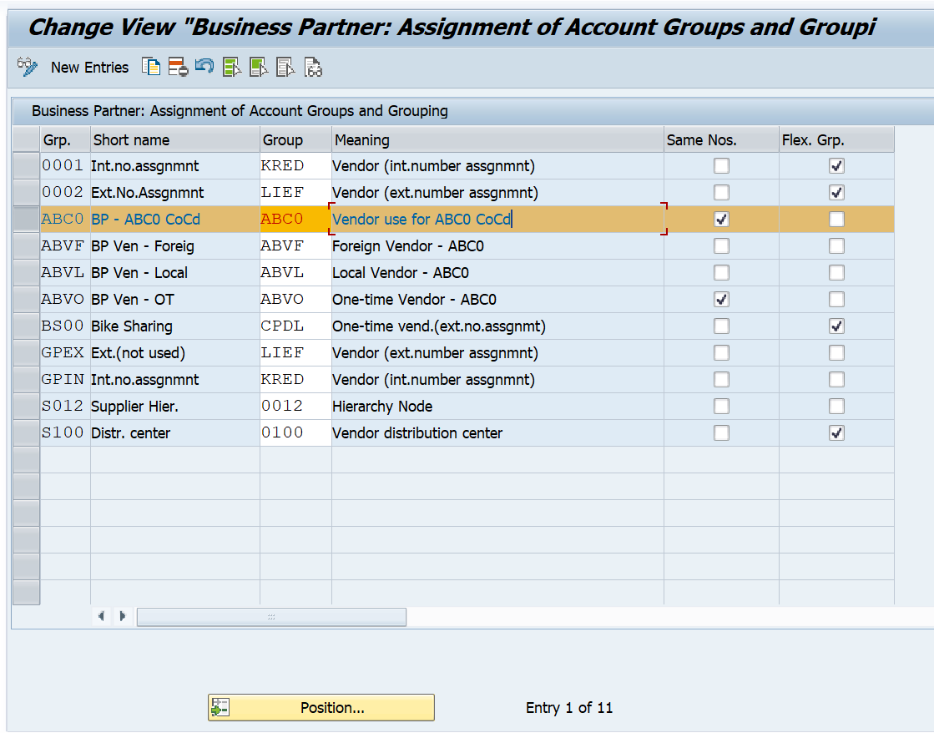

**Create and maintain Business Partner in Fiori – BP Application**

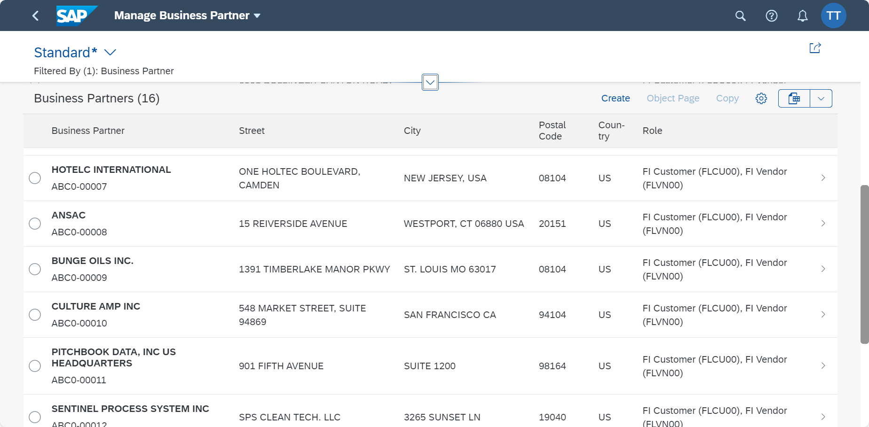

#### 2.3.3 Bank Master Data

Within the SAP framework, bank master data is recognized as a fundamental component. This data acts as a critical conduit between the company code and the bank's financial standing. For the purpose of simplification, the banking structure is bifurcated into two distinct segments: one segment utilises Bank Statements and the other employs Lockbox services. Both banking divisions are characterized by a high volume of daily transactions, which are efficiently processed by the system to facilitate the automated posting of journal entries.

**Create House Bank - Manage Banks**

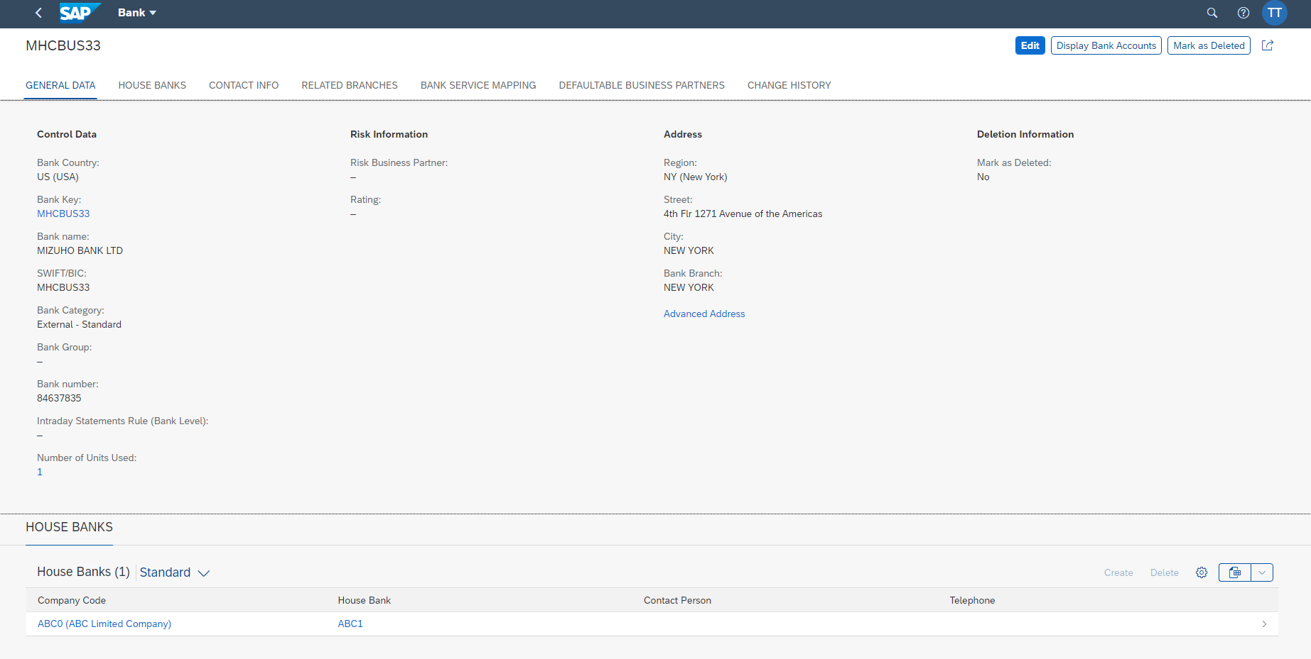

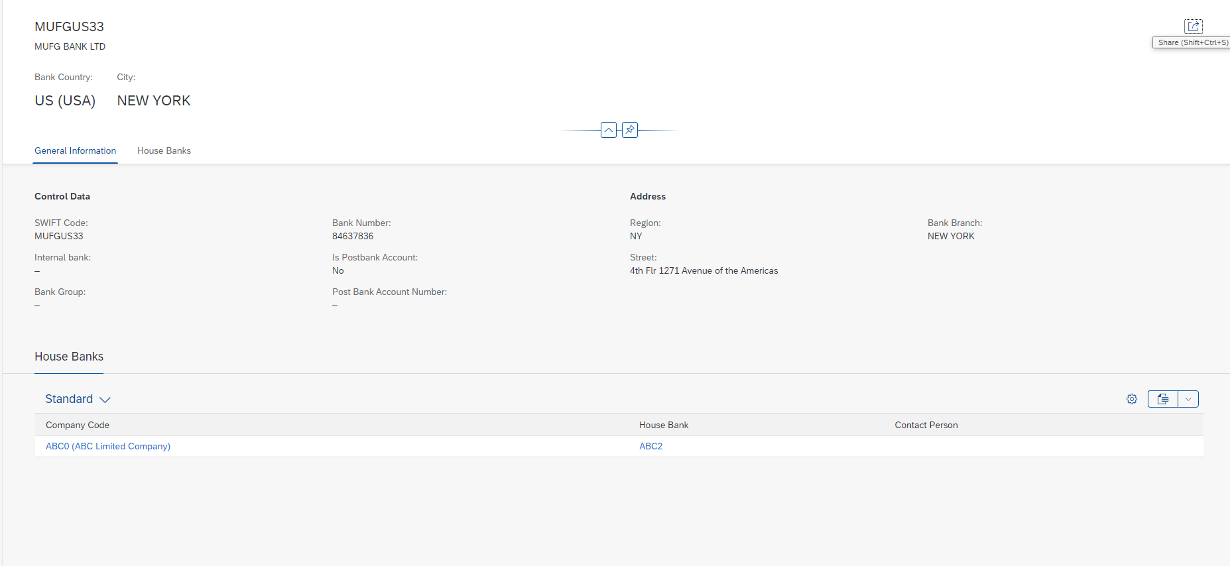

**Create Bank Account No - Manage Bank Accounts**

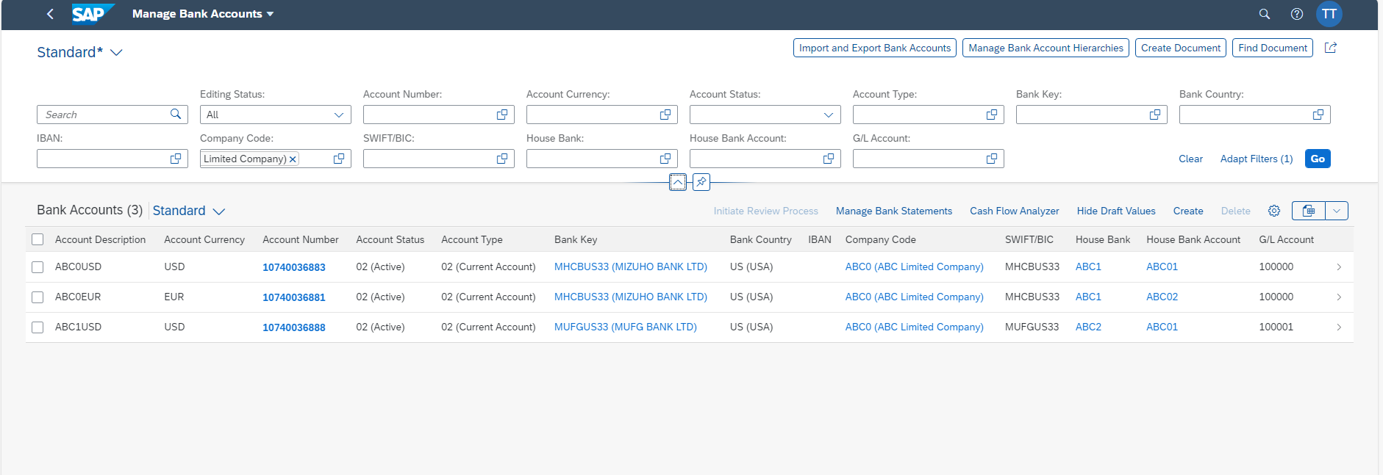

### 2.4 Electronic Banking Statement Configuration

In this Customizing activity, you can make basic settings for the account statement. There are six main steps to be carried out:

**Step 1. Create account symbol**

Specify G/L accounts (such as bank, cash receipt, outgoing checks) to which postings are to be made from the account statement. You assign account symbols to the G/L account numbers. These are required for the posting rules in step 2.

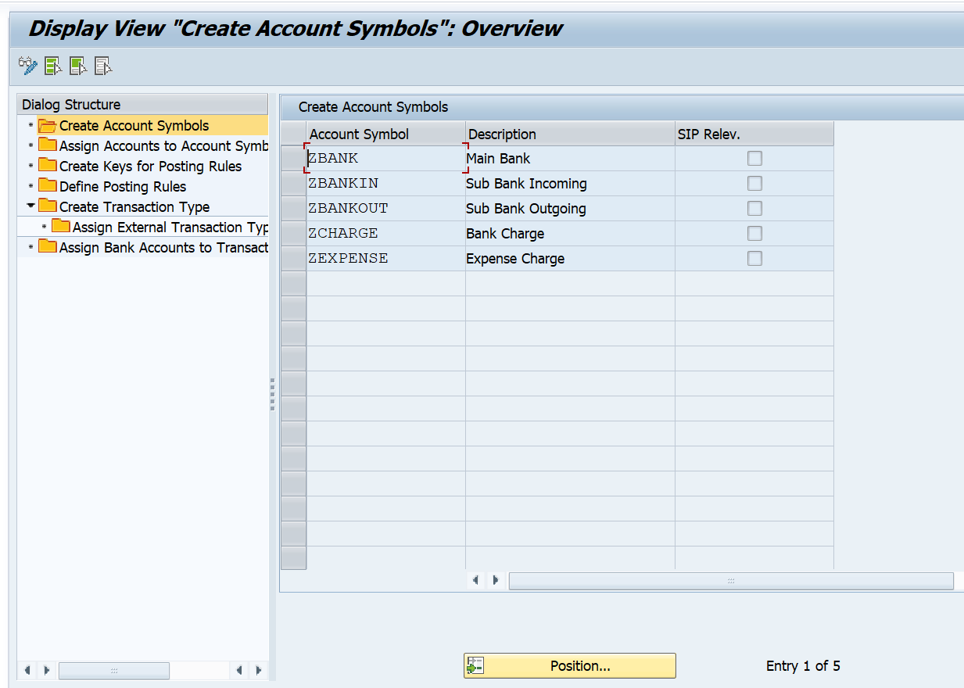

**Step 2. Assign accounts to account symbols**

Define postings to be triggered by possible transactions in the account statement (such as bank transfer, debit memo).

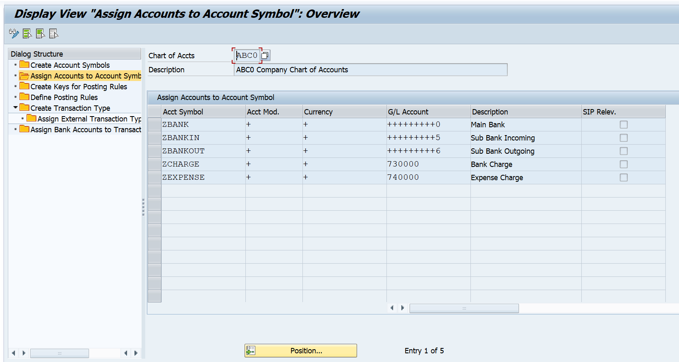

**Note: In the posting specifications debit -> credit that you define here, use the account symbols from step 1, not the G/L account numbers. This prevents similar posting rules being defined several times, the only difference between them being the accounts to which postings are made.**

**Step 3. Create keys for posting rules**

Assign the posting rules to the possible transactions in the account statement file. A list of such assignments where one external transaction code is assigned to one posting rule is called a transaction type.

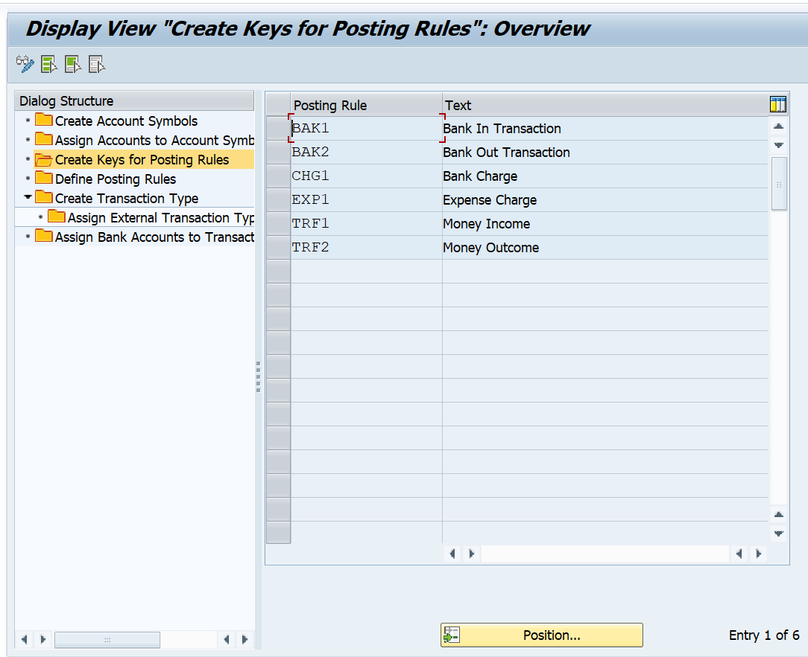

**Step 4. Define posting rules**

Create a posting specification for each posting rule. You thereby specify how a given business transaction is to be posted.

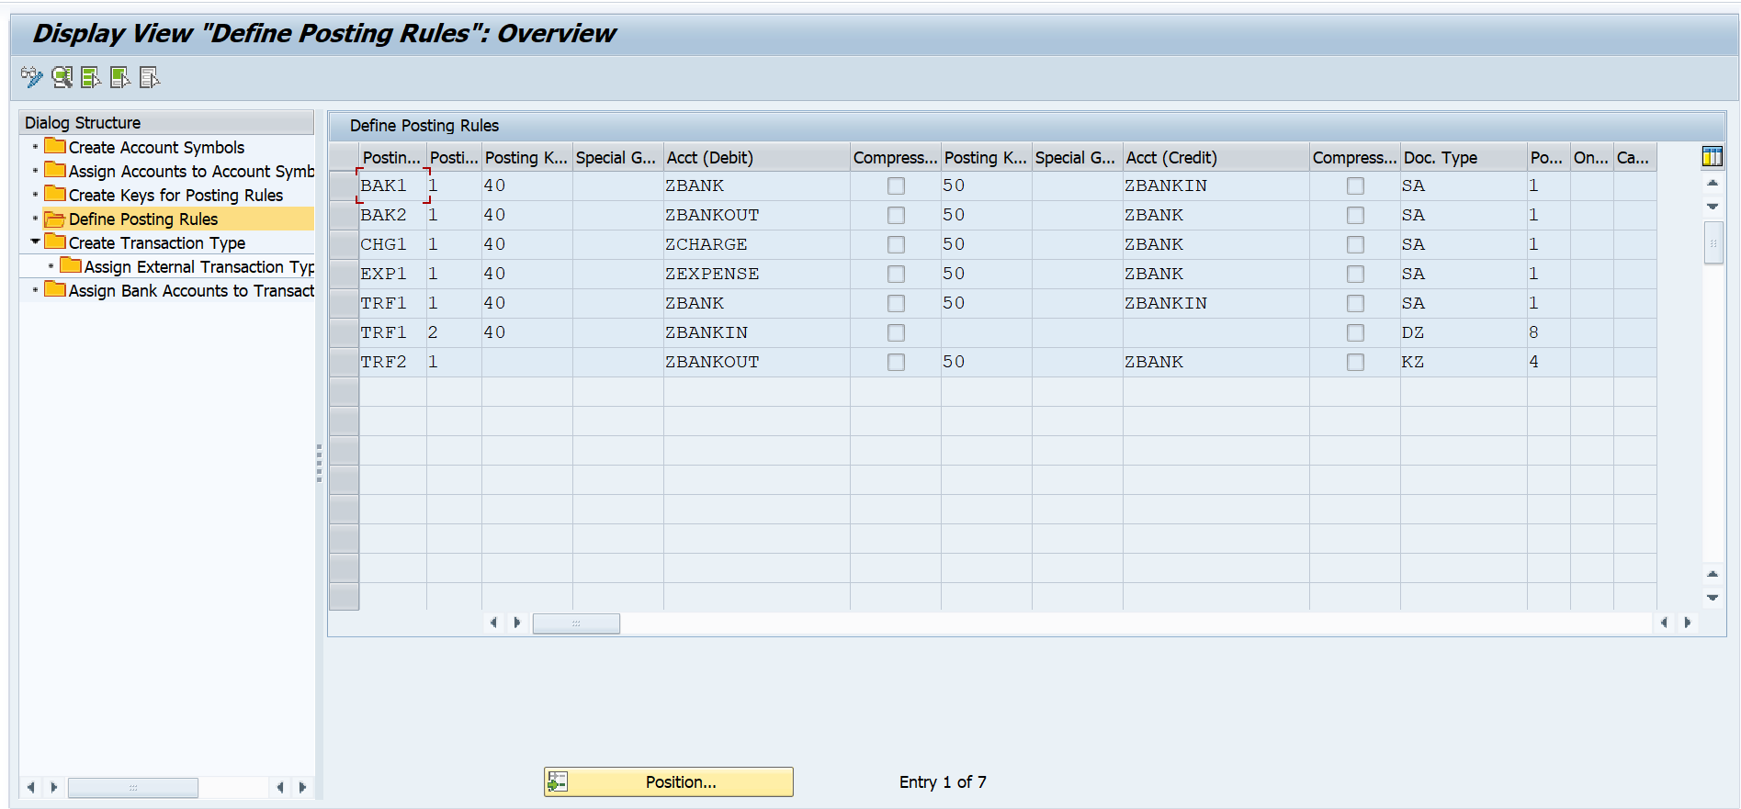

**Step 5. Create a transaction type**

Create the names and descriptions of the various transaction types you require.

In this activity you assign (external) business transaction codes to an (internal) posting rule. As a result, you can use the same posting specifications for different business transaction codes.

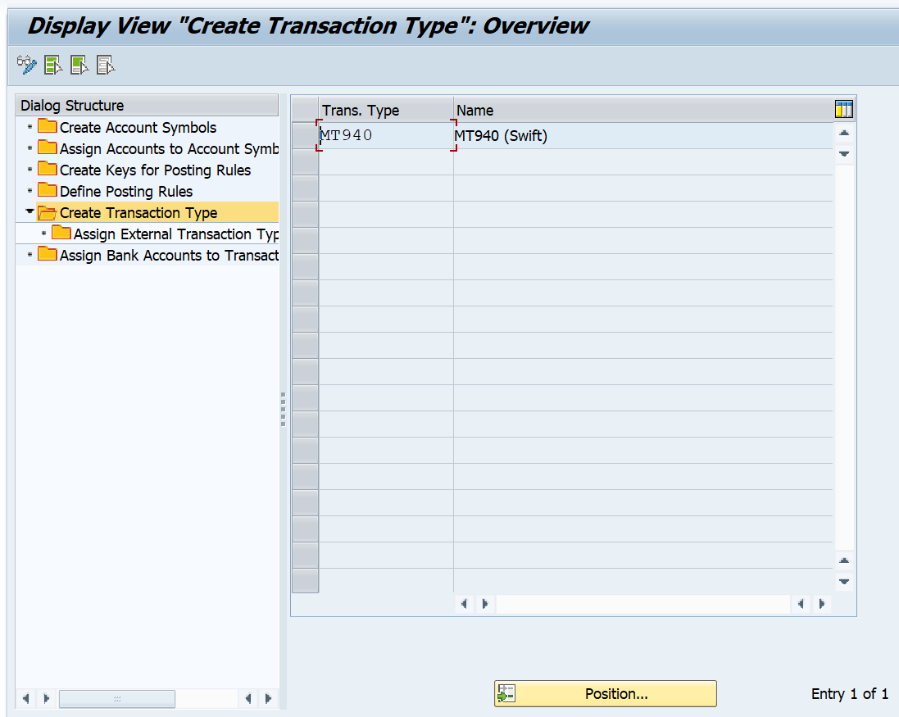

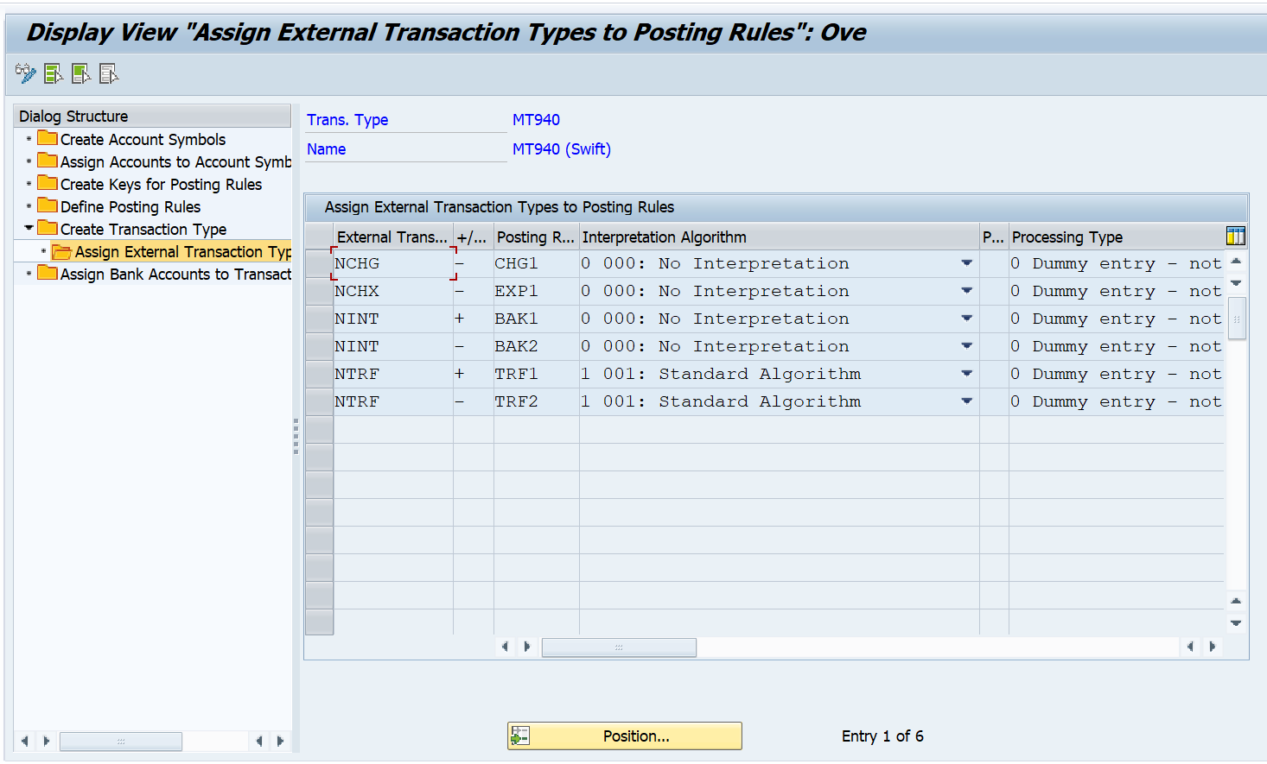

**Step 6. Assign bank accounts to transaction types**

Assign the bank details to a transaction type, for which the account statements are to be imported. All the house bank accounts at a particular bank are usually assigned to the same transaction type.

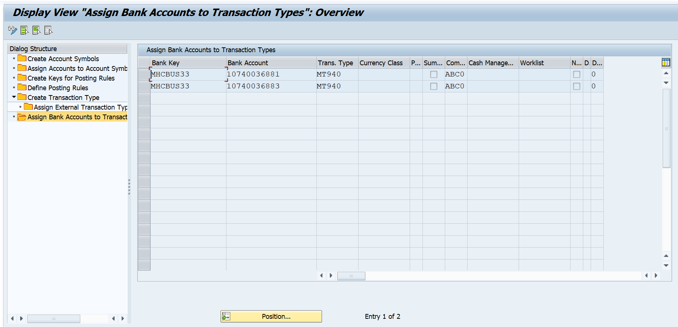

**Step 7. Configure Formats for Import**

In this Customizing activity, you can define the formats for electronic Bank Statements and payment rejections that are allowed to be imported using the Manage Incoming Payment Files Fiori app. You can also associate the formats with specific transaction types.

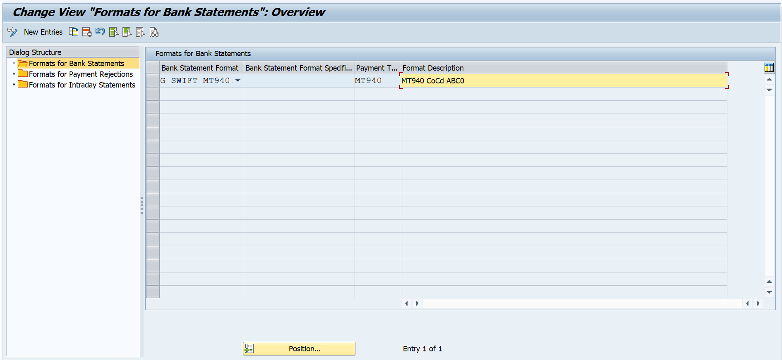

### 2.5 Lockbox Configuration

**Step 1. Define Lockboxes for House Banks**

In this step, you define your lockbox accounts at the house banks. Thus, on the outgoing invoice you can inform your customer of the lockbox to which payment is to be made. By specifying this, you can optimize the payment transactions. The lockbox procedure is currently used only in the USA.

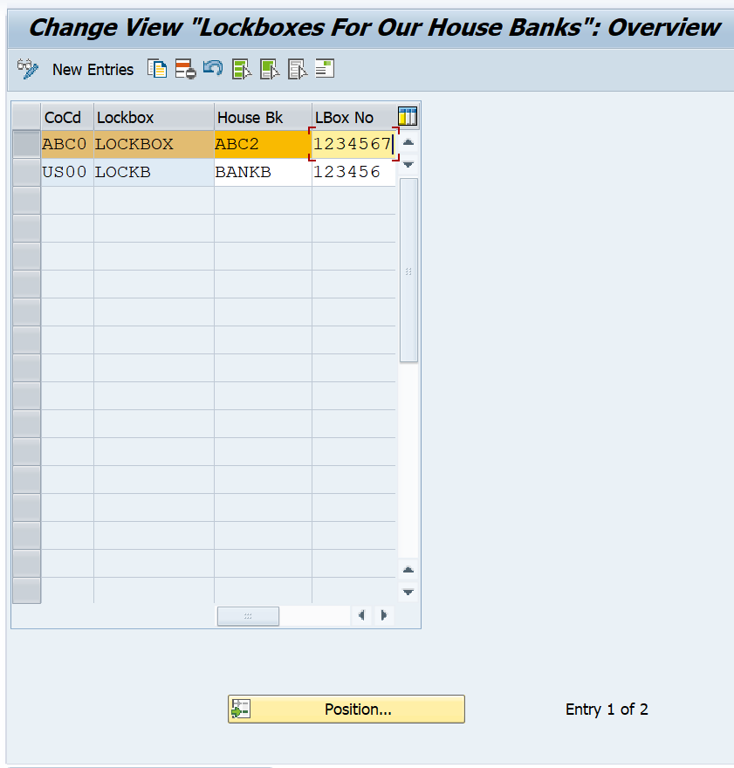

In the following activities, you store the specifications for the lockbox procedure. This procedure is used to process incoming payment transactions (normally checks) in the USA. The Lockbox program will process a file of payment transactions from the bank, create general ledger posting for cash received and clear Accounts Receivable open items.

**Step 2. Define control parameters:**

In this activity you store control data for the lockbox procedure. Currently, only the procedure LOCKBOX is supported. This data is needed for importing lockbox files sent by banks. Currently, only BAI and BAI2 file formats are supported by SAP. It includes the following:

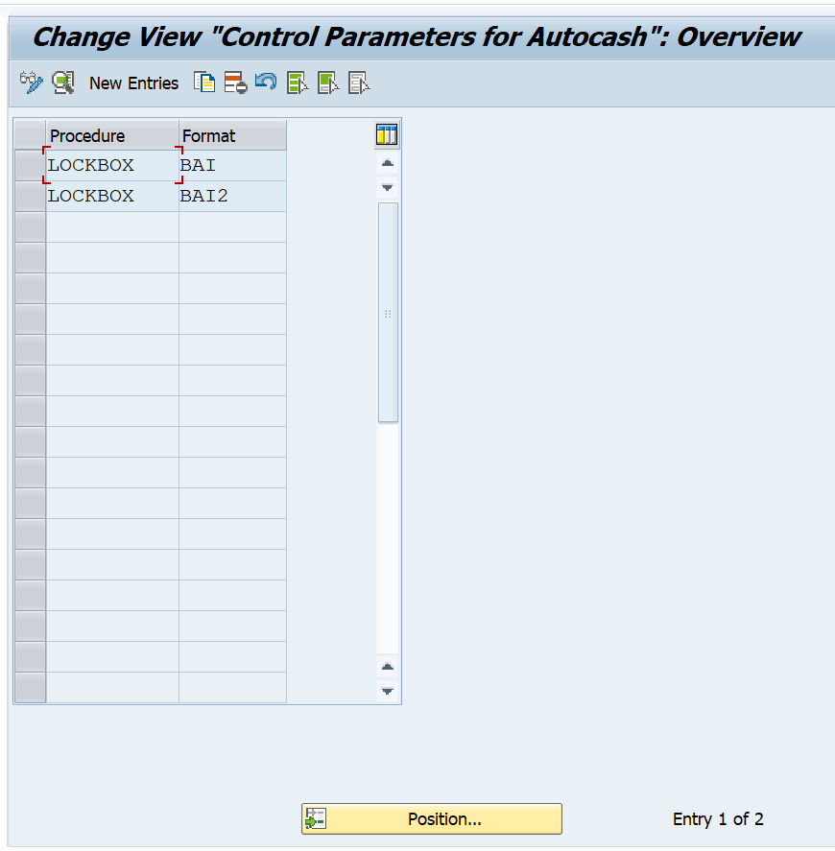

BAI Record Format: Specify the length of the document numbers (10 in the standard SAP System) and the number of document numbers in record types 6 and 4 of the BAI file. Your bank must agree on this format information.

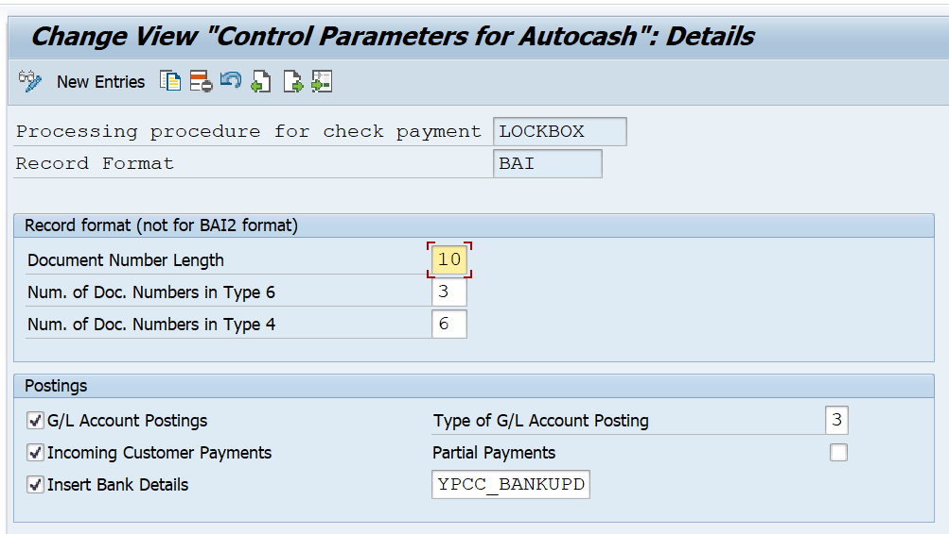

BAI2 Record Format: It is not necessary to specify the length of the document or the number of document numbers in record types 6 and 4. This is because the BAI2 file is designed so that each document number is on a different record type 4 with its corresponding payment and deduction amounts. Your bank must agree on this format information.

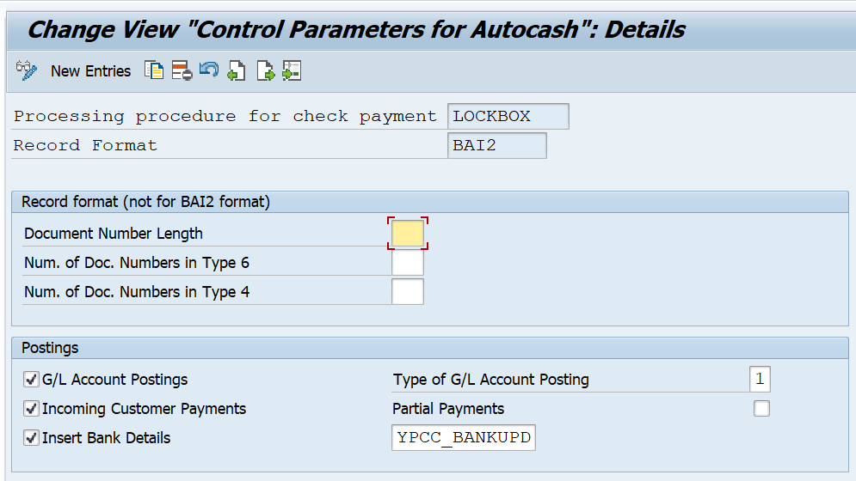

**Step 3. Define posting data**

In this activity you store information needed to process particular lockbox data and generate postings. The Destination and Origin are routing information and defined by your bank. For every unique destination/origin, posting information is needed to create the following postings:

G/L posting - Debit bank account (incoming checks)/credit payment clearing account

A/R posting - Debit payment clearing account/credit customer account

Specify a company code who holds the lockbox. Enter in Bank account number [Bank (clearing) acct] field the general ledger account number which corresponds to the lockbox (clearing) bank account. Enter in the Bank clearing acct [Payment clearing acct] field the general ledger account number which corresponds to the AR clearing account (the balance in this account will represent all unapplied (lockbox) payments). In addition, specify the document types and posting keys for these postings.

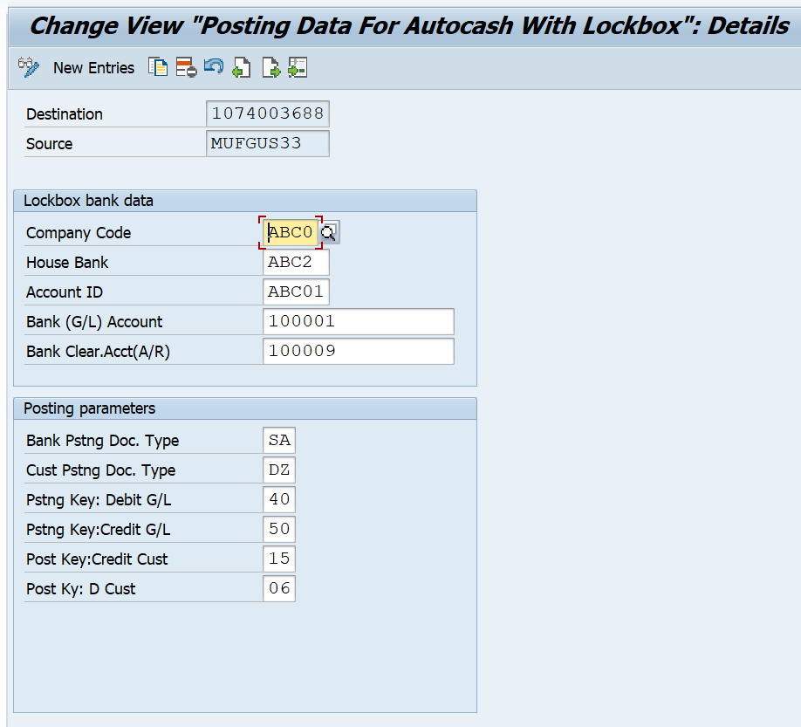

### 2.6 DMEE Configuration

**Step 1. Create Payment Medium Formats**

In this activity you can create payment medium formats yourself. In this Step, according to the company requirement, in each payment method we will define one Payment Medium Format (in Flat File).

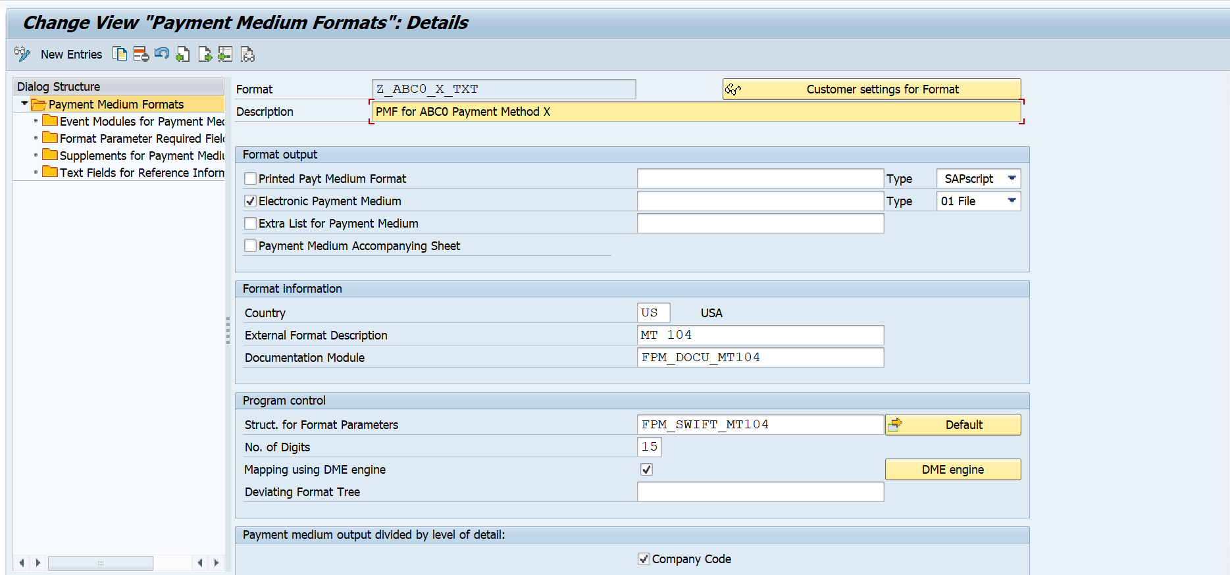

**Step 2. Create DMEE Tree**

DME or Data Medium Exchange goes hand in hand with SAP Payments. It is triggered through a payment run where you can expect a payment medium output.

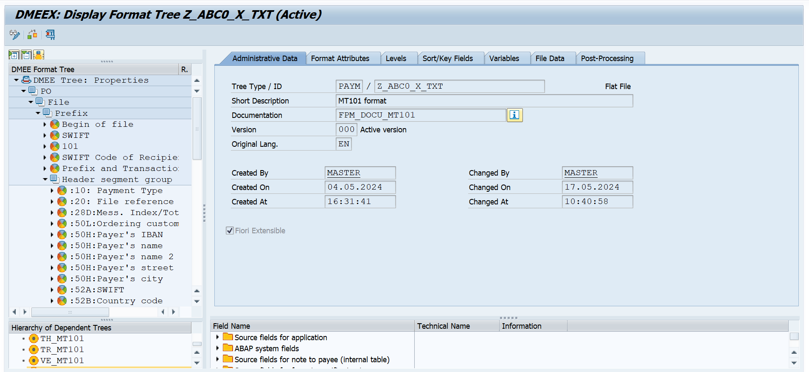

**Step 3: Assign DMEE format with each Payment Method accordingly**

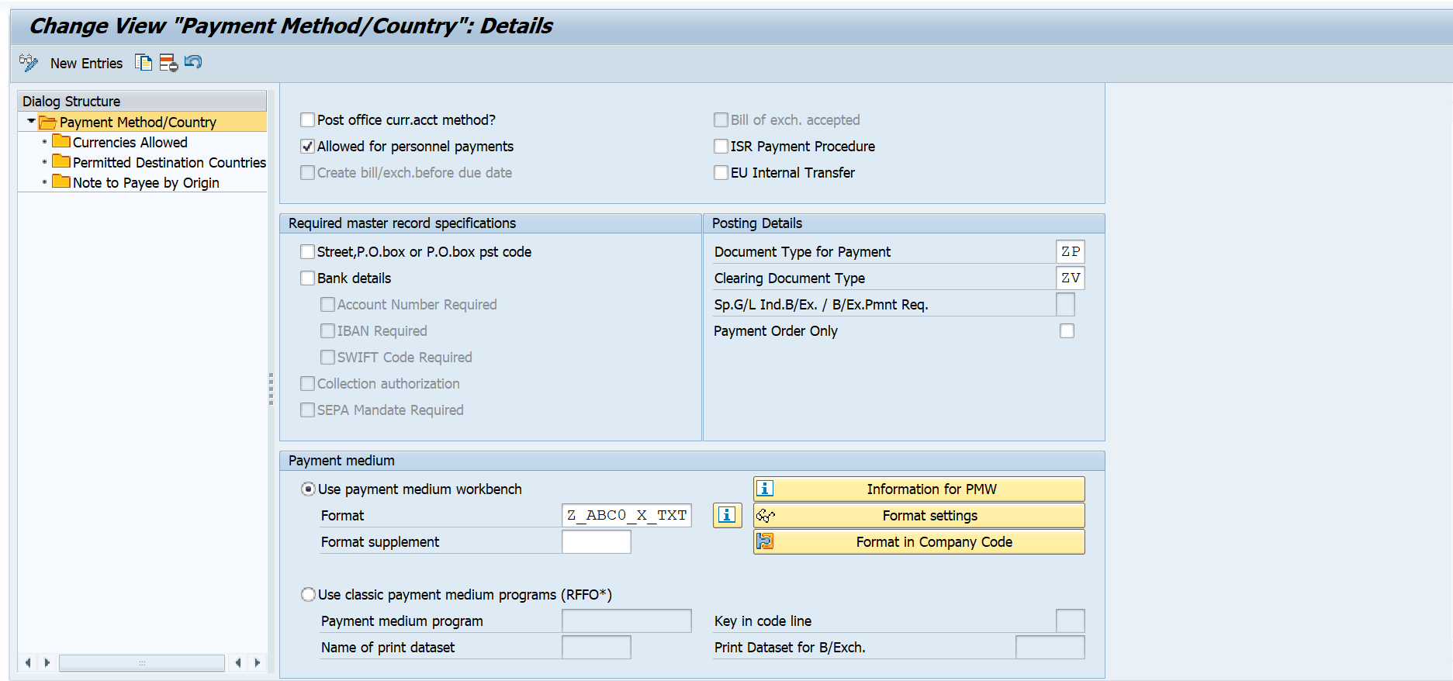

**Step 4: Create/Assign Variants**

In this activity you can create and assign selection variants for a format. Selection variant maintenance is a requirement for automatically scheduling the payment media of the Payment Medium Workbench in the payment program.

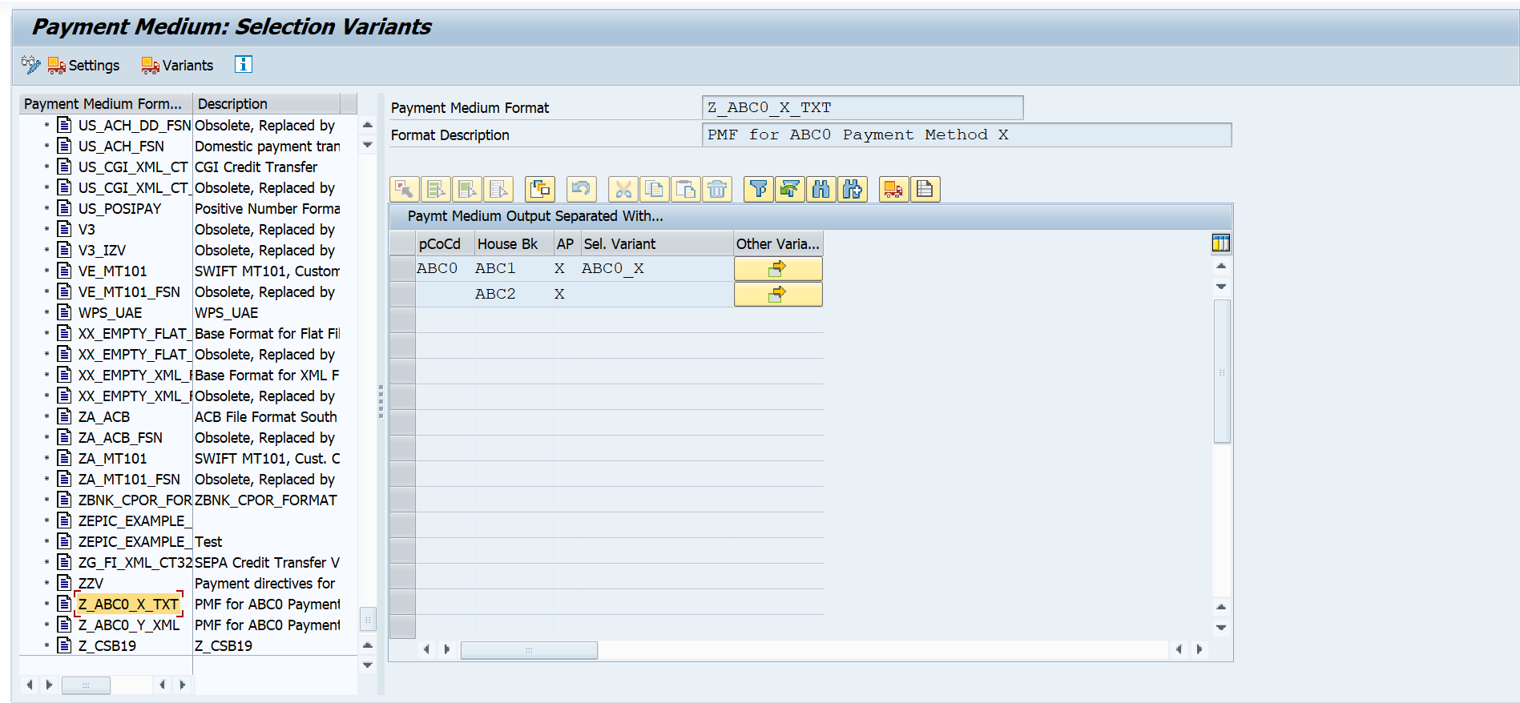

### 2.7 File Format Explanation

#### 2.7.1 Bank Statement

**Purpose**

In this project, we utilize the MT940 format for bank statements within our SAP system. MT940 stands as a standardized electronic format essential for integrating bank transaction data seamlessly. Its structured layout provides detailed information, including transaction dates, amounts, currency codes, and types, facilitating efficient processing and accurate reconciliation of accounts.

**Procedure**

The following is the explanation SWIFT MT940 format:

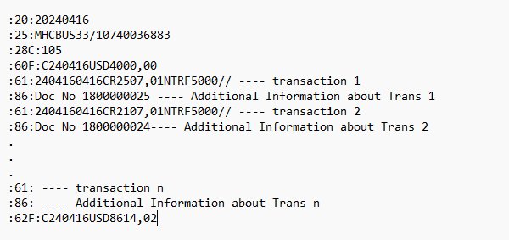

| :20:20240416 | |
| --- | --- |
| Field Value | Description |
| :20: | Statement Date Tag |
| 20240416 | YYYYMMDD |

| :25:MHCBUS33/10740036883 | |
| --- | --- |
| Field Value | Description |
| :25: | Bank Information |
| MHCBUS33/10740036883 | MHCBUS33: Bank Key 10740036883: Bank Account Number |

| :28C:105 | |
| --- | --- |
| Field Value | Description |
| :28C: | Statement Number Tag |
| 105 | 105 is statement number |

| :60F:C240416USD4000,00 | |
| --- | --- |
| Field Value | Description |
| :60F: | Opening Balance Tag |
| C | C-Credit-(inflow) D-Debit--- (outflow) |
| 240416 | YYMMDD --- date of opening balance |
| USD | ISO Currency Code |
| 4000,00 | Opening Balance Amount |

| :61:2404160416CR2507,01NTRF5000// | |
| --- | --- |
| Field Value | Description |
| :61: | Transaction Tag |
| 240416 | YYMMDD-Posting Date |
| 0416 | MMDD-Entry Date (optional). While posting system will consider this date as Document date in SAP |
| CR | CR-Credit (inflow) DR-Debit--- (outflow) |
| 2507,01 | Transaction Amount with comma as decimal separator |
| NTRF | Transaction Code, first character must be ‘N’ |
| 5000 | Reference number if no reference then NOREF |
| // | BANK Reference if any given by bank |

| :86:Doc No 1800000025 | |
| --- | --- |
| Field Value | Description |
| :86: | Additional Information tag about Transaction Tag 61 before |
| Doc No 1800000025 | Note-to-payee additional information about 61 Tag Field |

| :62F:C240416USD8614,02 | |
| --- | --- |
| Field Value | Description |
| :62F: | Closing Balance Tag |
| C | C-Credit-(inflow) D-Debit--- (outflow) |
| 240416 | YYMMDD --- date of Closing balance |
| USD | ISO Currency Code |
| 8614,02 | Closing Balance Amount |

#### 2.7.2 Lockbox

**Purpose**

In this project, we utilize BAI2 format for Lockbox within our SAP System. The BAI2 format is a cash management balance reporting specification.

For the preparation of uploading files for lockbox, a specific BAI2 format is required. If the BAI2 format received from the issuing bank does not match the SAP BAI2 format, the file cannot be processed.

**Procedure**

The following code is designed to create our BAI2 format. Copy the code into a text editor application and follow the instructions below:

1001074003688MUFGUS332404162015

500100112345672404161074003688MUFGUS33

60010010001000000LOCKB0X110000000000000000220

400100160191800000030

800000012345672404160010001000000

999900

Using the provided code block, make the following changes:

1. In the first line of the file, change the red number to reflect the correct date and time. The file uses the format of *yymmddhhmm*.

*(Ex: We created the file on Monday, April 16th 2024 at 20:15 so it would be 2406142015)*

1. In the second and fifth line, we did the same but not with the time (hour and second)
2. In the third and fifth line, the blue-colored one represents the amount of money.
3. In the third line, the green-colored one represents the specific customer invoice

#### 2.7.3 DMEE

**Purpose**

In this project, we utilize SWIFT MT101 format for DMEE within our SAP System. The body of SWIFT MT101 Message contains header, sender/ordering party details and customer/receiving party details. It means there will be blocks of each transaction in MT101 file and each transaction block will contain sender and receiver details.

**Procedure**

The following is the explanation SWIFT MT101 format:

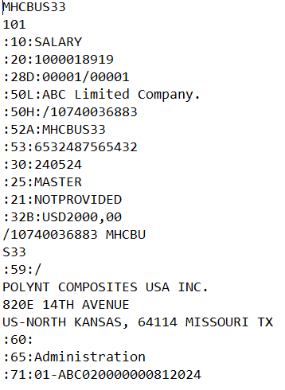

| **MHCBUS33** | Bank key |
| --- | --- |
| **101** |  |
| **:10:SALARY** | Payment Type (Salary/Normal) |
| **:20:1000018919** | File Reference |
| **:28D:** | Mess. Index/Tot |
| **:50L:** | Ordering customer |
| **:50H:** | Bank account |
| **:52A:** | Bank key |
| **:53:** | CoCd Country Tax |
| **:30:** | Execution Date |
| **:25:** | User name |
| **:21:** | Transact ref.no |
| **:32B:** | Payment amount |
| **:59:** | Vendor’ Information |
| **:60:** | Fee rule |
| **:65:** | Cost category |
| **:71:** | Payment doc |

## 3. SAP Coding

### 3.1 Background

Currently, after meticulous gathering and analysing of the necessary requirements, coupled with the extensive setting up of configurations, it has become evident that the standard functionalities provided by SAP are insufficient to meet a small, yet crucial, subset of the user's specific requirements. Therefore, to ensure the smooth and uninterrupted execution of our processes, it is imperative that we undertake certain enhancements within the SAP system. In this regard, the implementation of a user exit for the Bank Statement is necessary to cater to the nuanced needs of our financial operations. Similarly, an exit function for generating the DMEE files will be incorporated to enhance the flexibility and accuracy of our data exchange processes. Furthermore, we will be creating a new form, designated as the "Cash in Bank Book Form", to accurately monitor and reflect the fluctuations in the Bank General Ledger (G/L) Account corresponding to each transaction processed within the SAP environment.

These enhancements necessitate the inclusion of custom coding within the project to bridge the gaps left by the standard functionalities and to tailor the system precisely to our organisational requirements. Consequently, the integration of these modifications will facilitate a robust and comprehensive SAP framework that aligns seamlessly with our operational needs, thereby ensuring overall process efficiency and reliability.

### 3.2 User Exit using in Bank Statement

User Exit is a type of enhancement technique used in SAP to add custom functionality at specific points within standard SAP programs. These exit points are predefined by SAP and allow users to implement custom code to meet specific business requirements.

*Types of User Exits:*

- Function Module Exits: These are predefined function modules provided by SAP at specific points within standard programs. Users can implement their custom logic within these function modules.

- Screen Exits: These exits allow users to add additional fields or screens to standard SAP transactions. The modifications are typically made using Screen Painter or Menu Painter.

- Menu Exits: These exits enable users to add custom entries to standard SAP menus.

- Field Exits: These exits allow users to define custom field validation or processing logic for specific fields within SAP transactions.

*User Exit Implementation Steps:*

1. Identify the appropriate user exit relevant to the customization requirement.

2. Implement the required custom logic or functionality within the exit.

3. Activate the user exit using Transaction Code: `SMOD` or `CMOD`.

4. Test the functionality to ensure it meets the desired requirements.

Specifically, for Bank Statements, User Exits allow to introduce additional processing steps when Bank Statement data is imported into the SAP system.

The process of working with electronic Bank Statements in SAP often involves the following steps: Data Import, Interpretation, and Post-processing. SAP provides several User Exits that can be utilized during these steps, especially in the modules dealing with Financial Accounting (FI).

Here, we'll focus on a few User Exits that are typically used for handling electronic Bank Statements within the SAP module for Financial Accounting (FI): FEB0004 – Raw data processing, user exit SWIFT MT940.

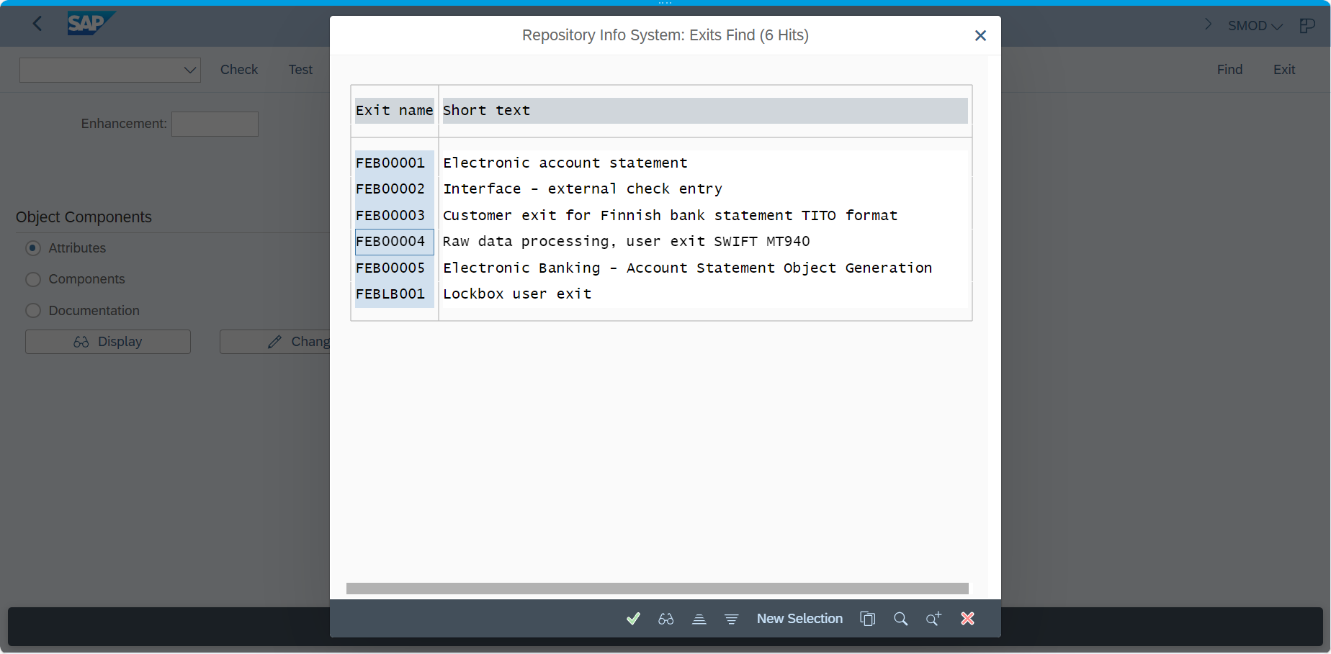

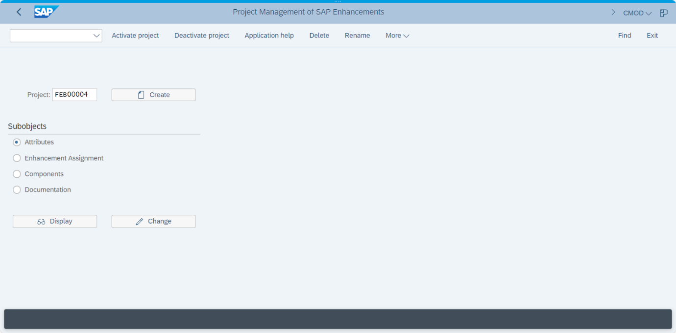

#### 3.2.1 Overview

User Exits are essential for organizations using SAP because they provide the flexibility to tailor the system's standard behavior to fit the unique requirements of their financial operations, including the detailed and accurate reflection of activities in bank statements. This customization capability is critical for efficient financial processing, compliance and ensuring that the ERP system supports the organization's specific business processes and reporting needs.

#### 3.2.2 Purpose/Background

- Customization of Processing Logic

- Integration with External Systems

- Compliance and Reporting

- Enhancement of User Experience and Efficiency

- Specific Business Logic Implementation

#### 3.2.3 Purpose/Background

**General Requirements:**

- User Exit: FEB00004

**Scenarios**

Scenario 1: With the HUF currency (Hungarian Forint), the banks are using the numbers behind the decimal point, but the SAP System is not. At this point, the conflict happens, which shows up the error when importing Bank Statement.

Scenario 2: With the USD currency (United States dollars), when the customers make the transactions (inflow) that have the amount over $10.000, the bank will be automatically charging $10 over the total bill.

**Logic Execution  
Scenario 1: Set logic for rounding when import Bank Statement with HUF Currency**

| Check File Bank Statement with Currency = HUF  Find Amount in Tag 60F, 61, 62F -> Remove decimal amount  Sum total of removed decimal amount in Tag 61 = X  If amount in Tag 60F + X = Amount in 62F -> Done  If amount in Tag 60F + X <> Amount in 62F -> Create more 1 line 61, 86 (1 transaction)  :61:<YYMMDDMMDD><D*/C*><Difference in 60F + X and 62F (Fraction Amount)><NRES>  :86: Residual Transaction for HUF Currency  Note: If Fraction Amount is > 0 => post to C*, otherwise, post to D*  NRES means Abbreviate of Residual Amount |
| --- |

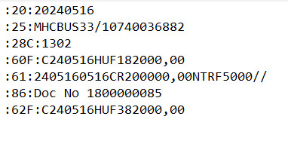

**Scenario 2: Set logic when import Bank Statement with currency USD, amount more $10.000**

| Check File Bank Statement with Currency = USD  In Tag 61, split line with format <YYMMDDMMDD><D*/C*><Amount><NTRF><Other Information>.  If Tag 61 with C* and NTRF, go to next step. Otherwise, cancel this process  Fine Tag 86, add string characteristic "CHARGES 10.00" and then import Bank Statement  Fine Tag 86, add string characteristic "CHARGES 10.00" and then import Bank Statement |
| --- |

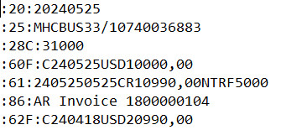

Charges was configured in Search String Configuration (OTPM)

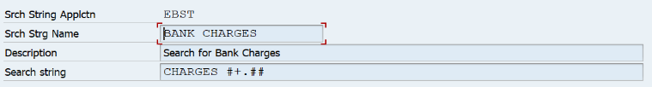



It means in case Tag :86: has String Characteristic CHARGES #+.##, it will automatically included Bank Charge G/L Account in Posting  
Therefore, in this enhancement, if we change line 86 to CHARGES 10.00, it will post journal entries with Bank Charge G/L Account

#### 3.2.4 Function Overview (Process Flow)

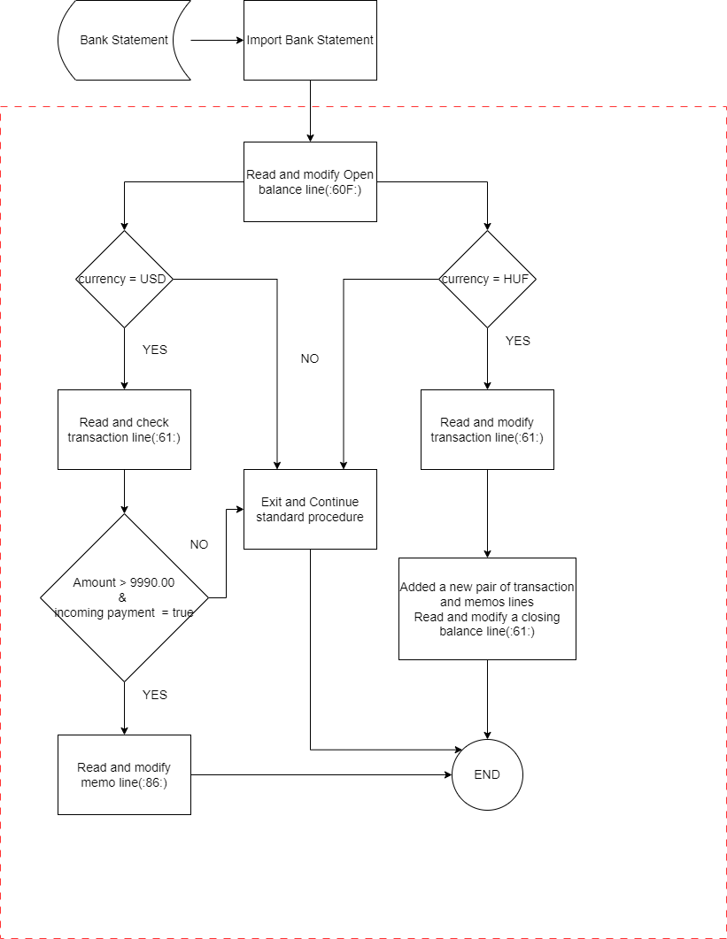

### 3.3 DMEE Enhancements by using Exit function

#### 3.3.1 DMEE Overview

DMEE is being used as the standard file generator which is required to generate files in a specific format in H2H setup (Communicating data from SAP to Third party server, example: Bank). This format is related to Bank Specification but sometimes, SAP Standard can not support getting this information. Therefore, we need to implement an exit function to get these according to Bank Regulation.

#### 3.3.2 Purpose/Background

* DMEE Form can be display all necessary informations according to both Bank Party and Company Code
* Bank Party can based on these information and sent Bank Statement with appropriate note related to DMEE File
* Different File formats can be created for different countries and different banks based on their own norm which replaces conventional ABAP programs.
* DMEE can be configured and run at the same time when user run Automatic Payment Program

#### 3.3.3 Operation Functional Requirements

#### General Requirements

Exit Function: **ZDMEE_EXIT_X_TXT_V2**

Based on: DMEE_EXIT_TEMPLATE_EXTENDED.

#### Scenarios

*Scenario 1:* In US Bank, Company ABC wants to display information about Charge Expense (share all, payee charge or payer charge) in DMEE Tree in Tag 60.

*Scenario 2:* In Tag 53 in DMEE Tree, according Bank Regulation, Company Tax Account must be displayed for detailed purposes. But in SAP DMEE Standard cannot support this.

*Scenario 3:* ABC Company wants to clarify the type of Payment. Currently, in this company, we have 2 Payment Types: Payment for Vendor (NORMAL) and Payment for Employee (SALARY).

*Scenario 4:* In Tag 65, Company ABC wants to display Cost Center Category (Research, Marketing, Development, .... for detailed information to make proper decisions.

#### Logic Execution

##### Scenario 1: Display Information about Charge

| With Node_ID = N01578633174, check structure FPAYH  If FPAYH-DTAWS = '1' -> Display value SHAR means Sharing the Charge Expense.  If FPAYH-DTAWS = '2' -> Display value CRED means Creditor will be charged.  If FPAYH-DTAWS = '3' -> Display value DEBT means Debitor will be charged.  If FPAYH-DTWS1 = '1' -> Display value SHAR means Sharing the Charge Expense.  If FPAYH-DTWS1 = '2' -> Display value CRED means Creditor will be charged.  If FPAYH-DTWS1 = '3' -> Display value DEBT means Debitor will be charged. |
| --- |

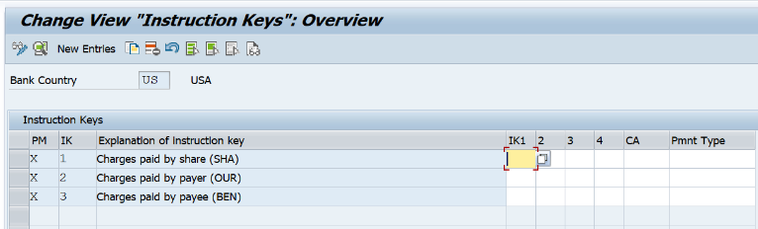

##### Scenario 2: Get Information about Country Tax Account

| When Node_ID = 'N01042478555',  In Table T001Z, input T001Z-BUKRS = Field Structure FPAYH-ZBUKR, T001Z-PARTY = 'SAPTIN', get T001Z-PAVAL |
| --- |

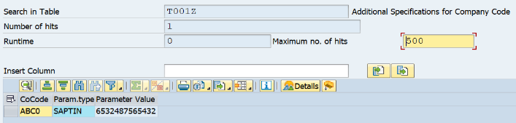

##### Scenario 3: Display Information about Payment Type

| With Node_ID = N01736083439, check structure FPAYH  If FPAYH-DTAWS = '1' -> Display value NORMAL means Normal Payment (Payment for Supplier).  If FPAYH-DTAWS = '2' -> Display value NORMAL means Normal Payment (Payment for Supplier).  If FPAYH-DTAWS = '3' -> Display value NORMAL means Normal Payment (Payment for Supplier).  If FPAYH-DTWS1 = '1' -> Display value NORMAL means Normal Payment (Payment for Supplier).  If FPAYH-DTWS1 = '2' -> Display value NORMAL means Normal Payment (Payment for Supplier).  If FPAYH-DTWS1 = '3' -> Display value NORMAL means Normal Payment (Payment for Supplier).  If FPAYH-DTAWS = 'Blank' -> Display value SALARY means Salary Payment (Payment for Employee).  If FPAYH-DTWS1 = 'Blank' -> Display value SALARY means Salary Payment (Payment for Employee). |
| --- |

##### Scenario 4: Display Cost Center Category

| With Node_ID = N01257760384, check structure FPAYHX  In Structure Field FPAYHX-INSTRID, substring as "INSTRID+3(4)"&"INSTRID+7(10)"&"INSTRID+17(4)"    Example: Results after substring is ABC0; 2000000068; 2024  1. Read ACDOCA, input RBUKRS = INSTRID+3(4); AUGBL = INSTRID+7(10); GJAHR = INSTRID+17(4)  Get RBUKRS, GJAHR, BELNR when AUGBL = INSTRID+7(10) <> BELNR **(1)**  2. Read ACDOCA, input RBUKRS, BELNR, GJAHR = Output in **(1)**  Get RCNTR, KOKRS when RCNTR <> blank **(2)**  3. Get TKT05-KTEXT in TKT05-KOSAR joint TKT05-SPRAS = "EN", CSKS-KOSAR, CSKS-KOKRS, CSKS-KOSTL = Output in (2) |
| --- |

##### 

#### 3.3.4 Function Overview (Process Flow)

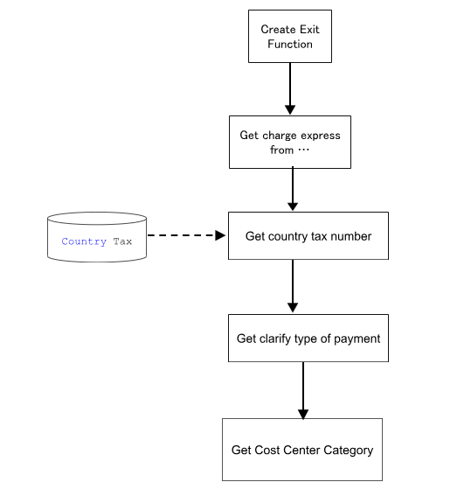

**Exit Function:** ZDMEE_EXIT_X_TXT_V2

**Remarks:** Get data from T001Z and process data

#### 3.3.5 Function Overview (Program Flow)

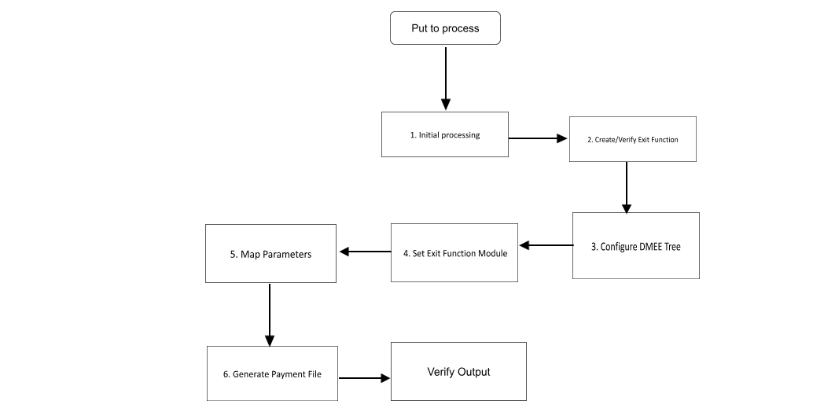

#### 3.3.6 DMEE Implementation

We will use T-Code DMEE and create new DMEE File

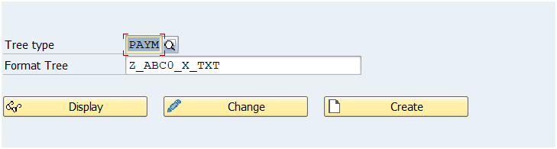

**Format used:** MT101 format

Format MT101 creates payment messages for domestic and foreign payment and can be used internationally. Only outgoing payments are supported.

Format MT101 corresponds to the specification of format 'MT101 Request for Transfer' of S.W.I.F.T. in accordance with the S.W.I.F.T. User Handbook, status September 2001.

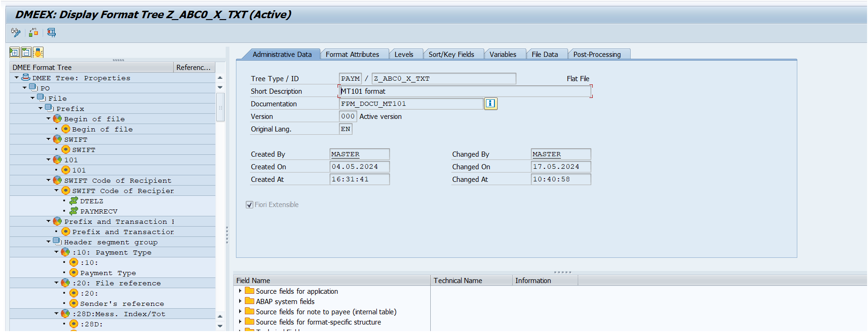

#### 3.3.7 Table Name Structure

#### 

#### 3.3.8 DMEE Tree Tags

**Scenario 1:**

DMEE Tag 60: Fee Rule

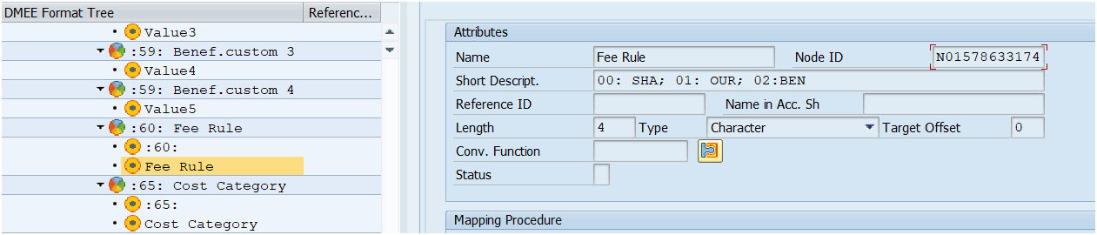

**Scenario 2:**

DMEE Tag 53: Tax Code Country

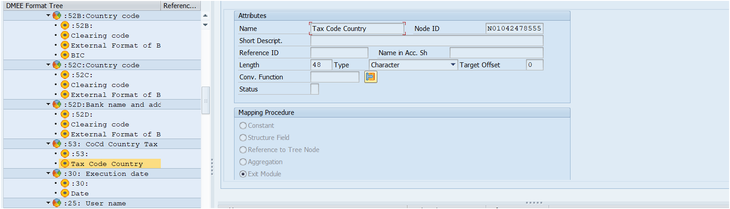

**Scenario 3:**

DMEE Tag 10: Payment Type

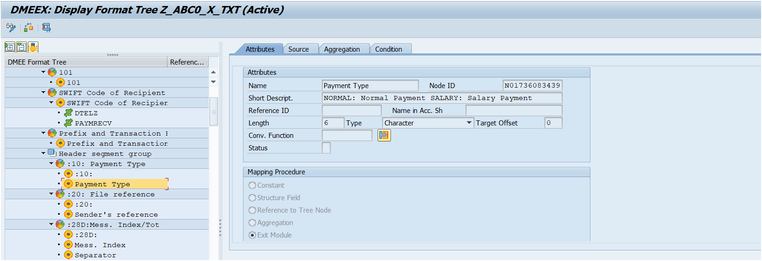

**Scenario 4:**

DMEE Tag 65: Cost Category

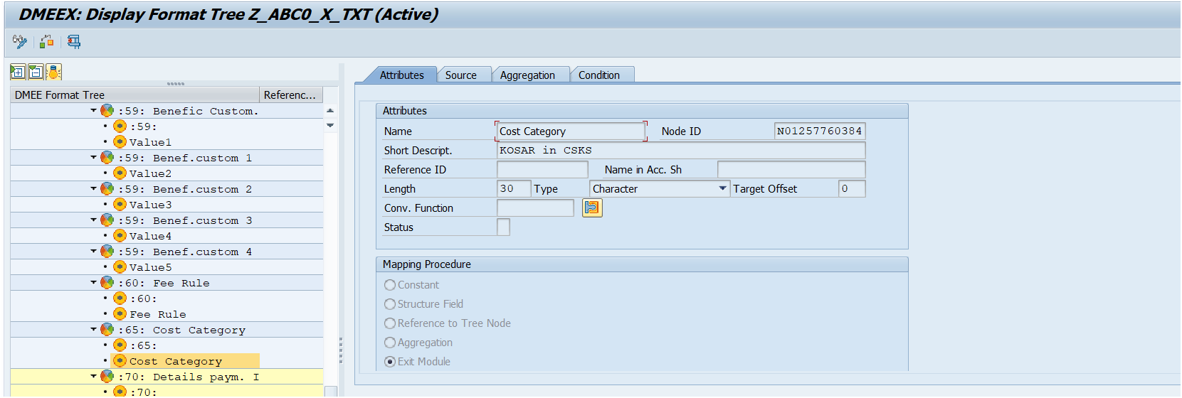

### 3.6 Smartforms

#### 3.6.1 Form Overview

This form is used as an official record and contractual agreement of the business transaction between customer and vendor, and outlines key information of the order. It is important for record keeping, auditing, and matching the information in order to issue payment.

The development of Smartforms relied on several tables:

| **Table Name** | **Description** |
| --- | --- |
| ADRC | Addresses (Business Address Services) |
| SKAT | G/L Account Master Record (Chart of Accounts: Description) |
| T012K | House Bank Accounts |
| T012 | House Banks |
| T012T | House Bank Account Names |
| SKB1 | G/L account master (company code) |
| ACDOCA | Universal Journal Entry Line Items |
| BKPF | Accounting Document Header |

The following serves as a sample representation of a Smartforms.

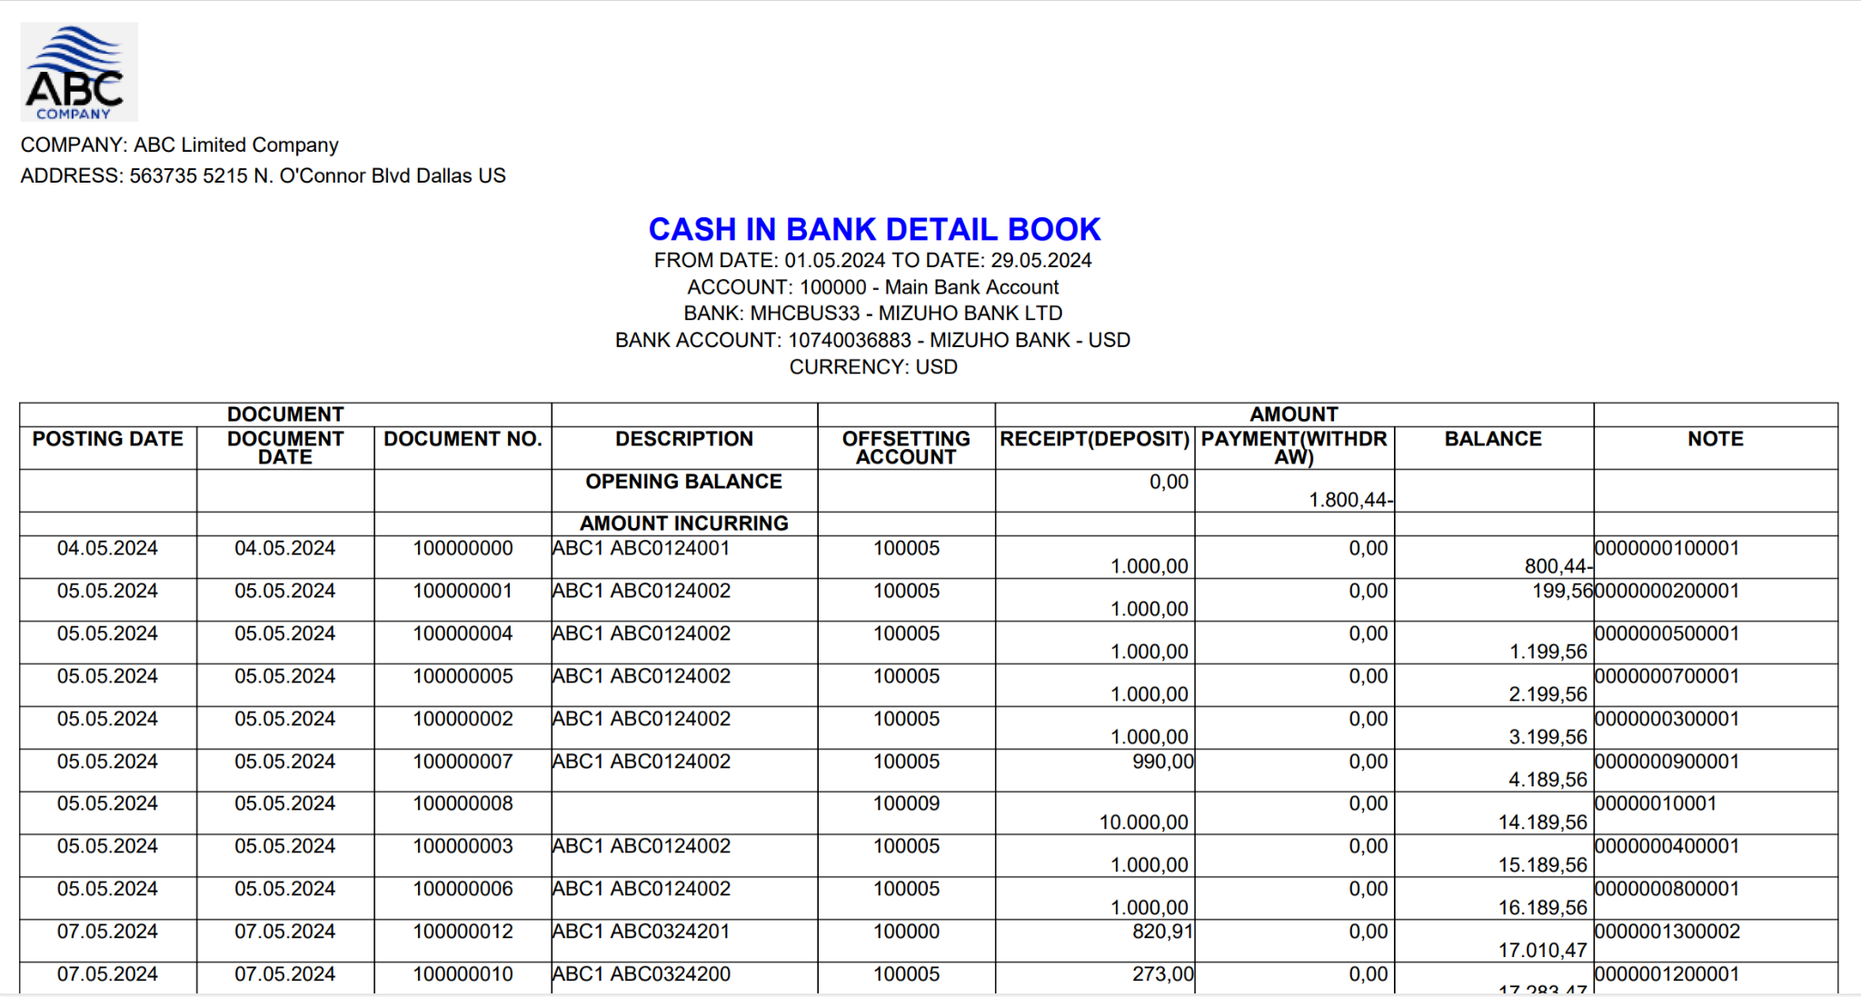

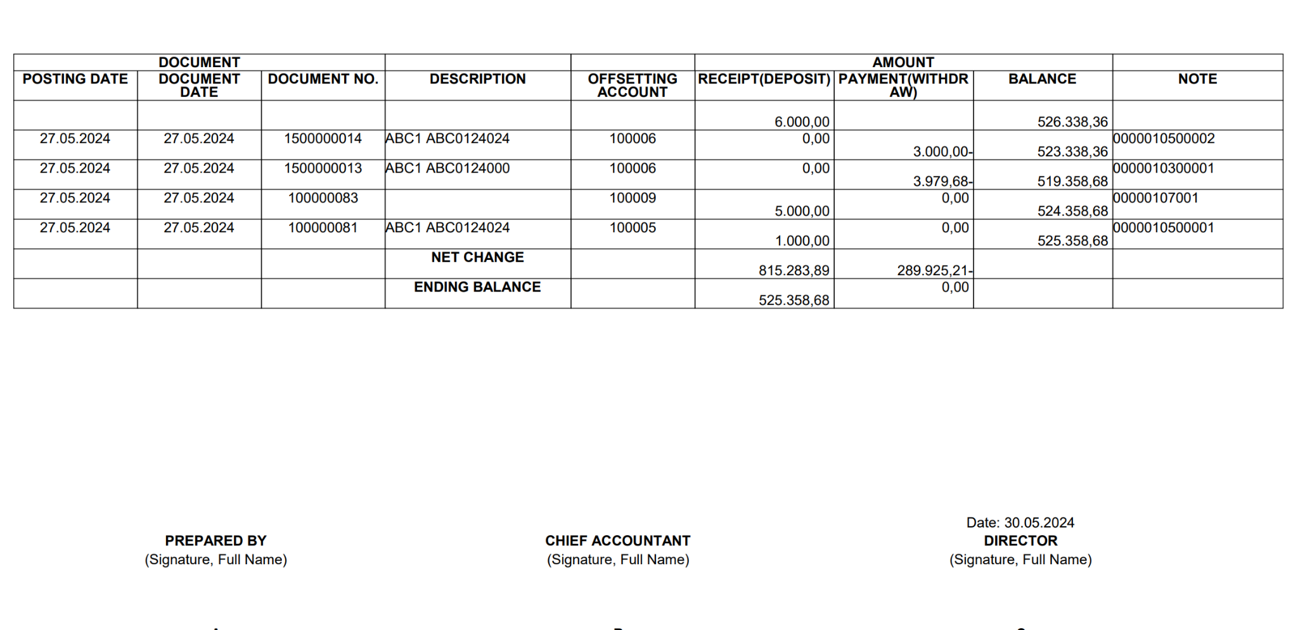

#### 

#### 3.6.2 ABAP Implementation

##### 3.6.2.1 Form

In order to streamline the functionality of SmartForms, it is crucial to establish specific functions for accessing data, setting form layout and design, and enabling the uploading of pertinent resources. The process of implementation can be outlined in the below tables:

| **Action** | **Description** | **T-code** |
| --- | --- | --- |
| Prepare company’s logo | Upload the company’s logo into SAP System. | SE78 |
| Create Smartstyles to streamlined form design. | Defining the form's style involves setting details like font choice, size, and other pertinent stylistic features. | SMARTFORMS -> Style |
| Create a main layout for Smartforms | Designing the layout involves determining the arrangement and positioning of elements such as pages and windows within the SmartForm interface. | SMARTFORMS -> Form |
| Create a driver program to call Smartform | Write a report program to act as a driver for a Smartform. This program acts as an intermediary, allowing your ABAP code to interact with the Smartform. It achieves this by calling the Smartform's corresponding function module. | SE38 |

*Table 19: Form Outline*

##### 

##### 3.6.2.2 Basic Design

| **Field Name** | **Description** | **Data type** | **Length** | **Logic/Rule for Development** |
| --- | --- | --- | --- | --- |
| COMPANY | Company Name | CHAR | 40 | Get ADRC-NAME1 in T001-ADRNR joint ADRC-ADDNUMBER when T001-BUKRS = Parameter (1) |
| ADDRESS | Company's Primary Address | CHAR | 10 | - Get ADRC-HOUSE_NUM1, ADRC-STREET, ADRC-CITY1, ADRC-COUNTRY in T001-ADRNR joint ADRC-ADDNUMBER when T001-BUKRS = Parameter (1)  - Display as ADRC-HOUSE_NUM1 & ADRC-STREET & ADRC-CITY1 & ADRC-COUNTRY |
| DATE | Date to display according Information | DATS | 20 | - Display value according to parameter (3) |
| ACCOUNT NO | G/L Account Number | CHAR | 10 | Get G/L account from parameter (4) |
| ACCOUNT NAME | G/L Account Text | CHAR | 50 | Get SKAT-TXT50 in SKAT-KTOPL joint T001-KTOPL when T001-BUKRS = parameter (1); SKAT-SAKNR = SKB1-SAKNR = paremeter (4) |
| HOUSE BANK | House Bank | DATS | 50 | Get T012K-HBKID in T012K when BUKRS = parameter (1) and HKONT = parameter (4). |
| BANK ACCOUNT ID | Bank Account ID | CHAR | 50 | Get T012K-HKTID in T012K when BUKRS = parameter (1) and HKONT = parameter (4). |
| BANK | Bank Key of the Bank | CHAR | 15 | Get T012-BANKL in T012K-HBKID joint T012-HBKID when T012K-BUKRS = parameter (1) and T012K-HKONT = parameter (4) |
| BANK NAME | Name of Bank | CHAR | 60 | Get BNKA-BANKA in BNKA-BANKL joint T012-BANKL and T012-BANKL = value from No. 5 |
| BANK ACCOUNT | Bank Account Number in Bank | CHAR | 18 | Get T012K-BANKN in T012K when T012K-BUKRS = parameter (1), T012K-HKONT = parameter (4), T012K-HBKID = Value A and T012K-HKTID = Value B |
| BANK ACCOUNT NAME | Description of Bank Account Number |  | 50 | Get T012T-TEXT1 in T012T when T012T-BUKRS = parameter (1), T012T-HBKID = Value A and T012T-HKTID = Value B |
| CURRENCY | Currency | CUKY | 3 | Get SKB1-WAERS in SKB1 when BUKRS = parameter (1) and SAKNR = parameter (4) |
| POSTING DATE | Posting Date | DATS | 8 | Get ACDOCA-BUDAT in ACDOCA when RBUKRS = parameter (1), GJAHR = parameter (2), RACCT = Parameter (4), BUDAT = parameter (3), XREVERSING = XREVERSED = XTRUEREV = "blank"  Display the Posting Date just found in ACDOCA by matching with its document number (No 10) |
| DOCUMENT DATE | Document Date | DATS | 8 | Get ACDOCA-BLDAT in ACDOCA when RBUKRS = parameter (1), GJAHR = parameter (2), RACCT = Parameter (4), BUDAT = parameter (3), XREVERSING = XREVERSED = XTRUEREV = "blank"  Display the Document Date just found in ACDOCA by matching with its document number (No 10) |
| DOCUMENT NUMBER | Document Number | CHAR | 10 | Get ACDOCA-BELNR in ACDOCA when RBUKRS = parameter (1), GJAHR = parameter (2), RACCT = Parameter (4), BUDAT = parameter (3), XREVERSING = XREVERSED = XTRUEREV = "blank" |
| DESCRIPTION | Description of each Document | CHAR | 16 | Get BKPF-XBLNR in BKPF when BUKRS = parameter (1), GJAHR = parameter (2), BELNR = Value in No 10 |
| OFFSETTING ACCOUNT | Offsetting Account in each Document | CHAR | 10 | Get ACDOCA-GKONT in ACDOCA when RBUKRS = parameter (1), GJAHR = parameter (2), RACCT = Parameter (4), BELNR = Value in No 10 |
| RECEIPT (DEPOSIT) AMOUNT | Amount in Debit Side means increase Bank Balance (Deposit) | CURR | 23 | - Get ACDOCA-HSL and ACDOCA-DRCRK in ACDOCA when RBUKRS = parameter (1), GJAHR = parameter (2), RACCT = Parameter (4), BELNR = Value in No 10  - If ACDOCA-HSL >= 0, ACDOCA-DRCRK = "S", display ACDOCA-HSL in No. 13  - If ACDOCA-HSL <= 0, ACDOCA-DRCRK = "H", display ACDOCA-HSL in No. 14 |
| PAYMENT (WITHDRAW) AMOUNT | Amount in Credit Side means decrease Bank Balance (Withdraw) | CURR | 23 | - Get ACDOCA-HSL and ACDOCA-DRCRK in ACDOCA when RBUKRS = parameter (1), GJAHR = parameter (2), RACCT = Parameter (4), BELNR = Value in No 10  - If ACDOCA-HSL >= 0, ACDOCA-DRCRK = "S", display ACDOCA-HSL in No. 13  - If ACDOCA-HSL <= 0, ACDOCA-DRCRK = "H", display ACDOCA-HSL in No. 14 |
| BALANCE | Balance can be follow the fluctuated amount |  | 23 | - In first line:  BALANCE = OPENING BALANCE + RECEIPT (DEPOSIT) + PAYMENT (WITHDRAW)  - From 2nd line:  BALANCE = BALANCE OF PREVIOUS LINE + RECEIPT (DEPOSIT) + PAYMENT (WITHDRAW) |
| NOTE | Display Note detail for transaction | CHAR | 18 | Get ACDOCA-ZUONR in ACDOCA when RBUKRS = parameter (1), GJAHR = parameter (2), RACCT = Parameter (4), BELNR = Value in No 10 |
| OPENING BALANCE | Total Balance before Specified Range of Date |  | 23 | Get Sum of ACDOCA-HSL in ACDOCA when when RBUKRS = parameter (1), RACCT = Parameter (4), BUDAT < Parameter (3), POPER <> blank and BSTAT <> "C"  - If result > 0, display in column (17a)  - If result < 0, display in column (17b) |
| NET CHANGE | Total Increase Amount in Specified Range of Date |  | 23 | Sum column (13) |
| NET CHANGE | Total Decrease Amount in Specified Range of Date |  | 23 | Sum column (14) |
| ENDING BALANCE | Ending Balance Amount of Bank Account |  | 23 | Formula: (17a) + (17b) + (18a) + (18b)  - If result > 0, display in column (19a)  - If result < 0, display in column (19b) |
| PREPARED BY | Name of Person who prepared this form | TEXT | 50 | Parameter (5) |
| CHIEF ACCOUNTANT | Name of Chief Accountant | TEXT | 50 | Parameter (6) |
| DIRECTOR | Name of Director | TEXT | 50 | Parameter (7) |
| CONFIRMATION DATE | Date for Confirmation and Signing | DATE | 8 | Display Current Execution Date: Format YYYY/MM/DD |

*Table 20: Form Basic Design*

##### 3.6.2.3 Upload the company’s logo

In this step, you'll utilize T-Code SE78 to transfer the company’s logo into the system.

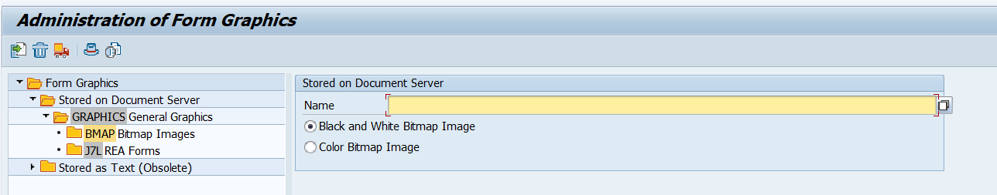

##### 3.6.2.4 Create Styles in Smartforms

We will use T-Code SMARTFORMS and create a Style.

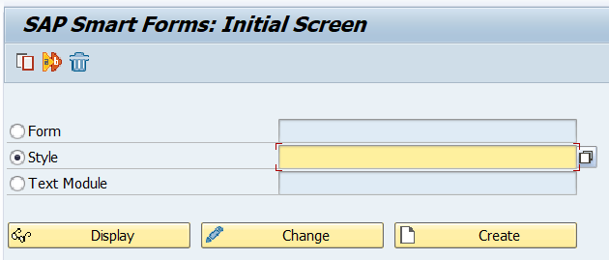

| **Type** | **Node** | **Description** | **Format** |
| --- | --- | --- | --- |
| Paragraph Formats | H1 | This style applies for the Header paragraph. | Alignment: Center  Font Family: ARIAL  Font Size: 13 pt |
| A1 | This style applies for the form title . | Alignment: Centered  Font Family: ARIAL  Font Size: 16 pt  Font Style: Bold |
| H3 | This style applies for Address and company field in header . | Alignment: Left-aligned  Font Family: Arial  Font Size: 13 pt |
| A2 | This style applies for footer Name and header of the table | Alignment: Centered  Font Family: ARIAL  Font Size: 13 pt  Font Style: Bold |
| A4 | This style applies field have show amount value. | Alignment: Right-aligned  Font Family: Arial  Font Size: 13 pt |
| A5 | This style applies for table Items which have center align. | Alignment: Centered  Font Family: Arial  Font Size: 13 pt |
| A3 | This style applies for table Items which have left align | Alignment: Left-aligned  Font Family: Arial  Font Size: 13 pt |

*Table 21: Style Outline*

##### 3.6.2.5 Create a Smartform in SAP

We will use T-Code SMARTFORMS and create a Form.

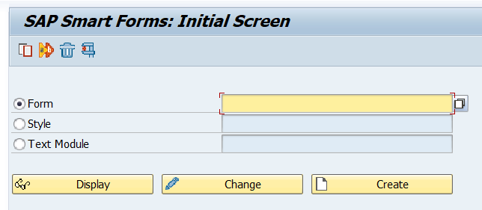

##### 3.6.2.6 Smartforms Initialization

- Create a purchase order smartform layout. The interface is divided into three main sections: A header window, a main window and a footer window. Details about each are provided below:

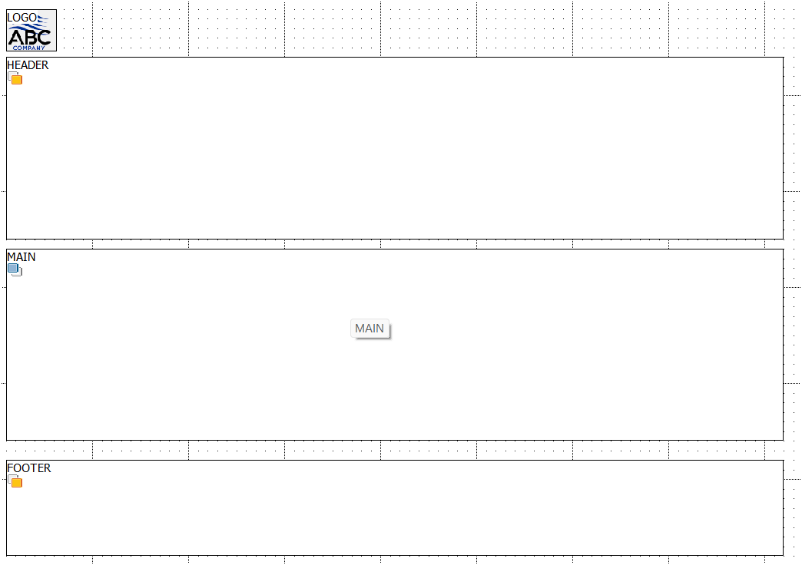

| **Window** | **Description** |
| --- | --- |
| HEADER | This window has a template to display the overview of general information |
| MAIN | This window has a template to display the document, display amount, etc,.. |
| FOOTER | This window has a template to display the total order value and signatures. |

*Table 22: Window Outline*

- Set the style for the Smartform in Form Attribute under the Output Options tab.

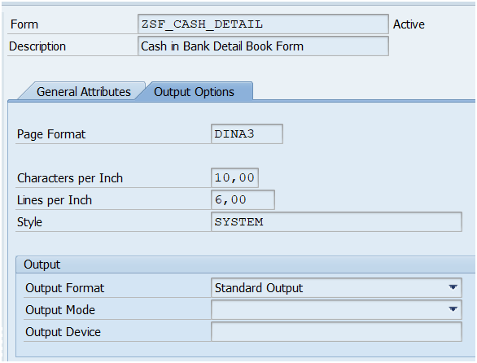

- Declare the internal table for displaying items in the Form Interface under the Tables tab.

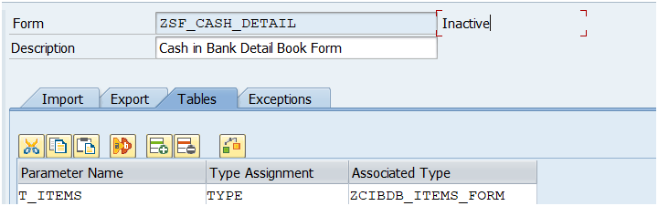

- Declare variables, such as work areas for the item table and for calculating the total order value, in the Global Definitions under the Global Data tab.

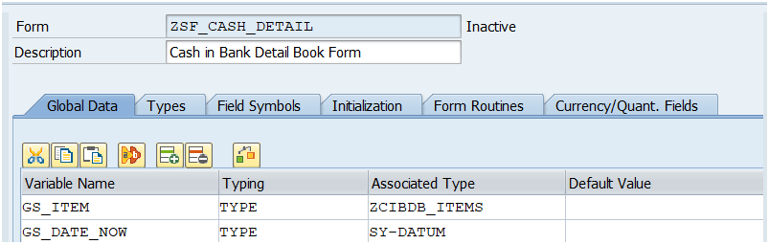

- In the MAIN window, there is a header template containing header information and a table. Within that table, the main area features a loop for storing items.

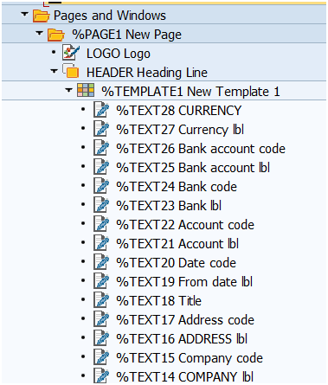

- In the Main Loop, we need to declare the internal table to work with items in the Data tab and declare the operation to calculate the total Net Value of the items in the Calculation tab.

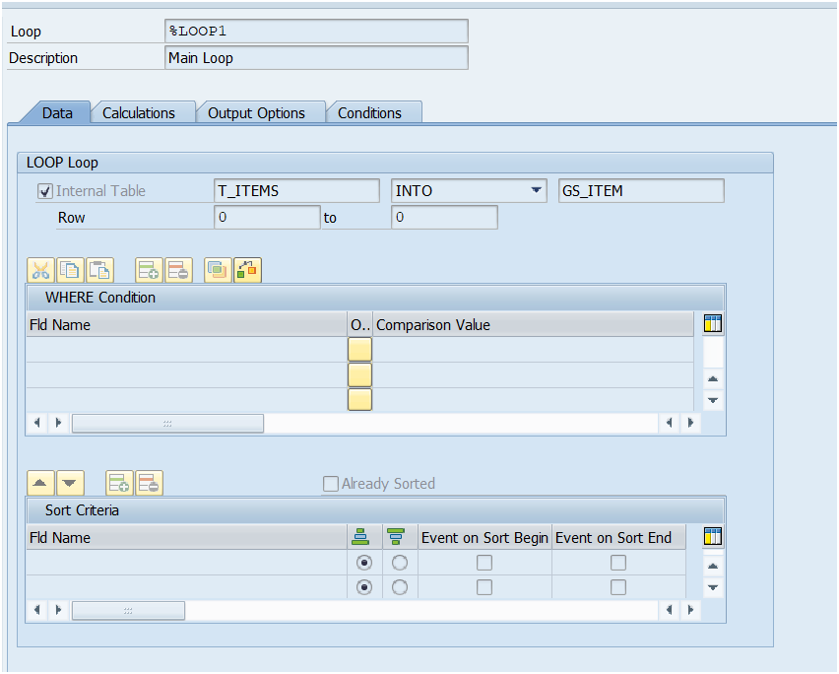

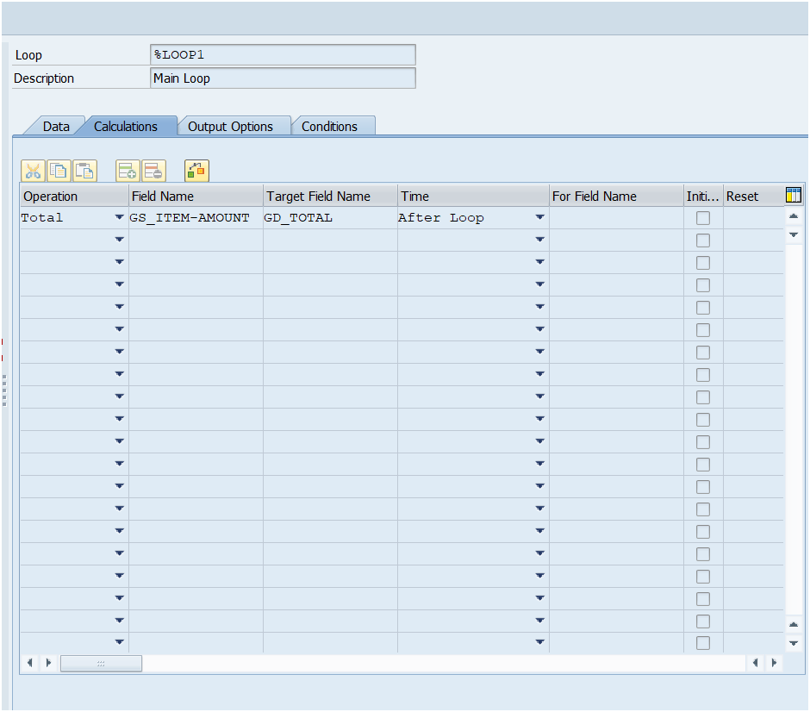

- In FOOTER window, there is a template containing the signatures, etc, ..

- Set the condition of this window as After end of main window only.

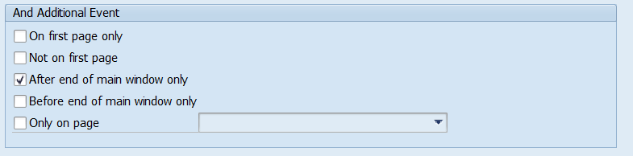

##### 

##### 

##### 3.6.2.7 Driver Program for Smartform

- We will use T-Code SE38 and create a new program.

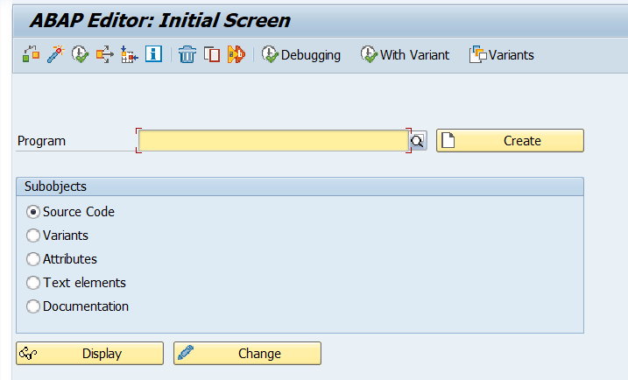

- When executing a smartform, each smartform generates a function module. We will use the driver program to call this function module.

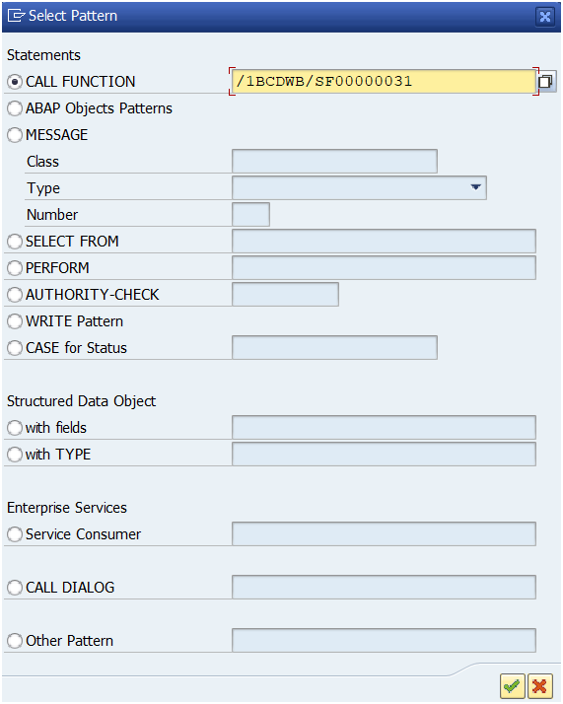

##### 

##### 

##### 

##### 3.6.2.8 How the Form works

- Users can access the Form by T-Code “ZABCBANK”.

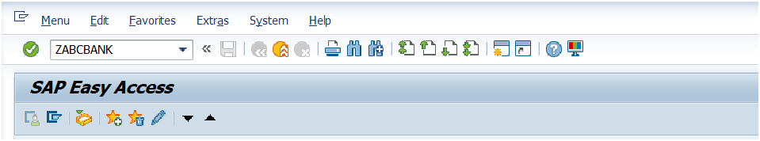

The next screen shows up

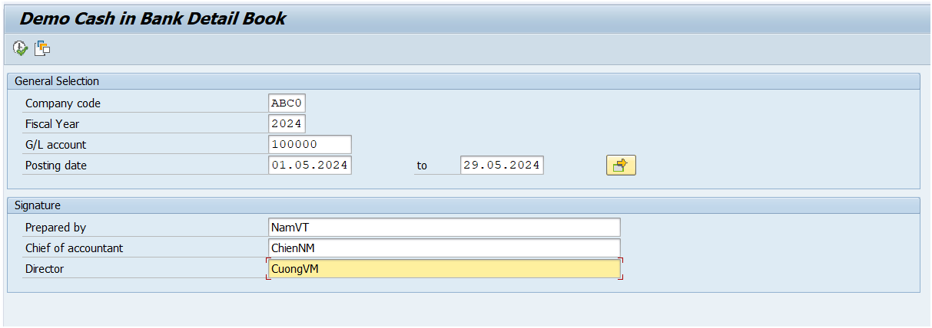

Type in important information, including the three Signatures:





**Deploy GUI Transaction to Fiori as Tile**

**Create Target Mapping**

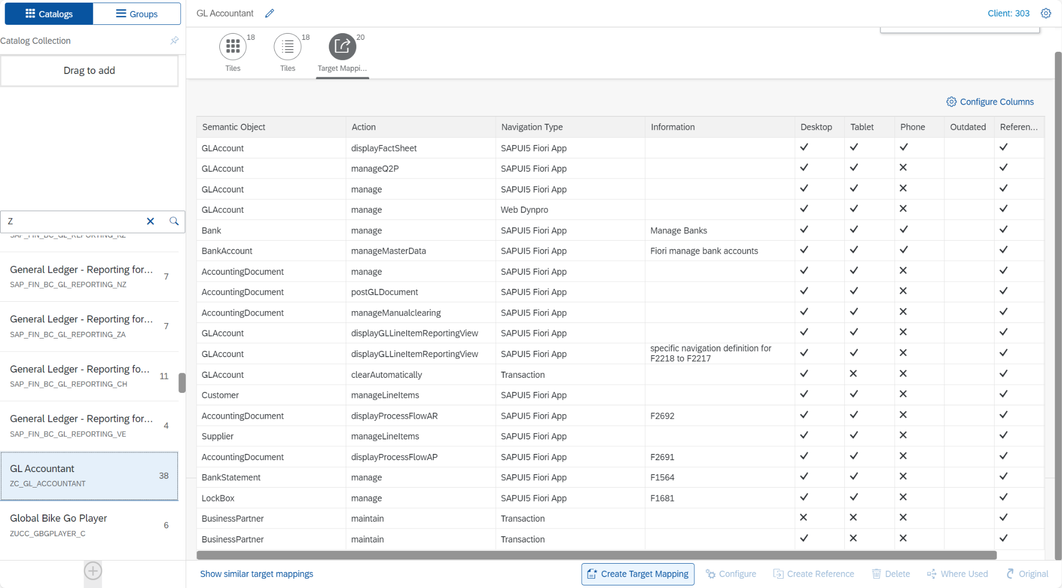

Each row displays details for an app, including the semantic object, action, navigation type, and additional information. Columns indicate the app's availability across different devices (desktop, tablet, phone) and its current status (outdated or not). The user can add apps to the catalog, configure columns, create target mappings, and perform other administrative tasks.

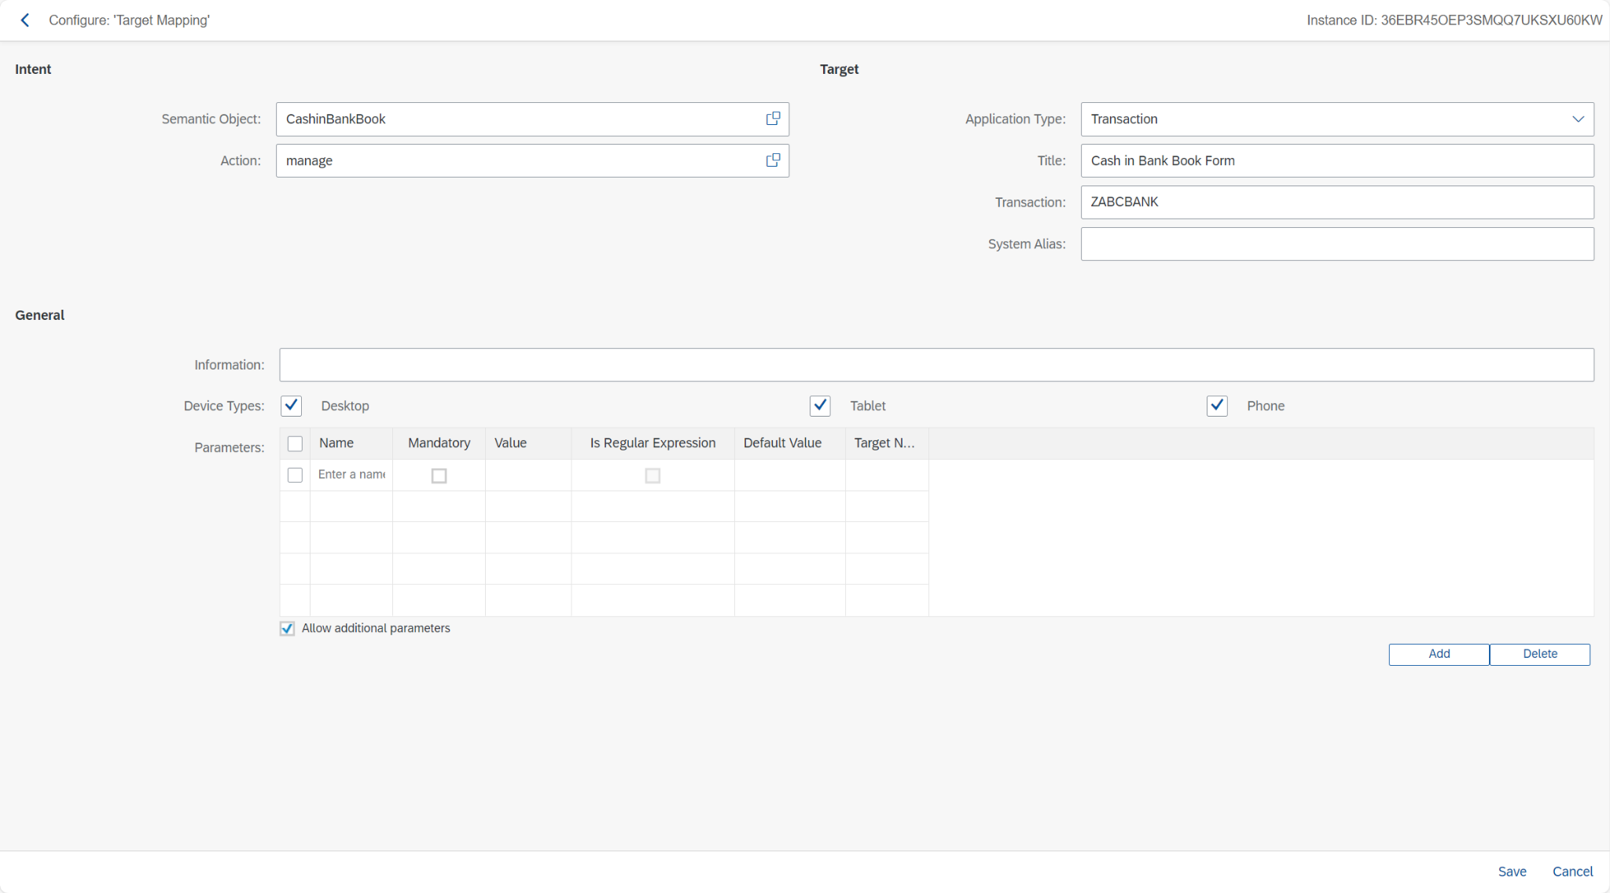

The semantic object is "CashinBankBook" with the action "manage." The target application type is a transaction titled "Cash in Bank Book Form," and the transaction code is "ZABCBANK." The device types enabled are Desktop, Tablet, and Phone. Parameters can be added with various attributes, including name, mandatory status, value, and default value. The user can save or cancel the configuration at the bottom of the screen.

**Add Tile**

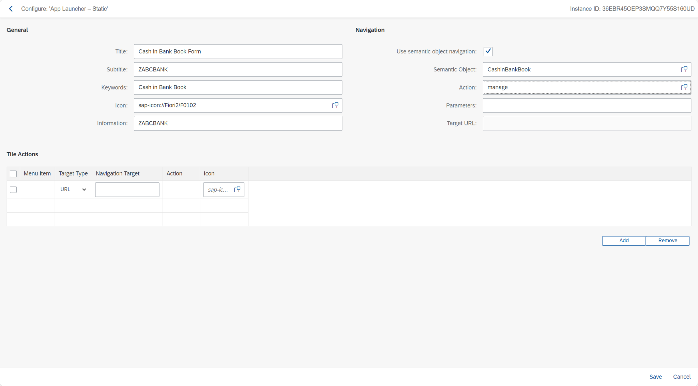

The General section includes fields for Title ("Cash in Bank Book Form"), Subtitle ("ZABCBANK"), Keywords ("Cash in Bank Book"), Icon, and Information. The Navigation section shows options for using semantic object navigation, with "CashinBankBook" as the Semantic Object and "manage" as the Action.

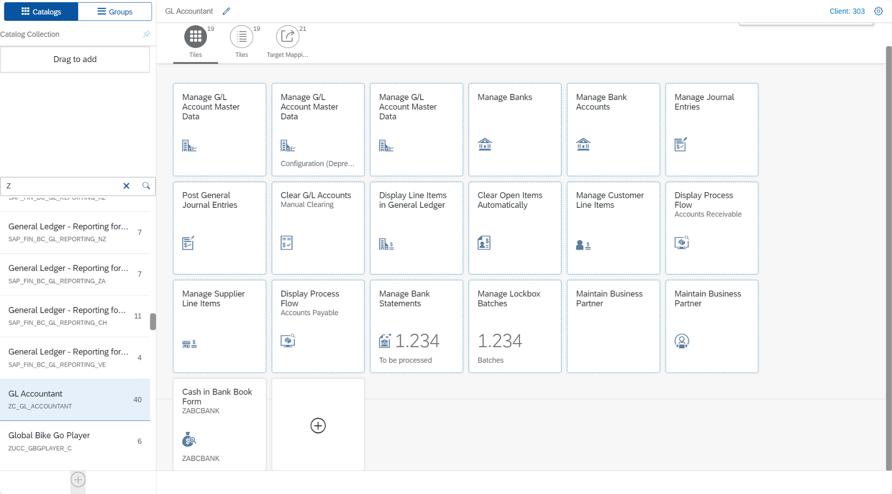

The screen includes a catalog on the left, listing available tiles and groups such as "General Ledger - Reporting for..." and "GL Accountant." On the right, a grid of tiles provides access to various applications like "Manage G/L Account Master Data," "Post General Journal Entries," and "Manage Banks." A specific tile, "Cash in Bank Book Form," is highlighted, indicating it is part of the selected catalog and available for user interaction.

**Add to Group**

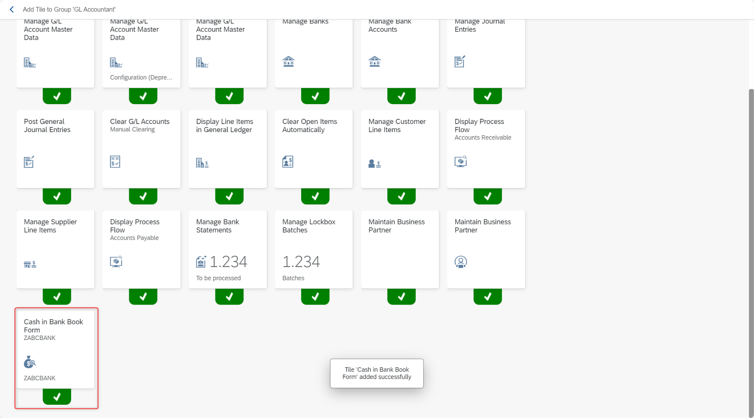

The app was added to the group successfully.

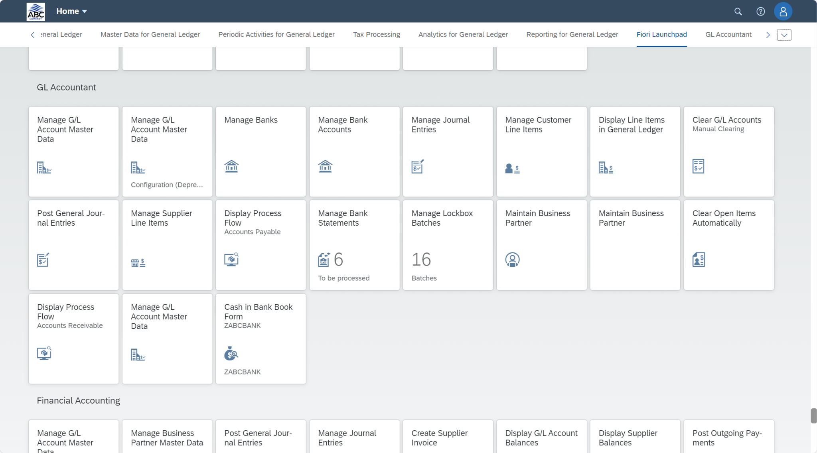

The app and its location on the main screen.

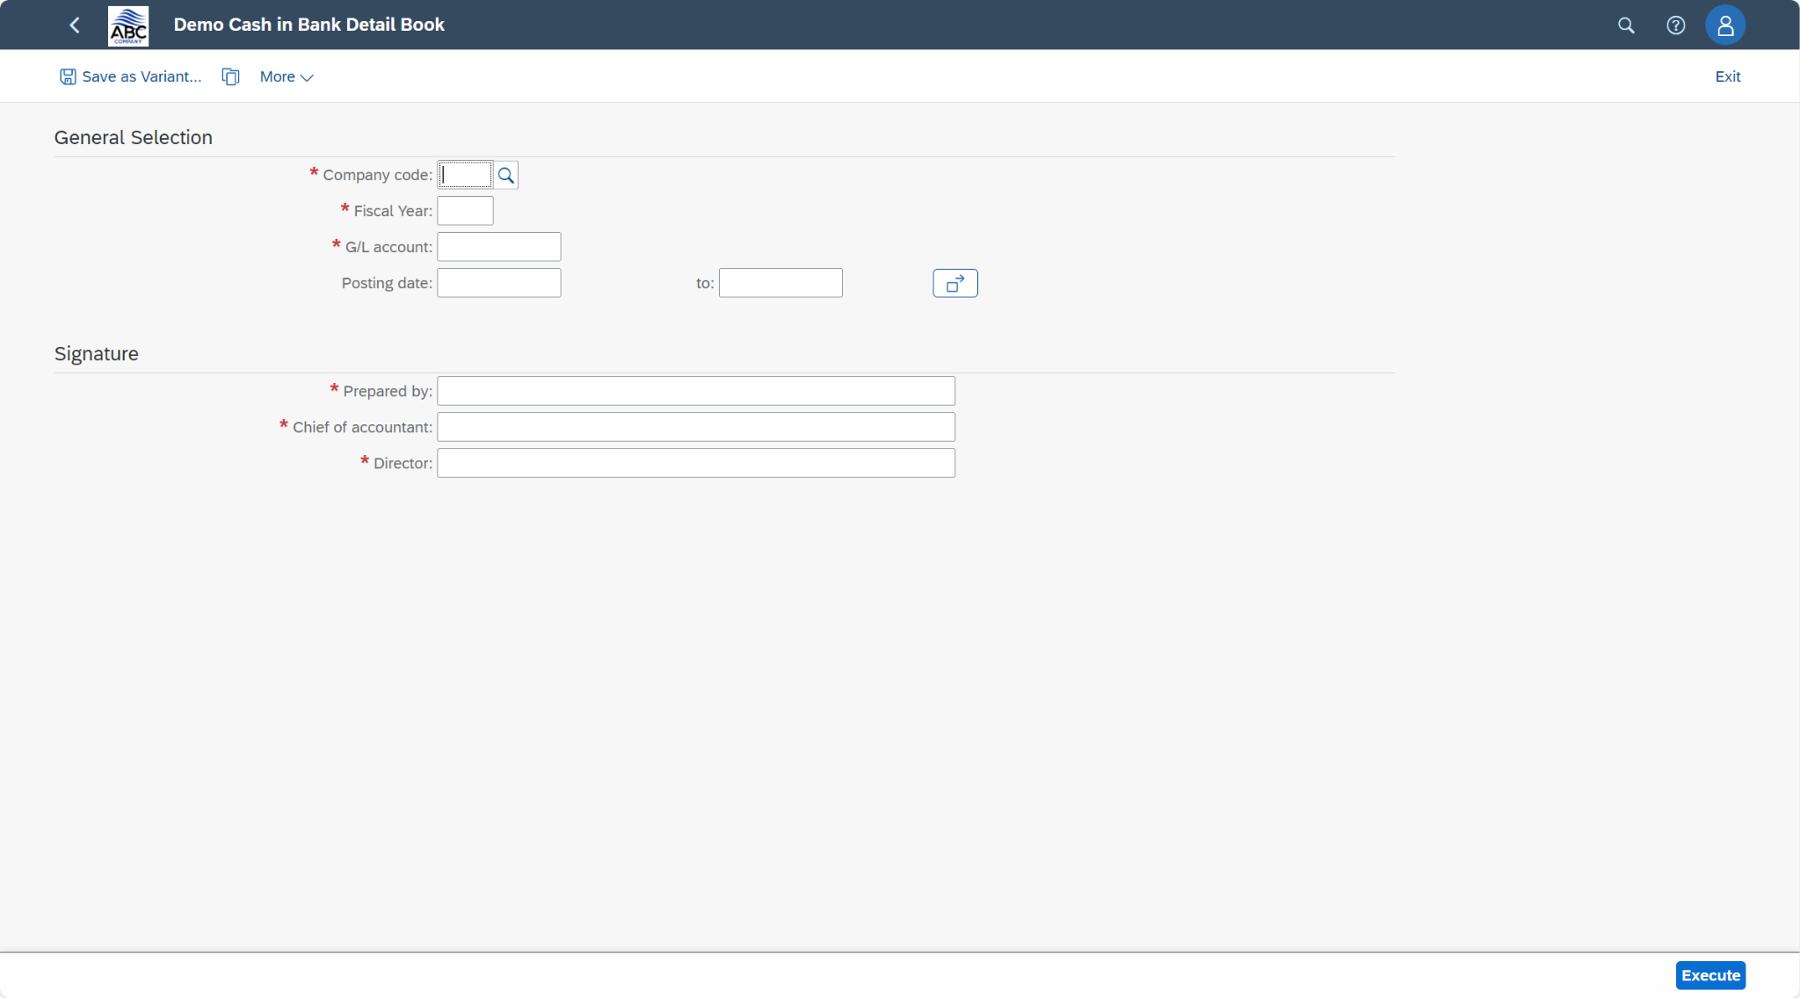

The app page and its relevant field.

## 4. Set Up Batch for Automatic Clearing (F.13)

Step 1: Create variant in F.13

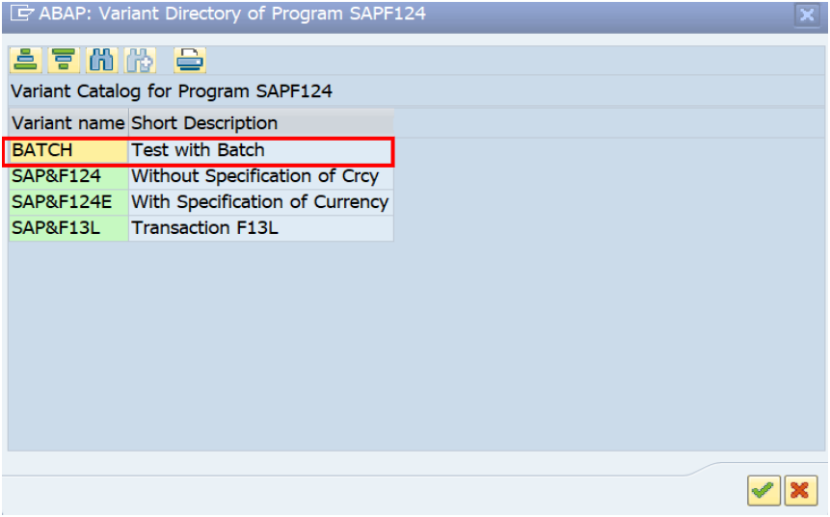

This section of the SAP interface is used to create and manage variants for the SAP program SAPF124.

A variant is a set of saved input values for a program that can be reused, simplifying the execution of the program with consistent parameters.

Variant Catalog for Program SAPF124:

The catalog displays the list of existing variants available for the program SAPF124.

Highlighted Variant (BATCH):

Variant Name: BATCH

Short Description: Test with Batch

This variant has been highlighted to indicate that it is the one being created or selected for use in this step.

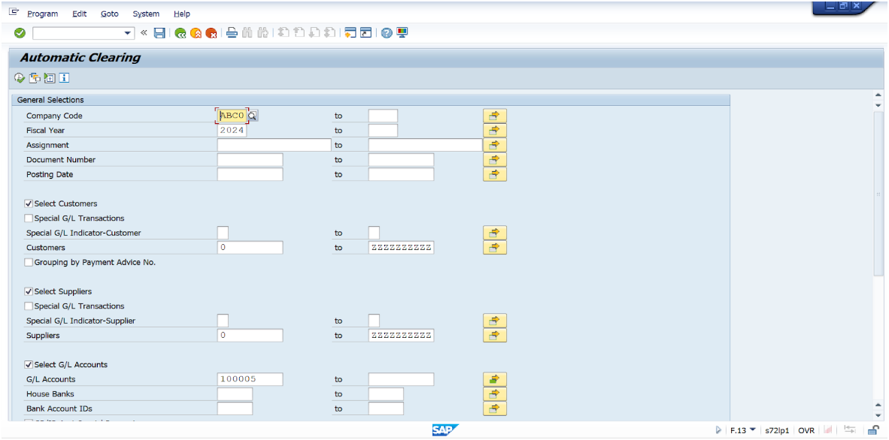

Users can specify various criteria, including company code, fiscal year, assignment number, document number, posting date, and ranges for customers, suppliers, and G/L accounts. The selections made on this screen determine which items will be considered for clearing based on the specified parameters.

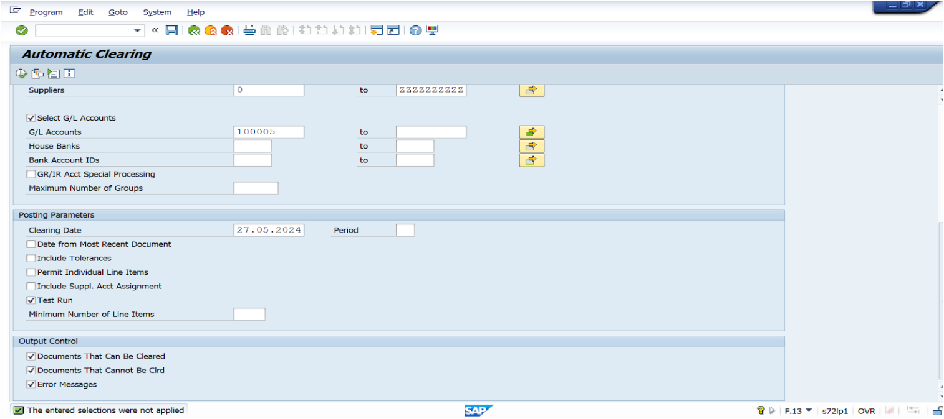

The user has selected parameters for clearing G/L accounts, specified a clearing date, included tolerances, and allowed individual line items. The process is set to run as a test. Output control options are selected to display both documents that can and cannot be cleared, along with error messages. The status message indicates that the selections made have not yet been applied.

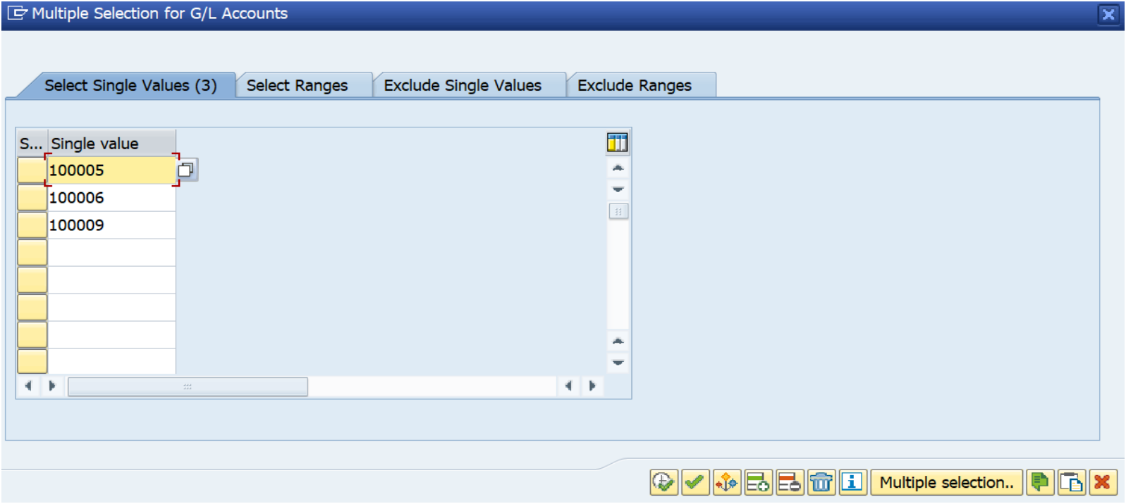

Account Numbers: Input account numbers (e.g., 100005, 100006).

Step 2: Go to SM36 and give a batch job name

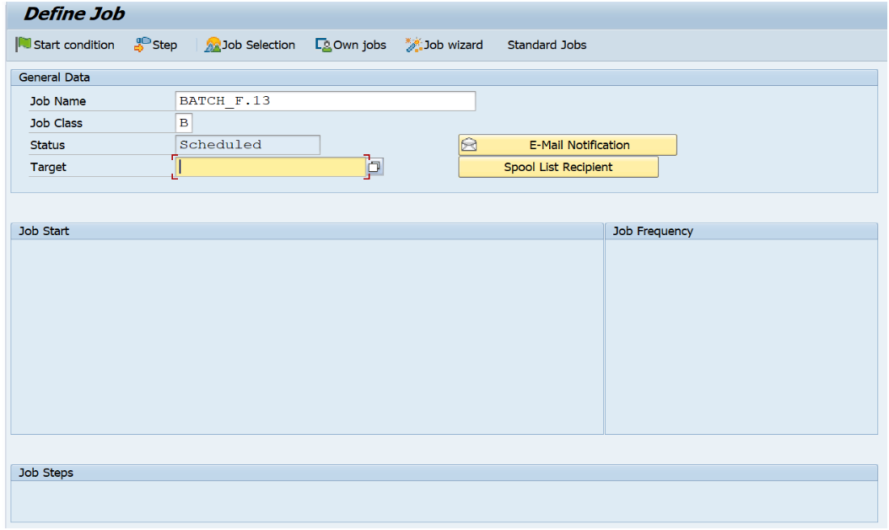

In SAP, a batch job is a program that runs in the background without user intervention. Batch jobs are often used to automate tasks, such as data processing or report generation. SM36 is a transaction code that allows users to view and manage batch jobs.

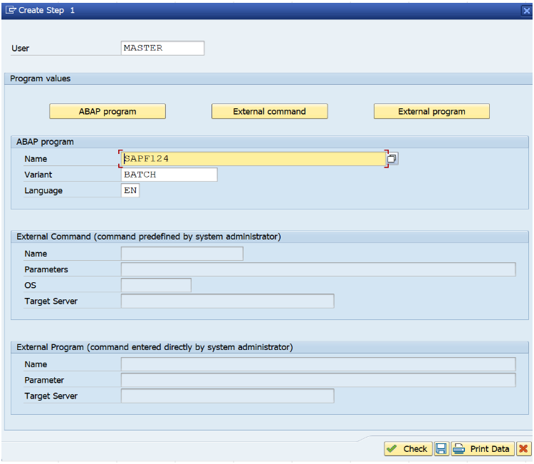

There are options for different types of programs including ABAP program, external command, and external program. There are also fields to enter a name, variant, language, target server, and other parameters.░

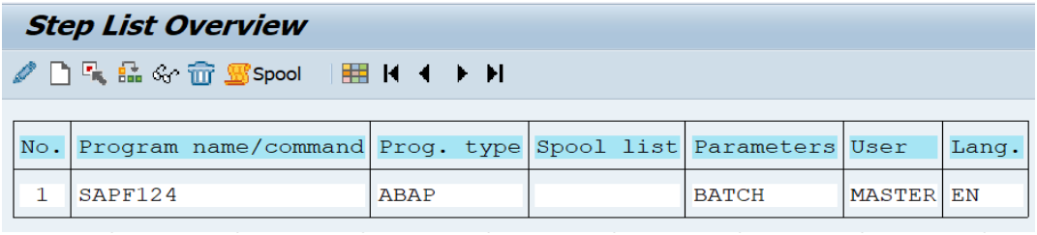

It includes a table with columns such as No., Program name/command, Prog. type, Spool list, Parameters, and User Lang. The entry shown is labeled ‘1’ with the program name/command ‘SAPFI24’ using the ABAP programming language. The spool list is ‘BATCH’, possibly indicating batch processing. ‘MASTER’ appears under parameters, and ‘EN’ signifies English language preference.

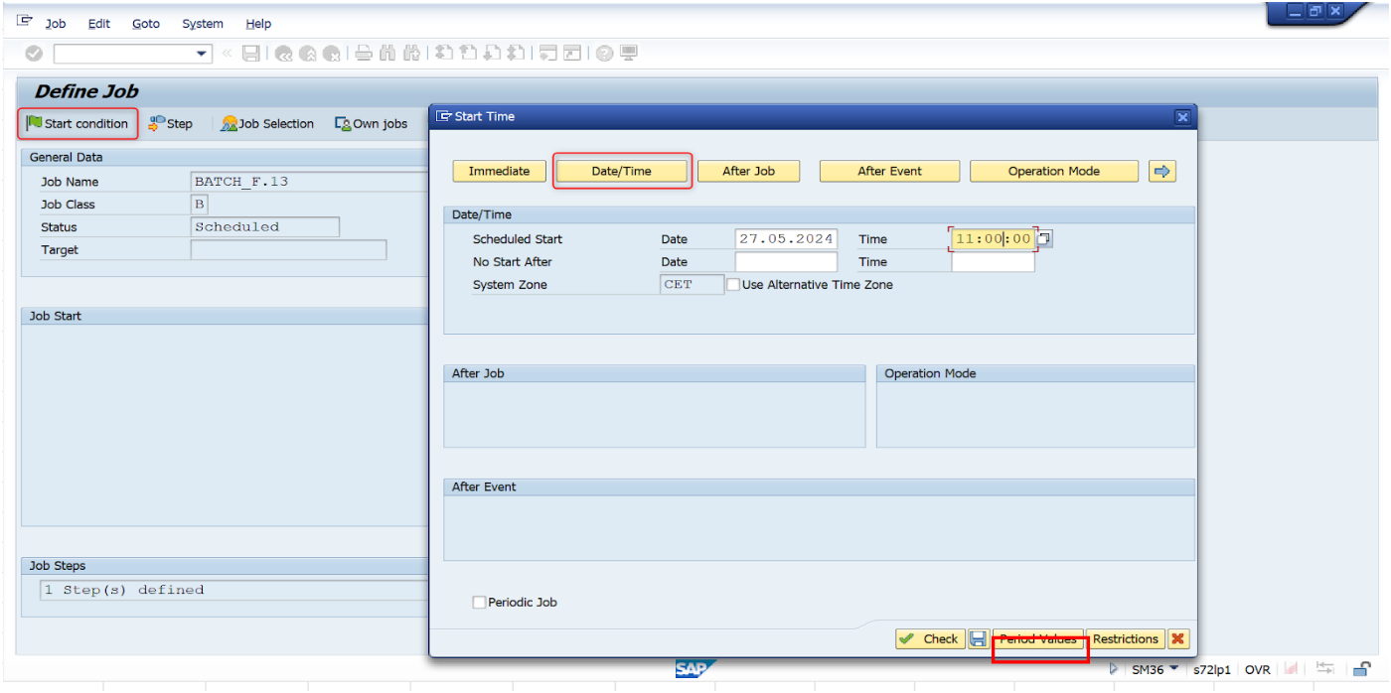

The screenshot depicts a job scheduling interface where a user can define a job. The focus is on the “Start Condition” section. Users can set the job to start and specify a date and time. There’s an option to use the system time zone or a custom one.

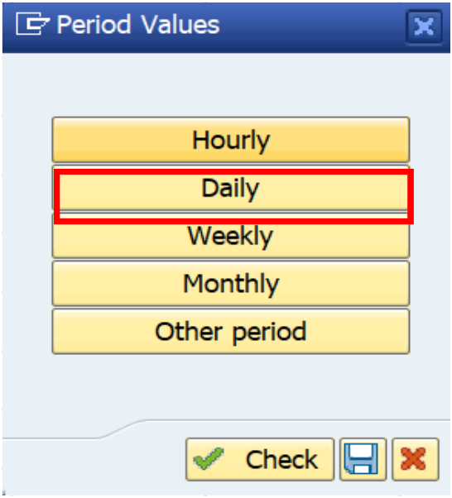

They can also check for the “Period Values”

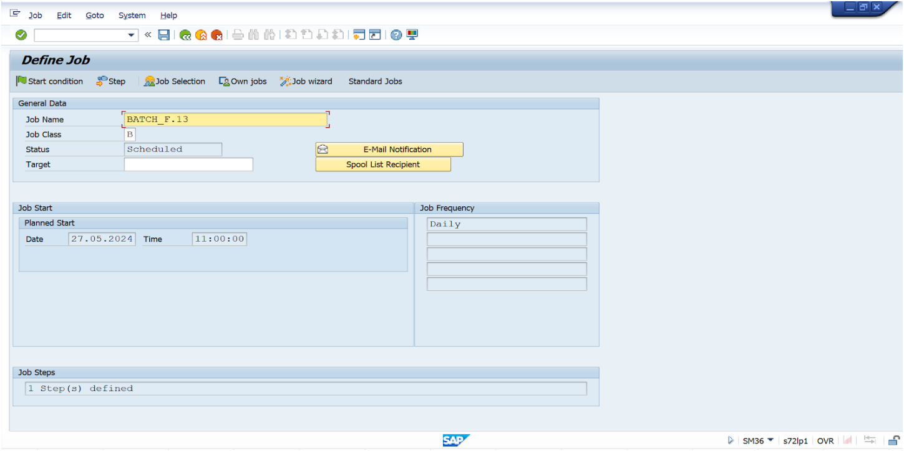

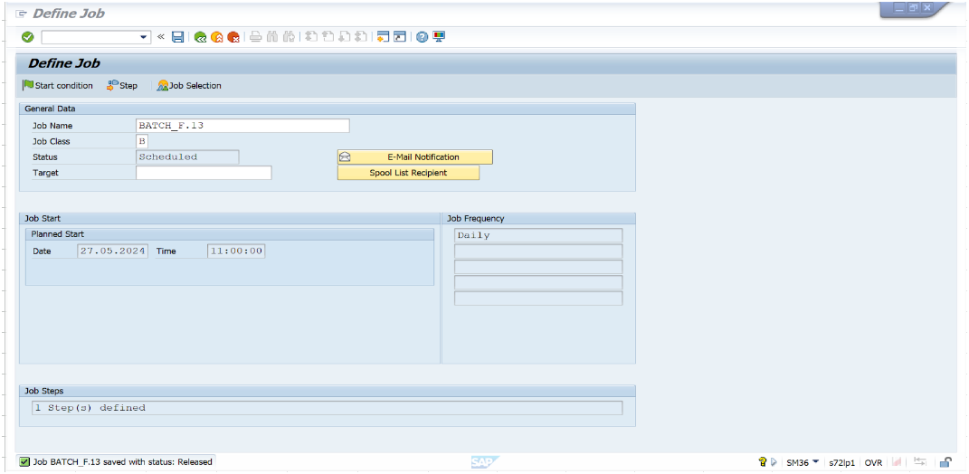

The interface includes fields such as ‘Job Name’, ‘Job Class’, ‘Target’, and ‘Script’. The ‘Job Name’ field is filled in as “finance_rj_13”. There’s also a section for scheduling the job, with options to start immediately or at a planned date and time (set to “28.10.2022” at “11:00:00”). The interface appears to be part of an automated system for scheduling and running tasks within an organization.

Step 3: Check Batch Job Status when Completed

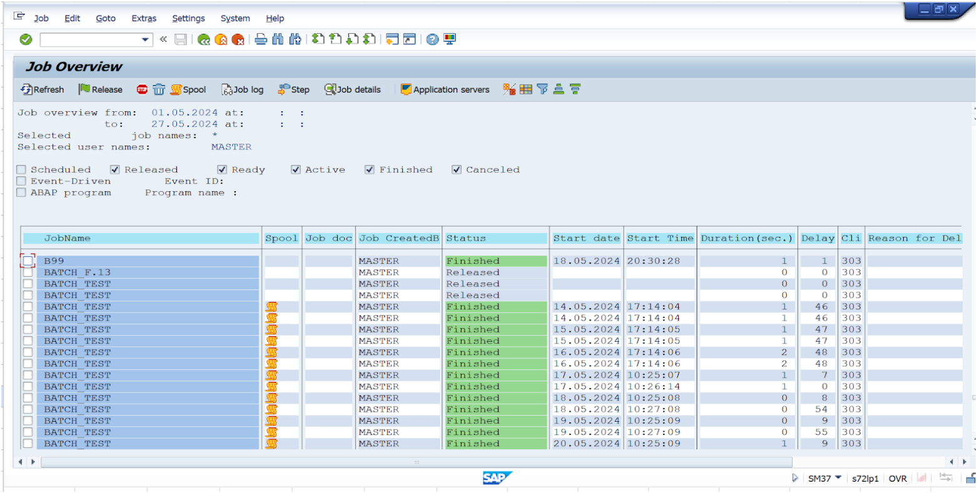

The "Job Overview" screen shows details of various batch jobs filtered by job name and user. Key information displayed includes job names, spool status, job documents, creators, current status (e.g., finished or released), start dates and times, durations, delays, and reasons for delays. This allows users to efficiently monitor and manage batch job executions.

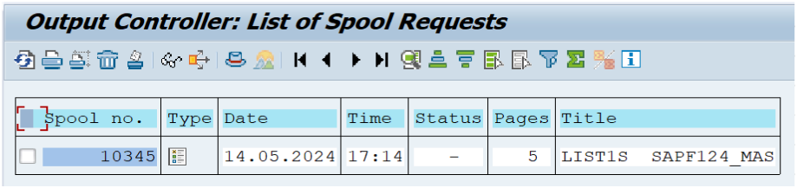

The output shows the "Output Controller: List of Spool Requests" screen in SAP. It lists spool request details, including spool number 10345, type, date (14.05.2024), time (17:14), status, number of pages (5), and title (LIST1S SAPF124_MAS). This interface allows users to view and manage print spool requests efficiently.

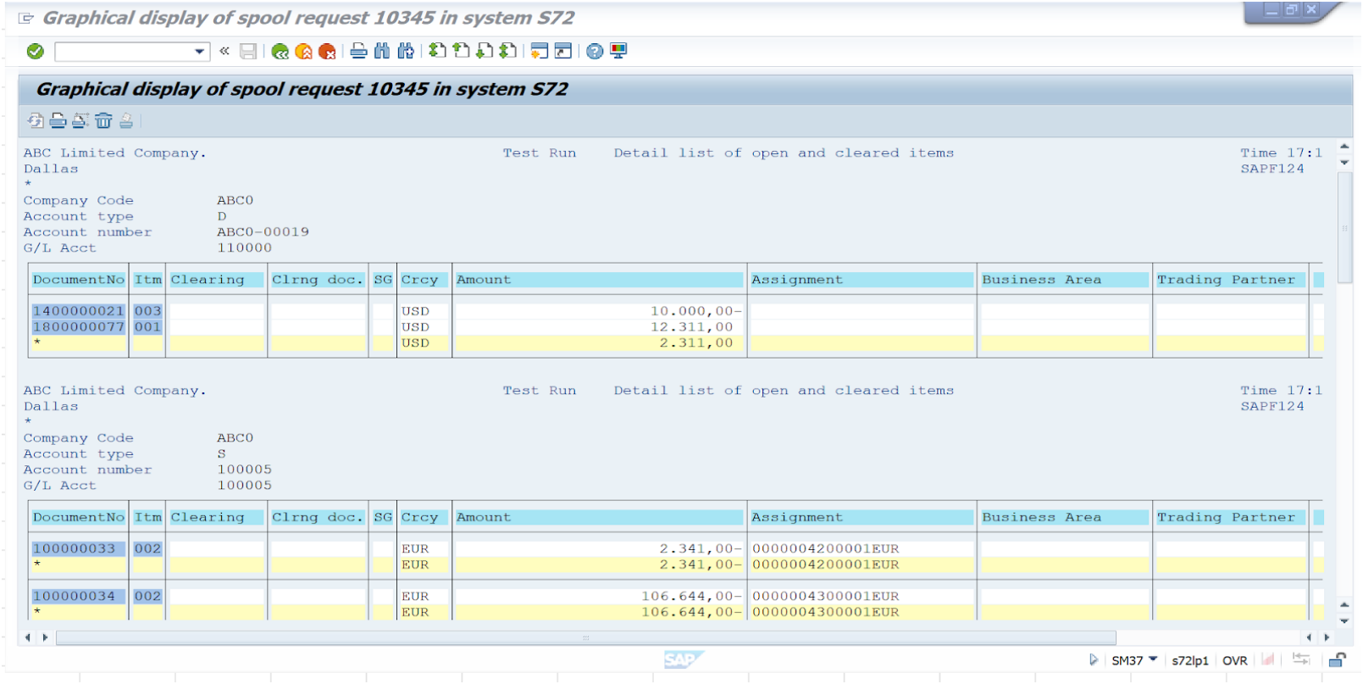

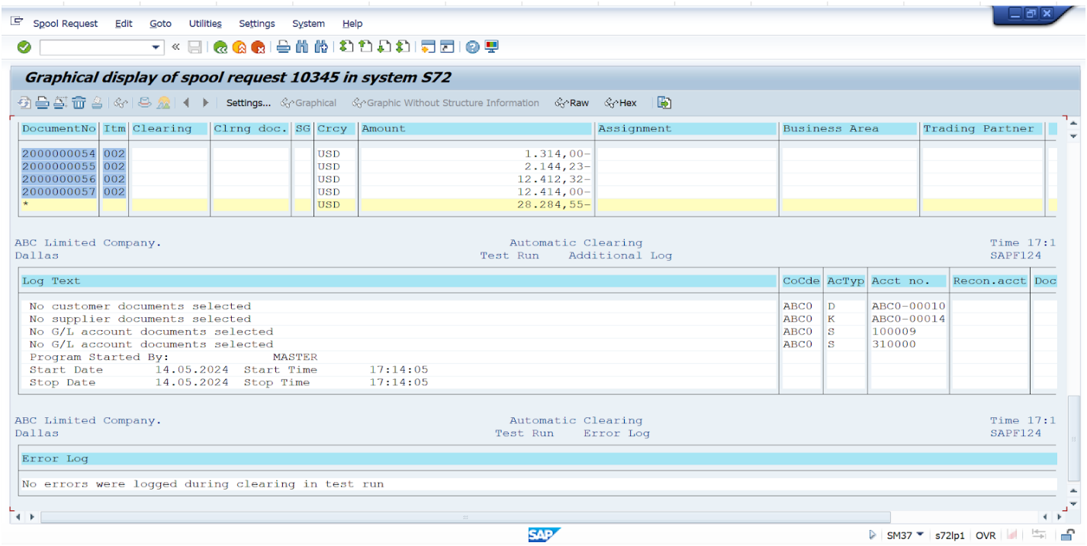

The results depict a graphical display of spool request 10345 in SAP system S72. It shows a detailed list of open and cleared items for "ABC Limited Company." The data includes document numbers, clearing items and documents, currency (USD and EUR), amounts, assignments, business areas, and trading partners. This visual representation helps users quickly assess financial transactions and their statuses.

## 

## 5. Authorization Settings

### 5.1 Role Matrix

In SAP, authorization refers to the process and mechanism that regulates user access to various SAP resources by assigning permissions based on the roles and responsibilities within an organization. Authorizations are critical for maintaining security and ensuring that users have the appropriate level of access to perform their jobs without compromising sensitive data or critical business processes.

The role of authorization settings in SAP is multifaceted. Primarily, these settings are designed to safeguard the system from unauthorized use by ensuring users can only access the data and transactions relevant to their role. Authorization checks are performed at various levels within the system, including transaction codes, organizational levels, and even field values within transactions.

Authorizations are managed through roles and profiles. An SAP role is a collection of authorization objects that represent a defined set of user privileges, which are then assigned to users. This modular approach allows flexibility and ease of administration, as adding or removing a user's access can be performed by adjusting their role assignments.

The proper configuration and management of authorization settings are fundamental for compliance with internal controls and external regulatory requirements. They help to maintain data integrity, protect against fraud, and ensure that the principle of least privilege is followed—users are granted only the access necessary to perform their job functions, no more, no less.

In summary, authorizations in SAP are a vital component of system security and compliance, controlling access to transactions, programs, and data, enforcing the division of duties, and minimizing the risk of unauthorized activities within the SAP environment.

| **Application name** | **App ID** | **GL Accountant** | **AR Accountant** | **AP Accountant** | **Finance Department** |
| --- | --- | --- | --- | --- | --- |
| Maintain Business Partner | BP | R | A | A | R |
| Manage G/L Acc. Master Data | F0731 | A | R | R | R |
| Manage Banks | F1574 | R | R | R | R |
| Manage Bank Accounts | F1366A | R | R | R | R |
| Manage Journal Entries | F0717 | R | R | R | R |
| Post Journal Entries | F0718 | R | R | R | R |
| Clear G/L Accounts | F1579 | A |  |  |  |
| Display Line Items in General Ledger | F2217 | R | R | R | R |
| Clear Open Items Automatically | F.13 | A |  |  |  |
| Create Outgoing Invoices | FB70 |  | A |  |  |
| Post Incoming Payments | F1345 |  | A |  | R |
| Clear Incoming Payments | F0773 |  | A | R | R |
| Manage Customer Line Items | F0711 | R | R | R | R |
| Display Process Flow - AR | F2692 | R | R | R | R |
| Create Incoming Invoices | FB60 |  |  | A |  |
| Manage Automatic Payments | F0770 |  |  | A | R |
| Post Outgoing Payment | F1612 |  |  | A | R |
| Clear Outgoing Payments | F1367 |  | R | A | R |
| Manage Supplier Line Items | F0712 | R | R | R | R |
| Display Process Flow - AP | F2691 | R | R | R | R |
| Manage Incoming Payment Files | F1680 |  |  |  | A |
| Manage Bank Statements | F1564 | R | R | R | A |
| Reprocess Bank Statement Items | F1520 |  | A | A | A |
| Upload Lockbox Files | FLB2 |  |  |  | A |
| Manage Lockbox Batches | F1681 | R | A | A | A |
| Reprocess Lockbox Items | F3398 |  | A | A | A |

| A | Full Authorization |
| --- | --- |
| R | Only Read |

### 

### 5.2 Role Settings Process

| **User ID** | **Group** | **Role** | **Catalog ID** |
| --- | --- | --- | --- |
| Master |  | SAP_ALL |  |
| AR_ACC | ZGR_AR_ACCOUNTANT | ZS_AR_ACCOUNTANT | ZC_AR_ACCOUNTANT |
| AP_ACC | ZGR_AP_ACCOUNTANT | ZS_AP_ACCOUNTANT | ZC_AP_ACCOUNTANT |
| GL_ACC | ZGR_GL_ACCOUNTANT | ZS_GL_ACCOUNTANT | ZC_GL_ACCOUNTANT |
| FI_ACC | ZGR_FI_ACCOUNTANT | ZS_FINANCE_BS_LB | ZC_FI_ACCOUNTANT |

### 5.3 Master Role Settings in SAP

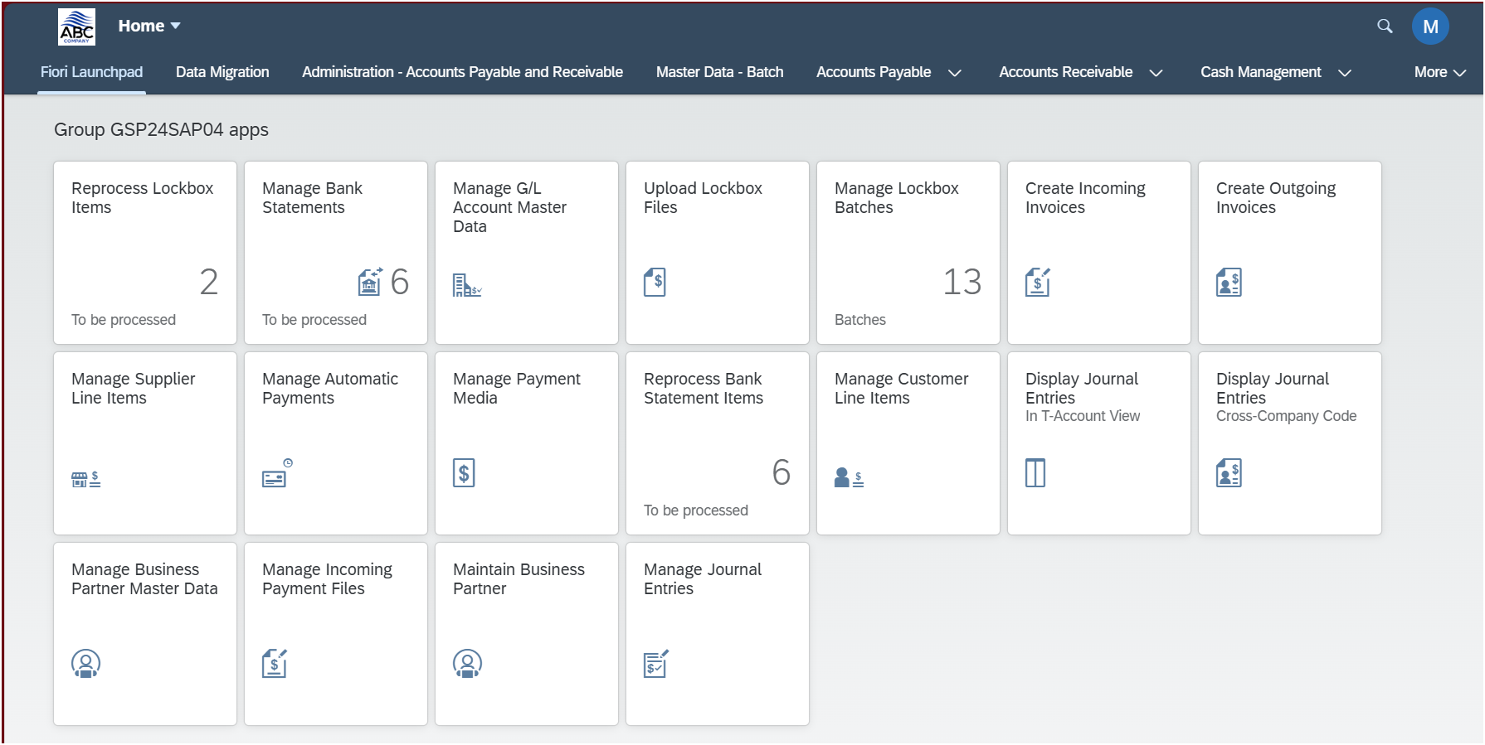

A Master Account has the screen of all apps under the section title **“Group GSP24SAP04 apps”**, which has all the access to every single app.

The main page is also designated with its own company logo at the top left of the homepage.

Using the Master Account to distribute **“Catalog Group & Role Creation”** SAP Fiori App

### 5.4 FI Role Settings in SAP

By logging into the FI Account, the FI Accountant will have access to several apps that are available just for them.

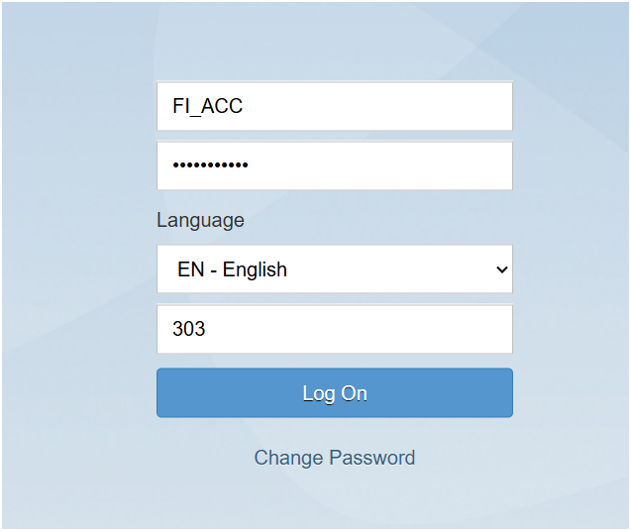

After logging in, the FI Accountant can see the page “FI Accountant” that has just been made for them with all of the necessary apps to work with the Fiori System.

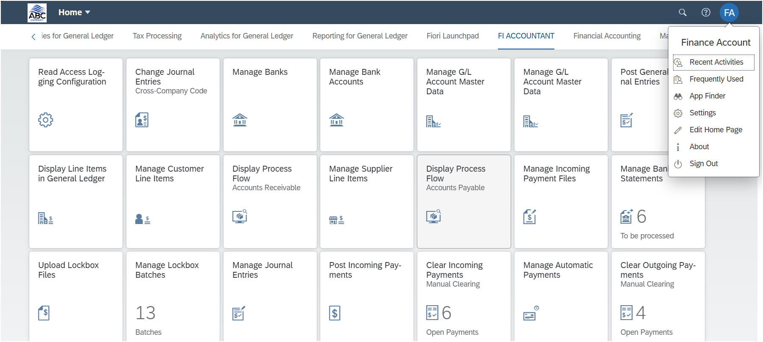

To make it possible for FI Accountant to get access to these apps, we have to do the following steps:

**Create new catalog for FI Role Settings**

#### 

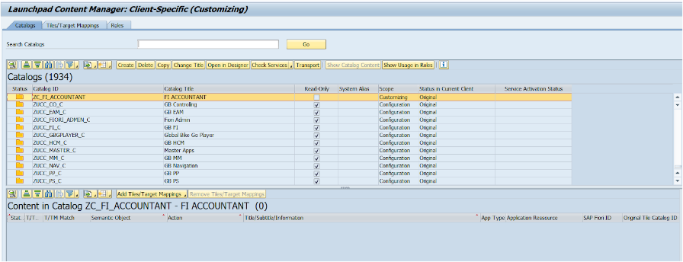

**Add all tiles for FI Role Settings**

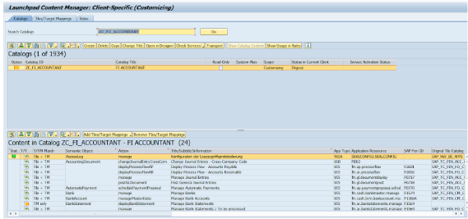

**Add to group for FI Role Settings**

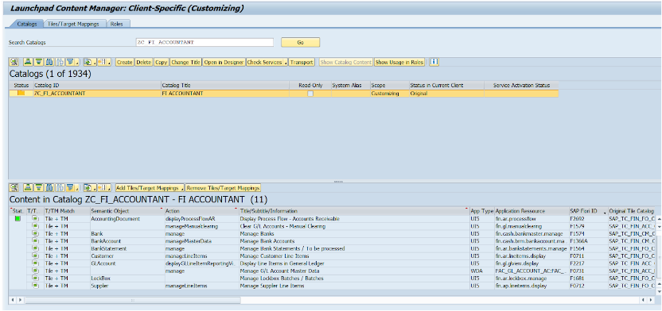

**Create catalog apps based on roles for FI Role Settings**

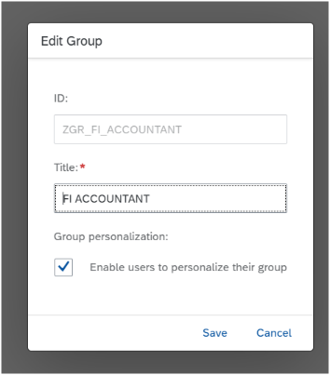

**Add all relevant apps for FI Role Settings**

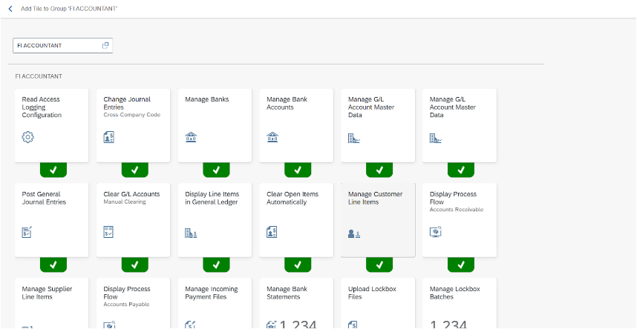

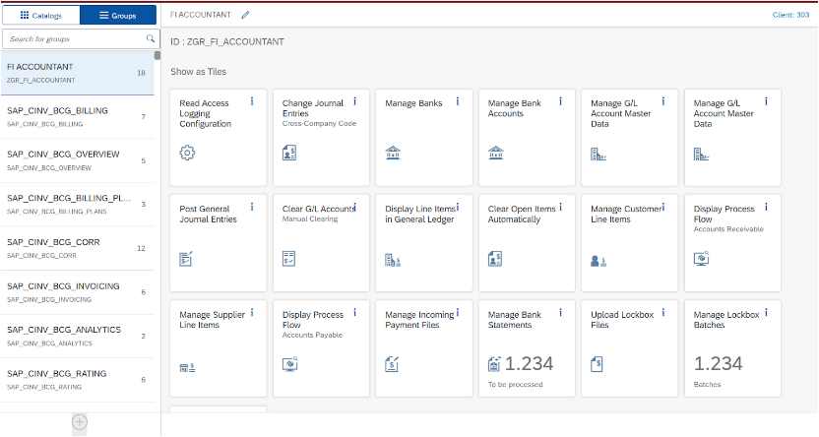

#### Create role for FI Role Settings

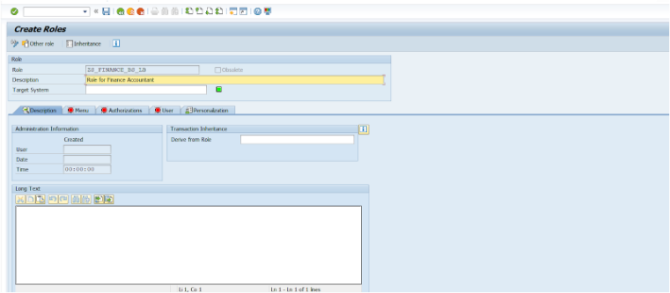

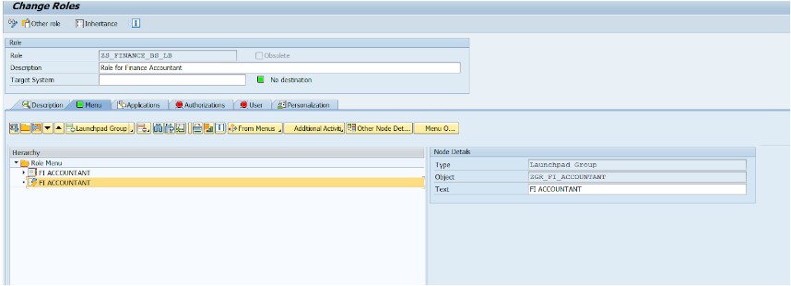

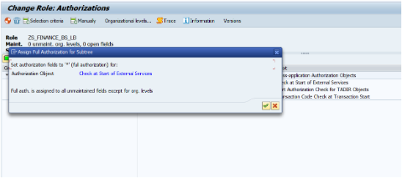

### 5.5 GL Role Settings in SAP

By logging into the GL Account, the GL Accountant will have access to several apps that are available just for them.

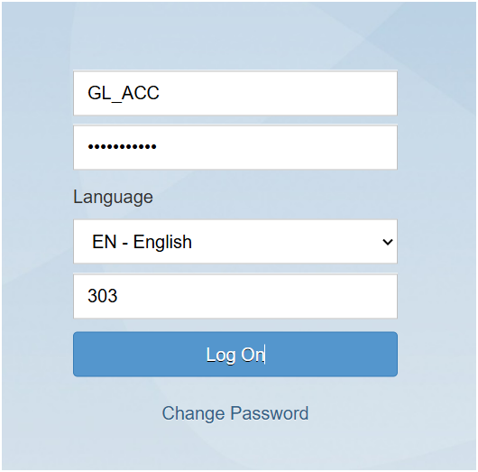

After logging in, the GL Accountant can see the page “GL Accountant” that has just been made for them with all of the necessary apps to work with the Fiori System.

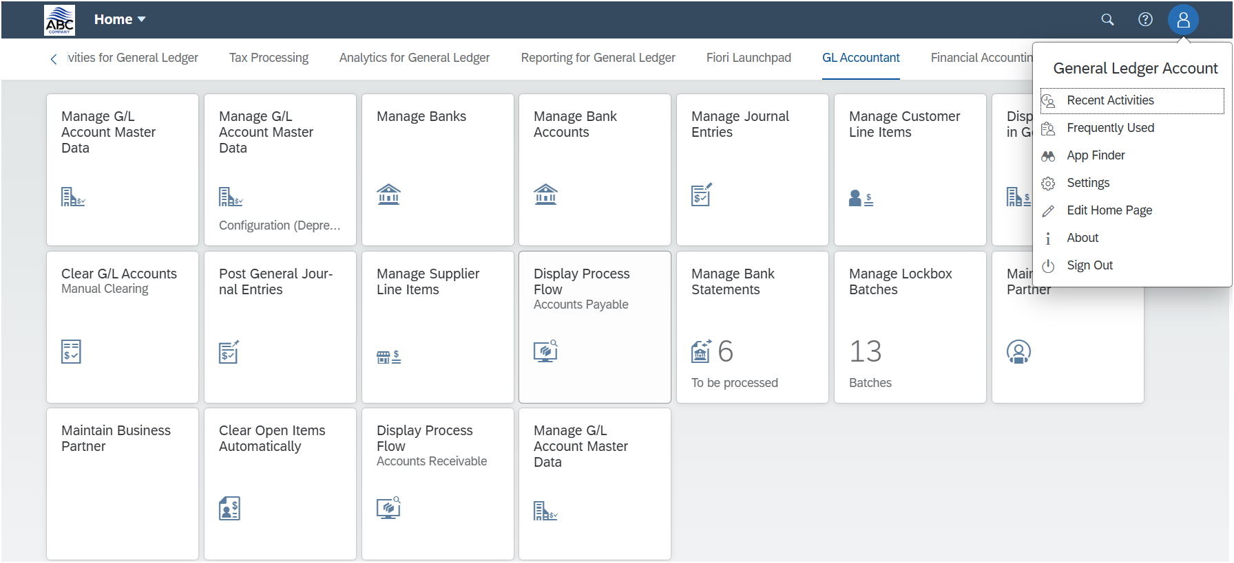

To make it possible for GL Accountant to get access to these apps, we have to do the following steps:

#### Create new catalog for GL Role Settings

#### 

#### 

#### Add all tiles for GL Role Settings

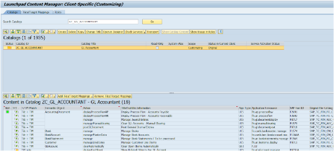

#### Add to group for GL Role Settings

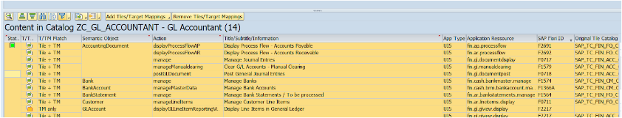

#### Create catalog apps based on roles for GL Role Settings

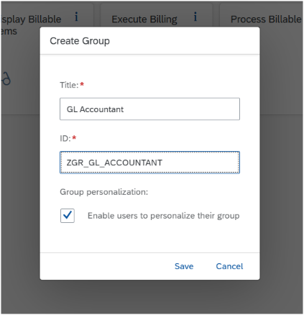

#### Add all relevant apps for GL Role Settings

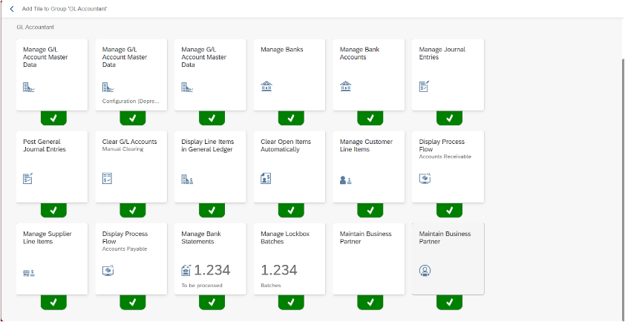



#### Create role for GL Role Settings

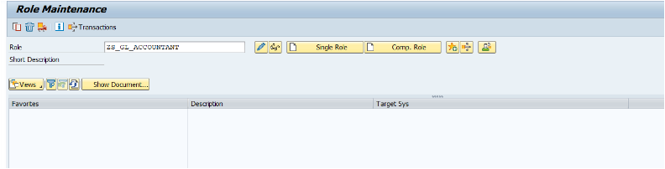

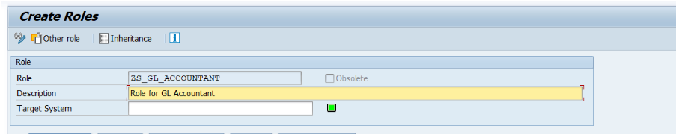

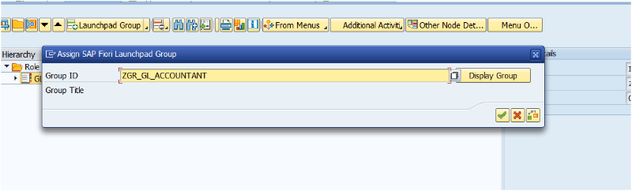

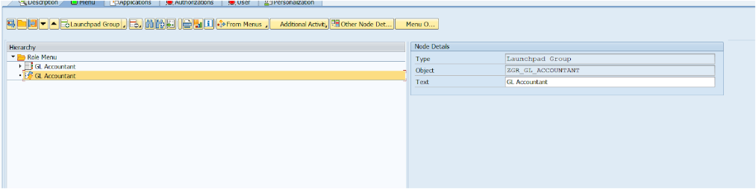

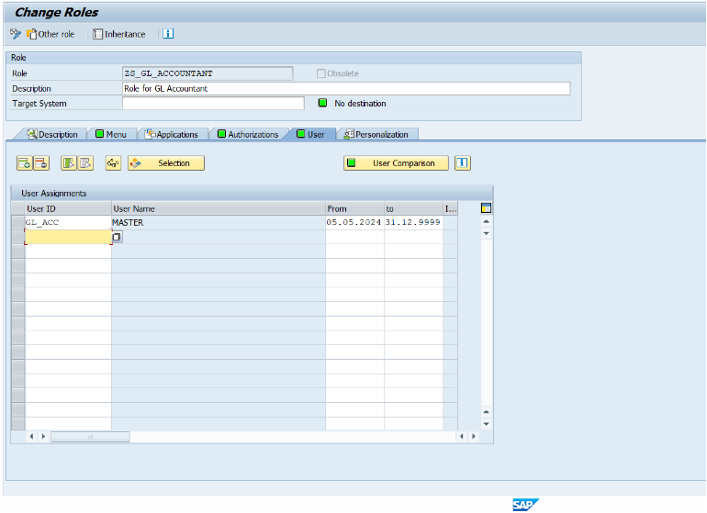

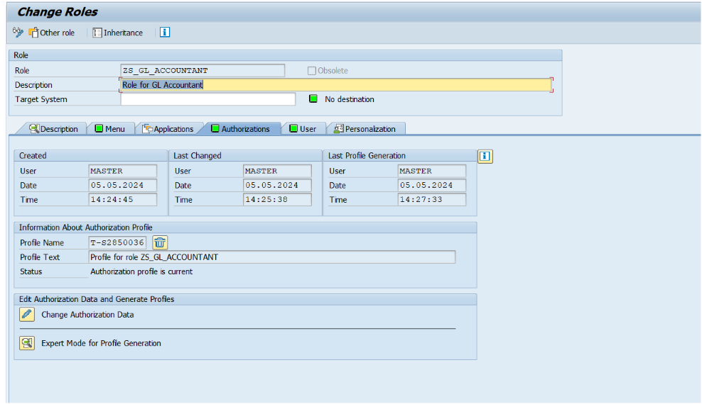

### 5.6 AP Role Settings in SAP

By logging into the AP Account, the AP Accountant will have access to several apps that are available just for them.

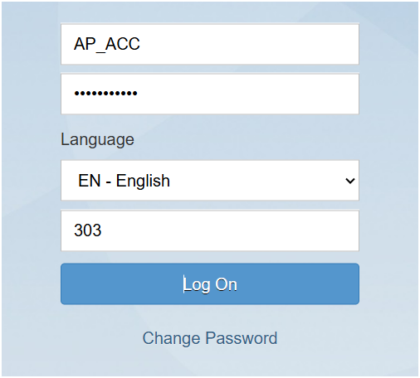

After logging in, the AP Accountant can see the page “AP Accountant” that has just been made for them with all of the necessary apps to work with the Fiori System.

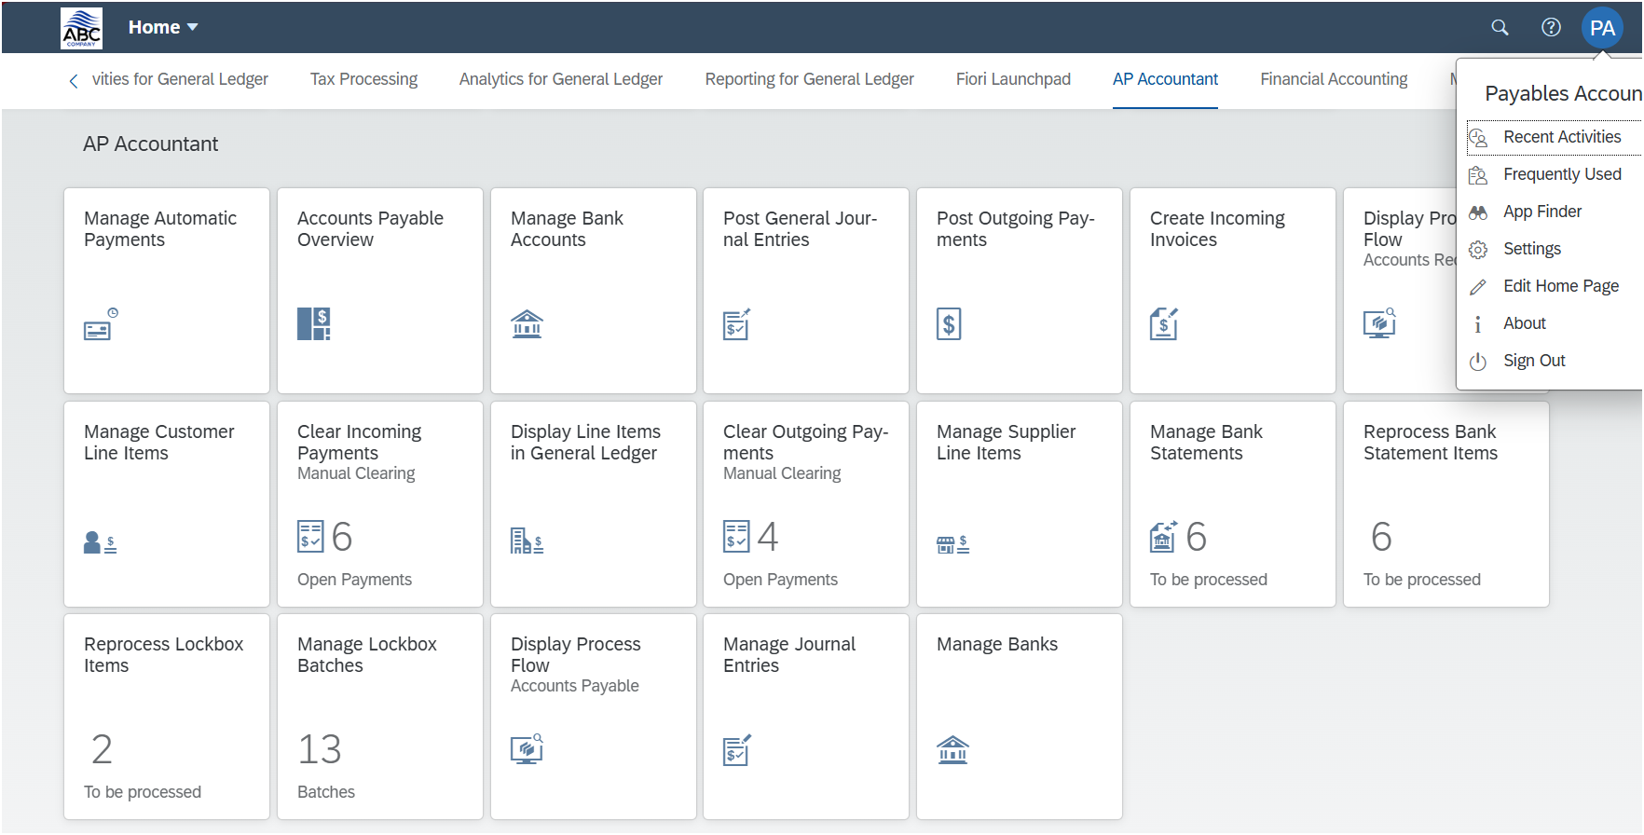

To make it possible for GL Accountant to get access to these apps, we have to do the following steps:

#### Create new catalog for AP Role Settings

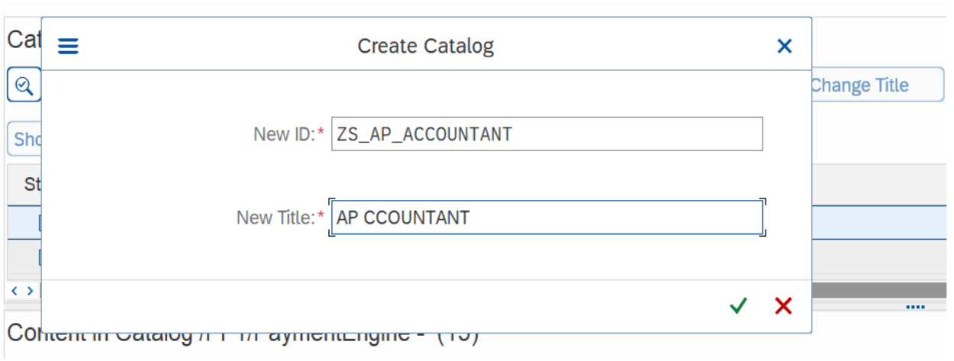

#### Add all tiles for AP Role Settings

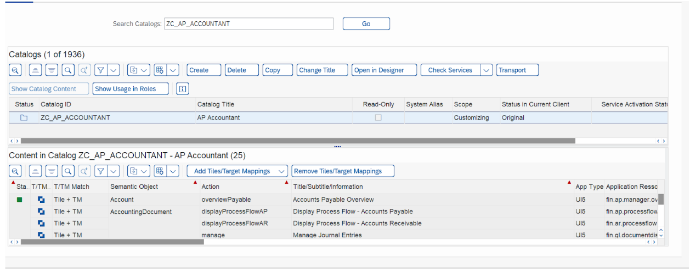

#### Add to group for AP Role Settings

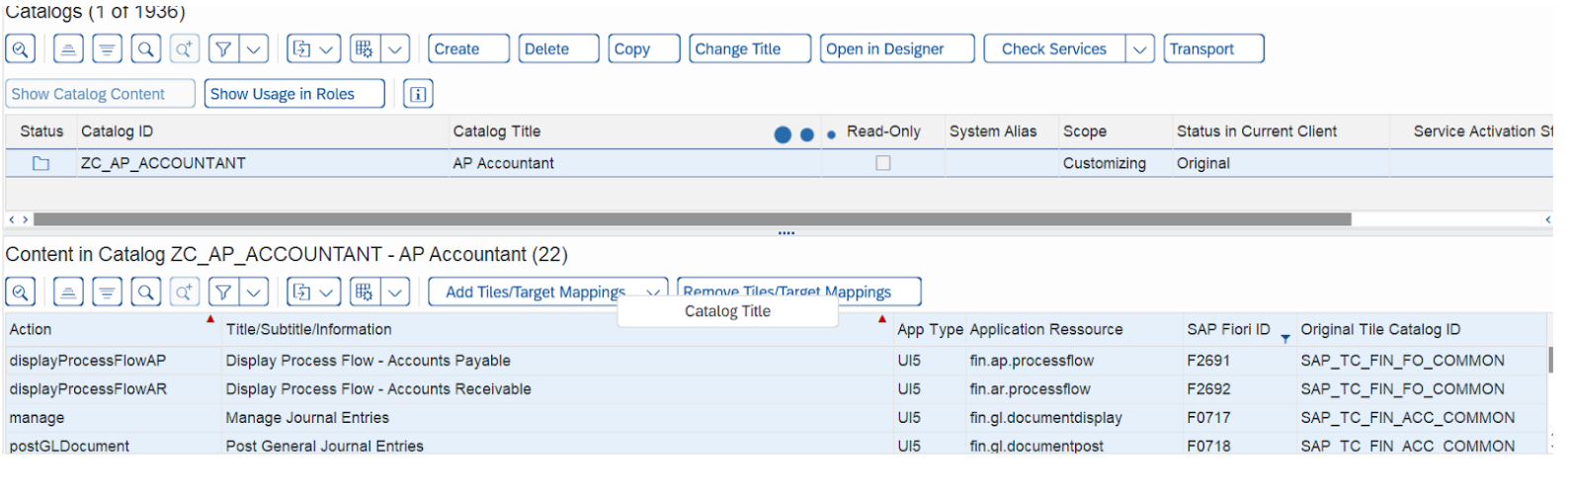

#### Create catalog apps based on roles for AP Role Settings

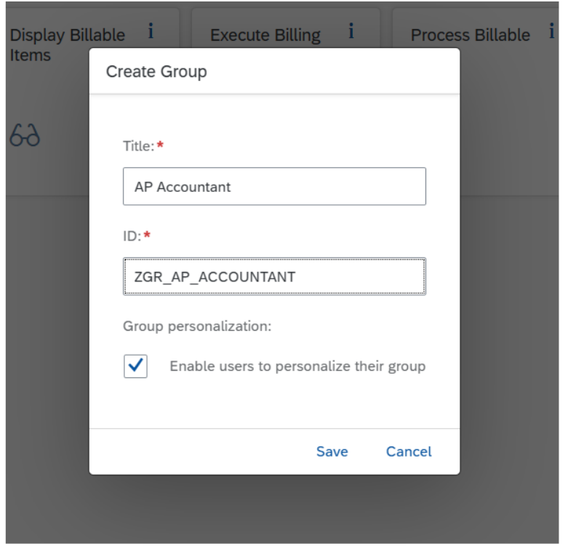

#### Add all relevant apps for AP Role Settings

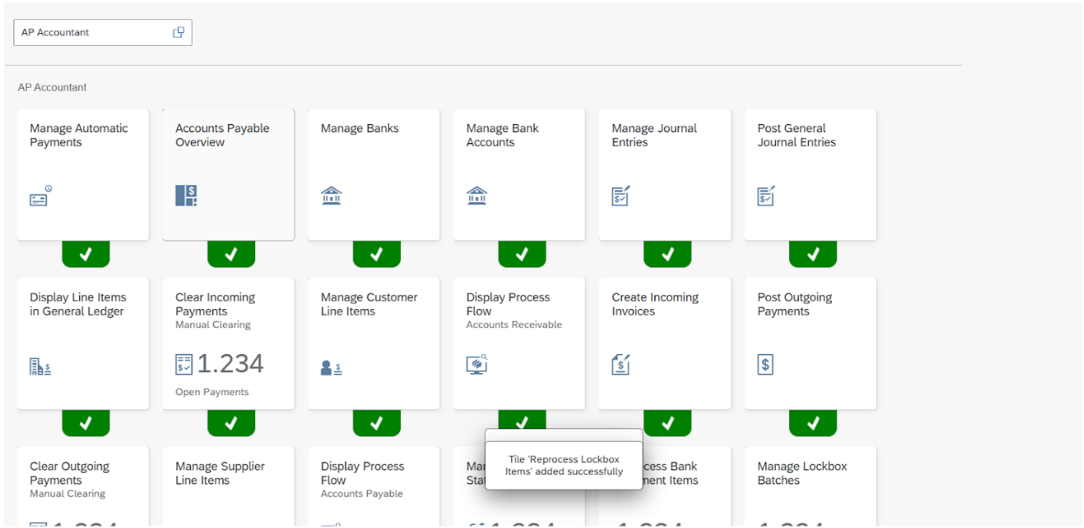

#### Create role for AP Role Settings

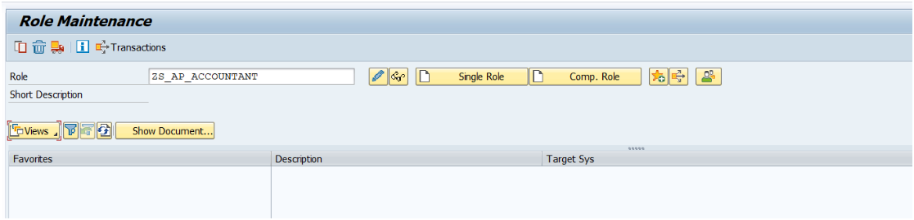

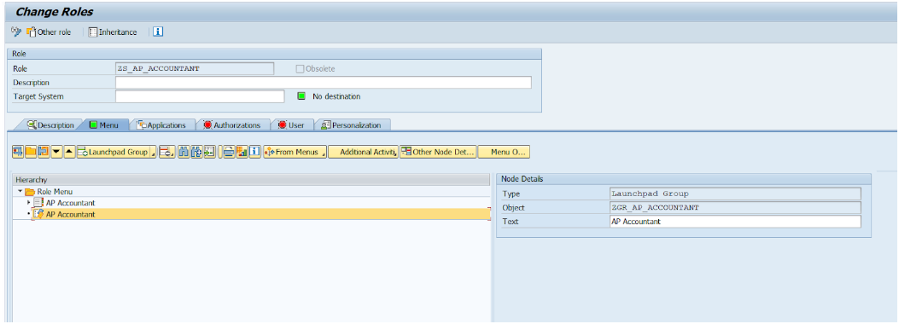

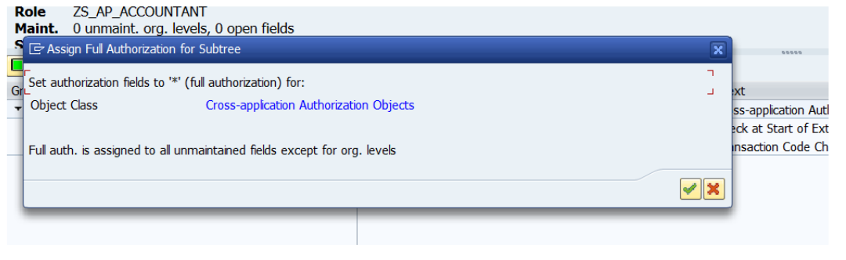

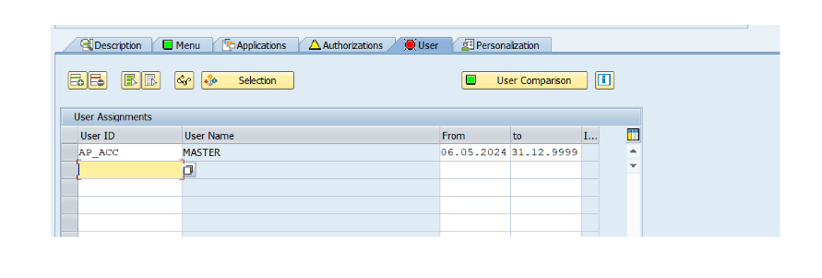

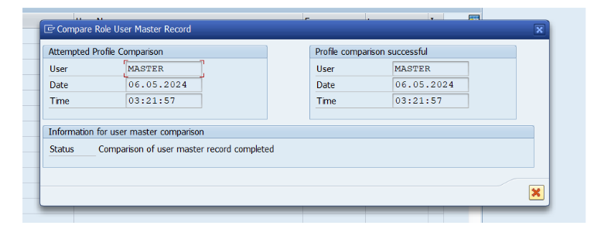

### 5.7 AR Role Settings in SAP

By logging into the AR Account, the AR Accountant will have access to several apps that are available just for them.

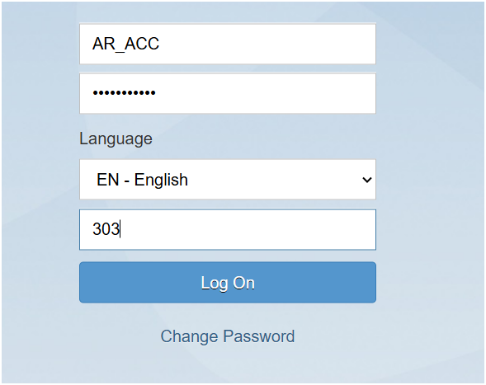

After logging in, the AR Accountant can see the page “AR Accountant” that has just been made for them with all of the necessary apps to work with the Fiori System.

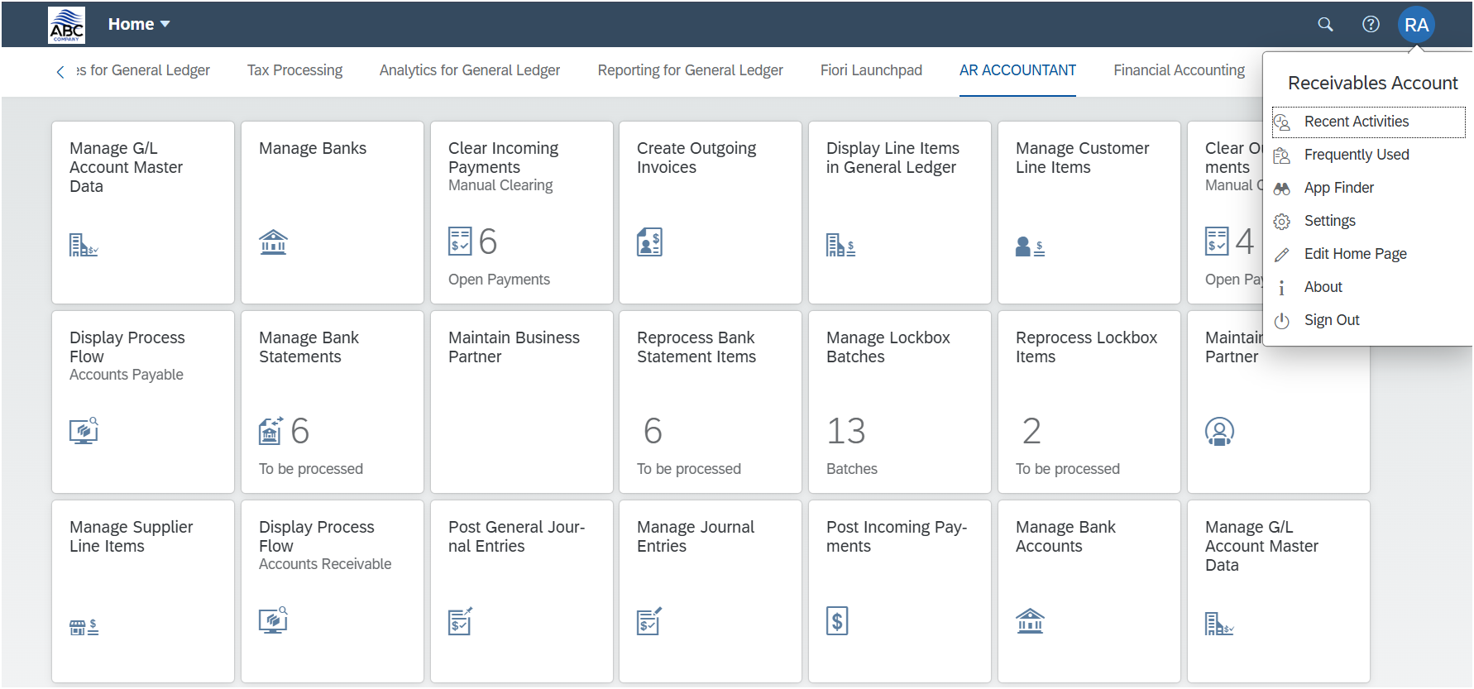

To make it possible for AR Accountant to get access to these apps, we have to do the following steps:

#### Create new catalog for AR Role Settings

#### 

#### Add all tiles for AR Role Settings

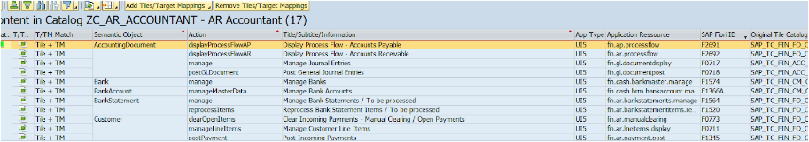

#### Add to group for AR Role Settings

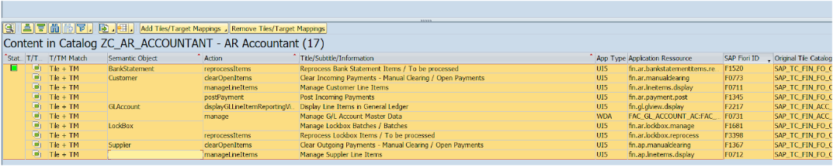

#### Create catalog apps based on roles for AR Role Settings

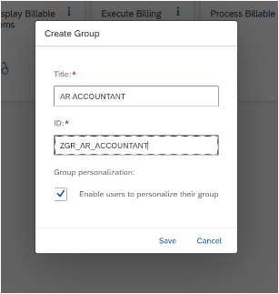

#### Add all relevant apps for AR Role Settings

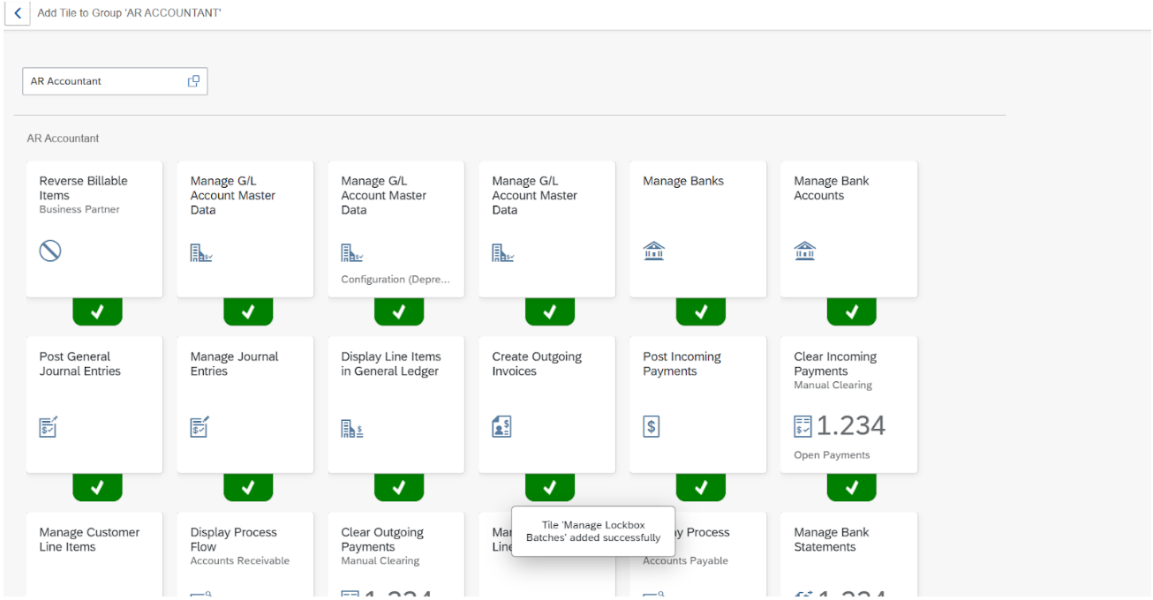

#### Create role for AR Role Settings

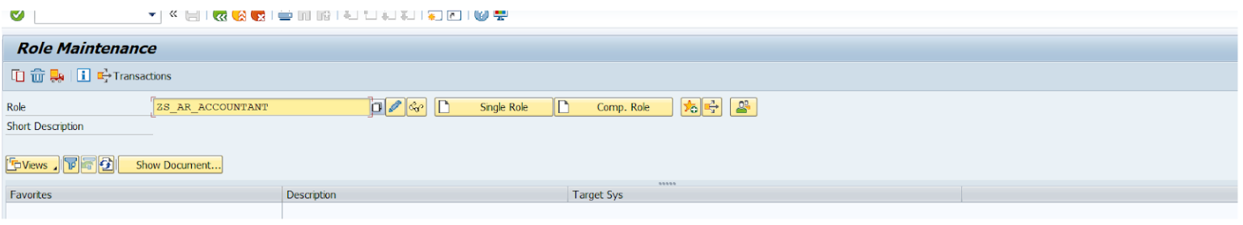

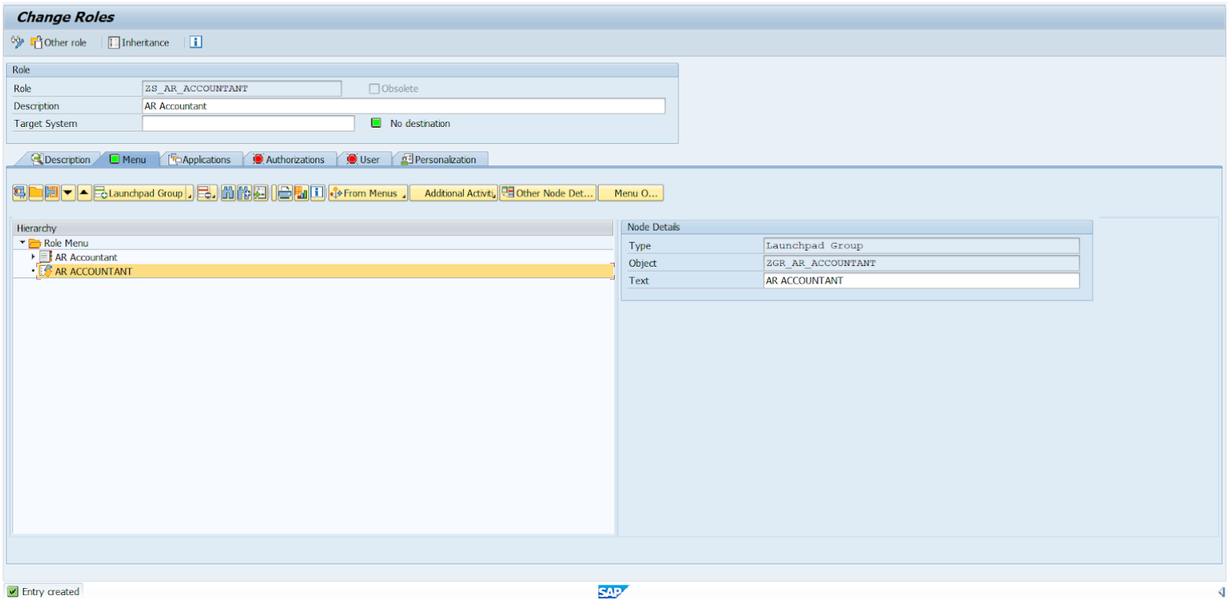

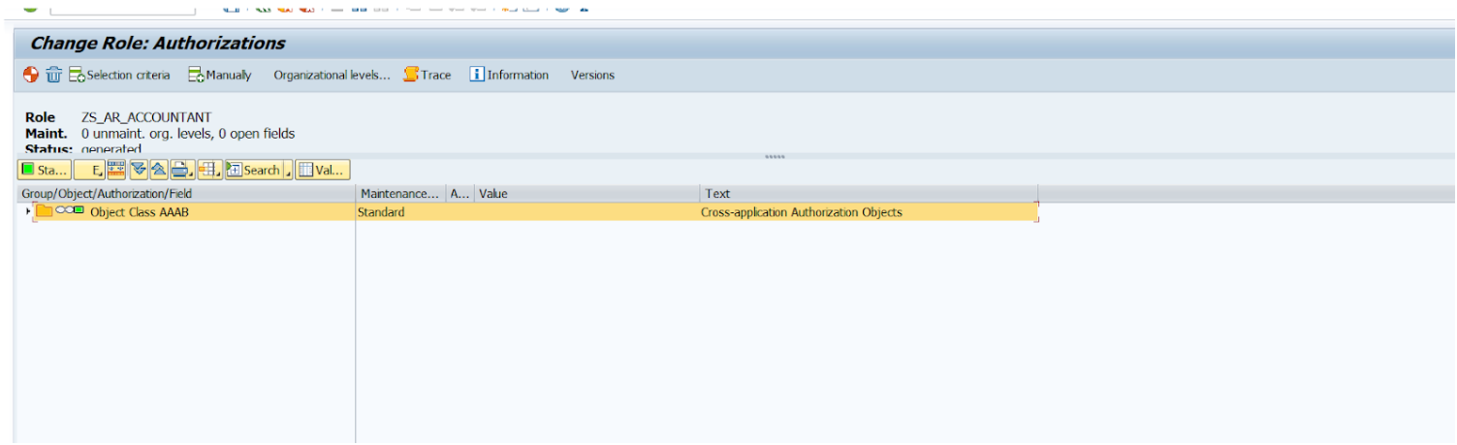

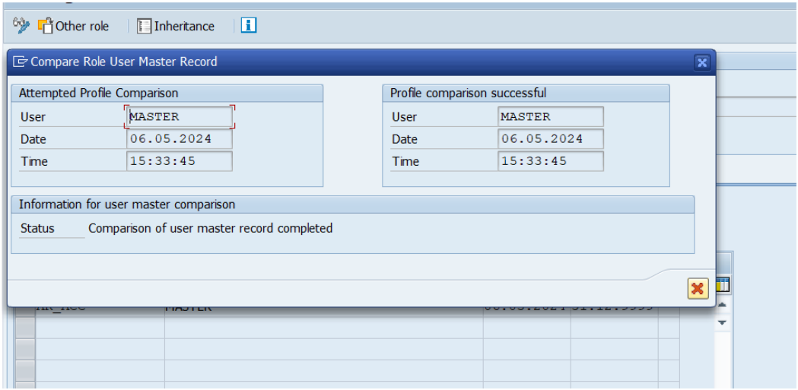

# III. Implementation & Testing

## 1. Implementation

### 1.1 SAP Process Execution

**Run Automatic Payments and Generate DMEE file**

AP Account would create an invoice with instruction key 1,2,3 or blank by using “ Create Incoming Invoice” application and then they go to “Manage Supplier Line Items” to check the status of invoice.

After double checking, the accountant has to create parameters of automatic payment in the “Manage Automatic Payment” application. After creating parameters successfully, they have to schedule and run it. The SAP system will generate a Payment Medium File. To check or download it, accountant uses “Manage Payment Media”

**Bank Statement related to Account Receivables**

First of all, Accountant uses AR Account to login into Fiori. Click onto “Create Outgoing Invoices” to create an AR invoice. Then check status in “Manage Customer Line Items”.

After receiving a bank statement file from the bank, the finance accountant imports the BS file into the SAP system and checks status (Success/Error). After that, move to “Manage Bank Statement” to check the status of BS (Complete/Not Complete). If it is not completed, the accountant will need to verify posted journal entries. Journal entries will be posted to two Ledgers (Bank Ledger and Subledger). If the statement is not complete, the accountant has to double check the information of Customer Document to reprocess BS in “Reprocess Bank Statement Items”.

When successful with reprocessing, the Accountant could double check the status BS in “Manage Bank Statement”.

Finally, they can check the status if it clearing or not in “Manage Customer Line Items”

**Bank Statement related to Account Payables**

After running automatic payment succesfully, The system would send a DMEE file to the Bank, and send back a bank statement. After that the finance accountant imports the BS file into the SAP system and checks status (Success/Error). After that, move to “Manage Bank Statement'' to check the status of BS (Complete/Not Complete). If the statement is not complete, the accountant has to double check the information of Customer Document to reprocess BS in “Reprocess Bank Statement Items”.

When successful with reprocessing, the Accountant could double check the status BS in “Manage Bank Statement''. Then they can check the status if it is cleared or not in “Manage Customer Line Items”.

**Bank Statement related to other processes (Bank charge, Direct expense)**

Upon importing a bank statement, additional transactions such as bank charges, direct debits, or inter-company transactions may be included. It is imperative for the General Ledger Accountant to verify the accuracy of the relevant journal entries against the Manage Bank Statement function. Most of these transactions are automatically posted, thereby eliminating the need for the Accountant to manually post them using the Reprocess Bank Statement Line Items feature.

**LockBox process**

The AR Accountant has to create a customer invoice by using “Create Outgoing Invoices”. Then use “Manage Customer Line Items” to check clearing status, document number,....

When they receive a Lockbox file from the bank, import it into the SAP system by using the “Upload Lockbox Files” application. Next step is checking complete status from “Manage Lockbox Batches” . If it is not completed, move to “Reprocess Lockbox Items”. After reprocessing, double check the status again and use “Manage Customer Line Items” to check clearing status.

**Cash in Bank Book Form process**

The Finance Accountant can use “Cash in Bank Book Form” application to save and print cash in bank detail form to trigger and follow up Accounting journal entries easily also can be used to make decisions about how to proceed with cash operation process

### 1.2 Installation Guides

The SAP ERP solution for Bank Statement and LockBox will be configured and deployed on cloud storage. ABC Company, in case of customization needs, can optimize the system using SAP GUI interface. Below are the instructions for SAP GUI installation:

**System Requirements**

* Operating System: Windows 7 or later
* Processor: Intel Pentium 4 or higher
* RAM: 2 GB or more
* Hard Disk Space: 500 MB for installation

**Steps to Install SAP GUI**

*1. Download SAP GUI Installer:*

* Visit the SAP Software Download Center website.
* Log in to your SAP account or create a new one if needed.
* Search for the SAP GUI software package suitable for your operating system (Windows).
* Download the SAP GUI installer file to your local system.

*2. Run SAP GUI Installer:*

* Locate the downloaded installer file "SAPGUI_XX_X_X.XXXX.XXX_XX_X_X.X_XX.XXX.exe”.
* Double-click on the installer file to start the installation process.

*3. Accept License Agreement:*

* Read and accept the SAP GUI End User License Agreement (EULA) presented during the installation process.
* Click "Next" to proceed.

*4. Choose Installation Options:*

* Select the installation type (Typical, Compact, or Custom).
* Choose the installation directory for SAP GUI or use the default directory.
* Click "Next" to continue.

*5. Install SAP GUI:*

* Review the summary of installation settings.
* Click "Install" to begin the installation process.

*6. Complete Installation:*

* Wait for the installation process to complete.
* Once the installation is finished, click "Finish" to exit the installer.

*7. Launch SAP GUI:*

* SAP GUI is now installed on your system.
* You can launch SAP GUI from the Start menu or desktop shortcut.
* Enter the SAP system connection details (e.g., server name, client, user ID, and password) to log in and access SAP applications.

**Additional Notes**

* Ensure that your system meets the minimum requirements specified above before proceeding with the installation.
* Make sure to have administrative privileges on your Windows system to install SAP GUI.
* It's recommended to close all other applications before starting the installation process to avoid potential conflicts.
* If you encounter any issues during the installation, refer to the SAP GUI installation documentation or seek assistance from your IT support team.

### 1.3 Installation Instruction

**Step 1:** Access SAP GUI setup file.

- Download the file from [here](https://drive.google.com/drive/folders/19X-6NbmF5tqcDRUnNMUIUCd6Dx8RgsYs?usp=sharing).  
- Unzip the file.  
- Find the path: **\GUI770forWindows\GUI\Windows\Win32**.  
- Locate the file **SetupAll.exe**.

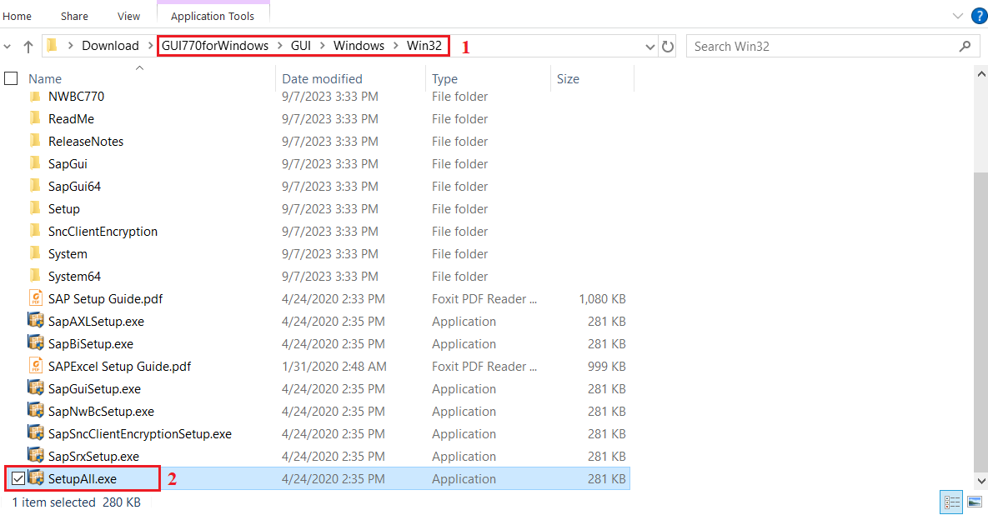

**Step 2:** Install SAP GUI 770.

- Double click on the file **SetupAll.exe**.  
- Click **Next**.

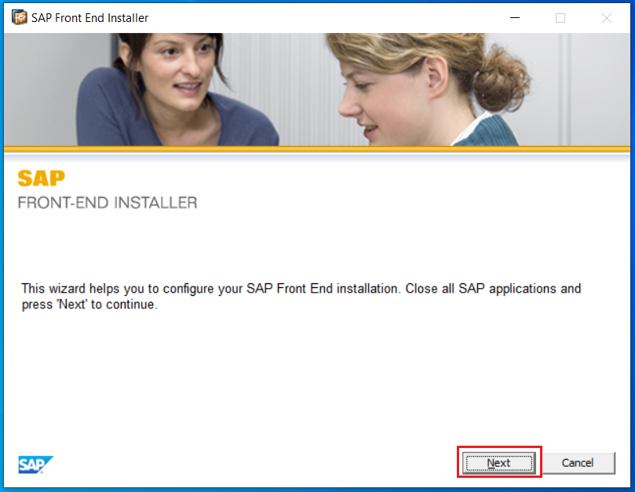

- Here, you have the flexibility to select for the most straightforward choice or select all available options to avoid concerns in the future.

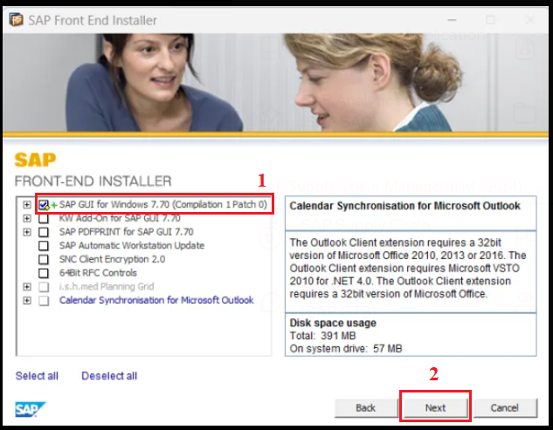

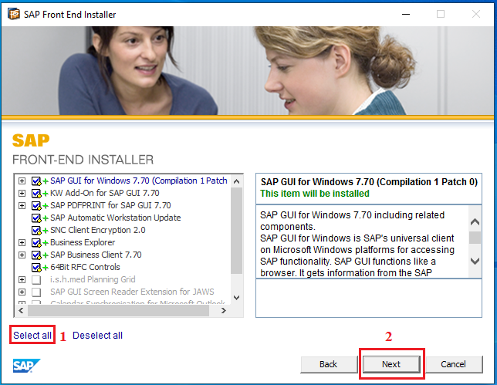

- Choose your path and click **Next**.

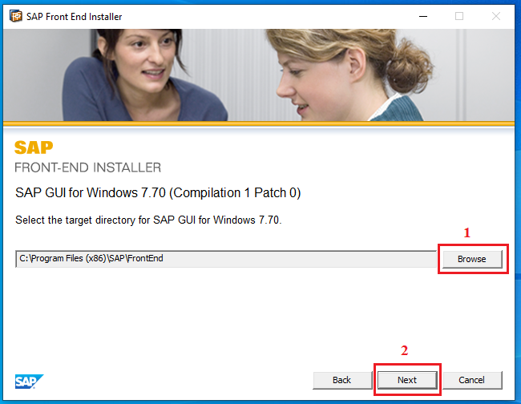

- Click **Close** to finish the installation.

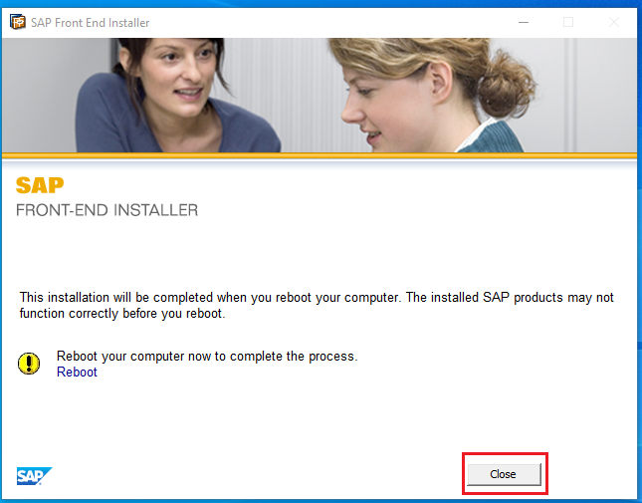

**Step 3:** Setup the connection

- Click on **SAP Logon.**



- Click on **Connection.**

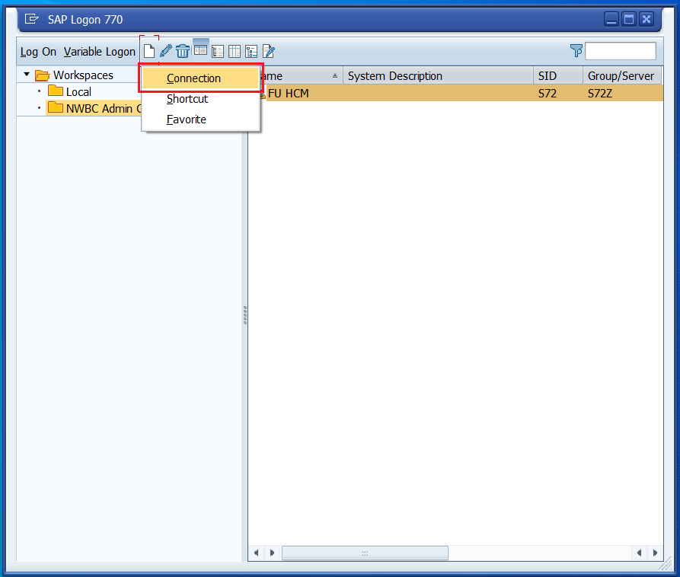

- Click **Next**.

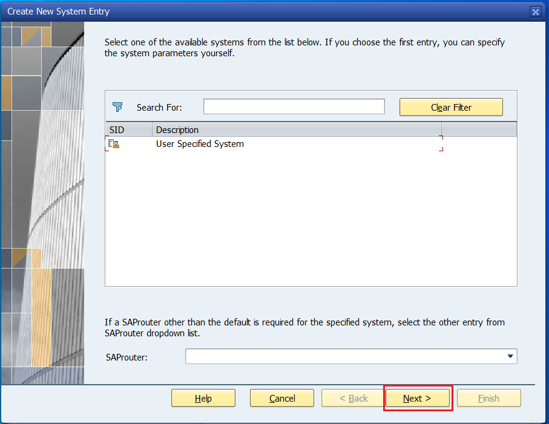

- Fill in the information below and click **Next**:

* Application Server: S72Z
* Instance Number: 00
* System ID: S72
* SAProuter String: /H/saprouter.hcc.in.tum.de/S/3298

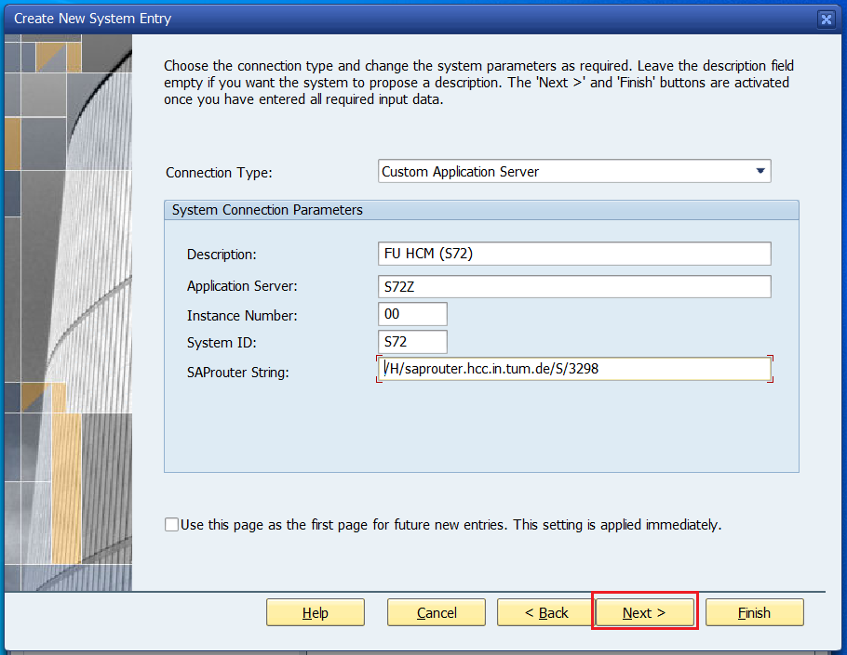

- Click on the system.

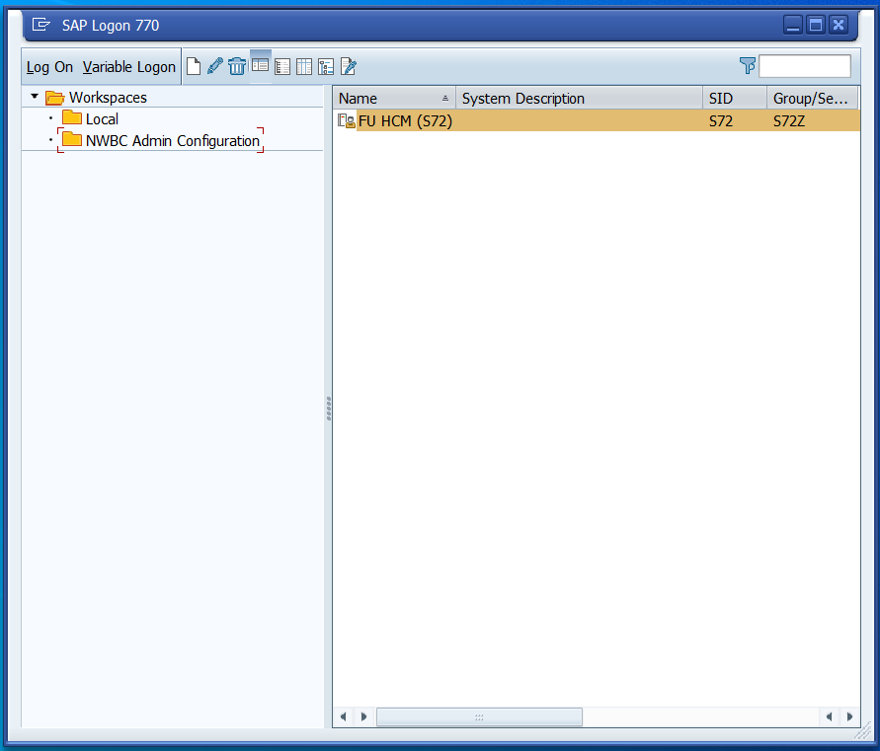

- Fill in the login information and press **Enter**.

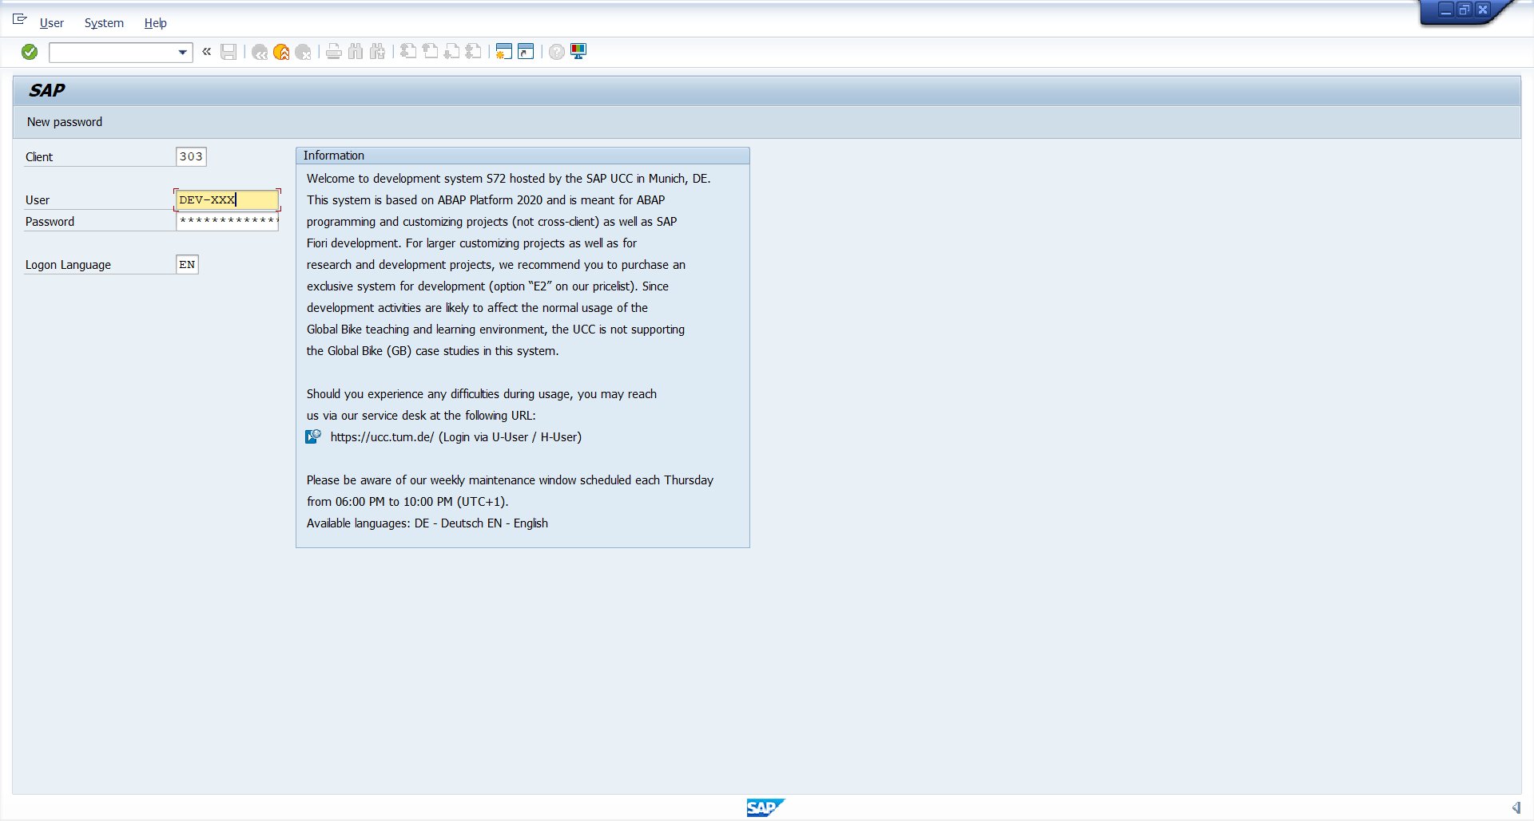

-

- After a successful installation this will be your window.

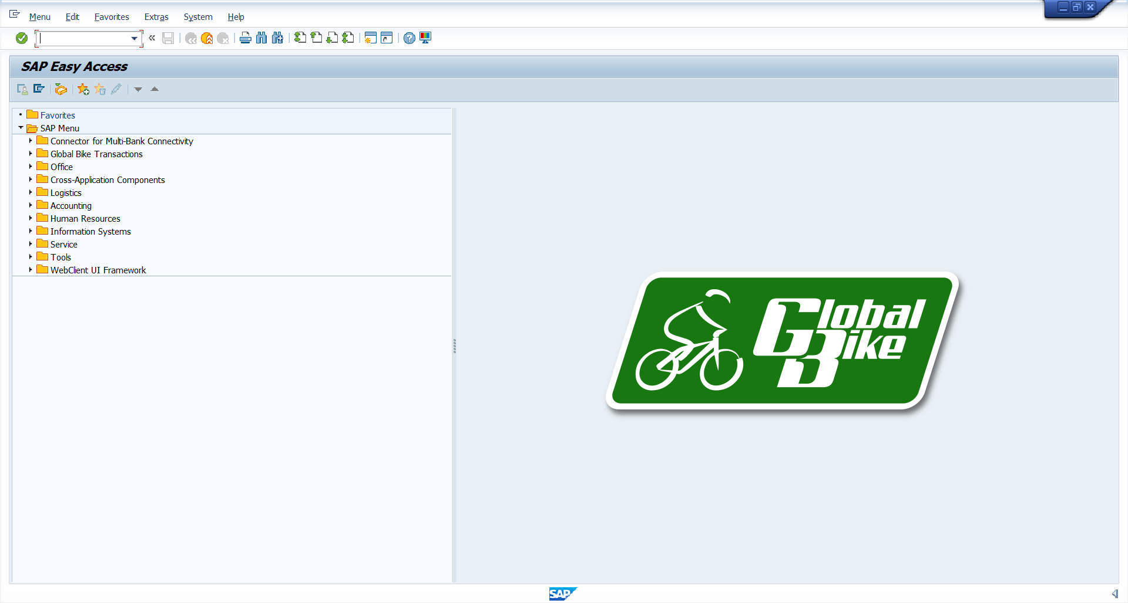

### 1.4 User Manual

SAP Fiori is a new user interface introduced by SAP. It is a major selling point behind SAP S/4 HANA and is supposed to provide a “delightful & seamless” experience for end users. Whether this statement accurately reflects the actual user experience is debatable and might be an interesting subject for a long discussion. But whether you like Fiori or not, you should get yourself familiarized with the latest features & functionalities provided by SAP. The purpose of this post is to provide an overview of the functionalities around import of bank statements via Fiori launchpad. I’ll describe baseline configuration for import of bank statements in S4 HANA & provide some additional technical details that might help you during troubleshooting of potential problems.

SAP provided a dedicated Fiori App F1680 “Manage Incoming Payment Files” for upload of various incoming payment files. This app can be used as a central access point to upload bank statements in various formats, lockbox batches, payment rejections, intraday statements, or payment files for Advanced Payment Management.

#### Workflow 1: Maintain Business Partner

**Purpose**: You can create, edit, and manage business partners, and integrate them with other functions.

**App Name**: Maintain Business Partner

**App ID:** BP

**Role:** AP Accountant, AR Accountant, FI Accountant, GL Accountant, Master

| **Explanation** | **Screenshot** |
| --- | --- |
| 1. In the homepage, click on the app **“Maintain Business Partner”** on the Page **“Group GSP24SA04 Apps”** |  |
| 2. Open the app **“Maintain Business Partner”** to show the fields to add.  Click **“Enter”** to show the results |  |
| 3. The results show up.  Click the **Partner number** to make changes. |  |
| 4. The relevant information shows up. |  |
| 5.You can make changes on the tab below |  |
| 6. Switch to the “**Payment Transactions**” tab to view Bank Details  Type ID, Country, Bank key and Bank account  Valid From: 01.01.2000  Valid To: 31.12.9999 |  |

#### Workflow 2: Create DMEE Files

**STEP 1: Create AP Invoice**

**Purpose**: Use this app to create supplier invoices or credit memos that have no purchase order in Financial Accounting. You can use it, for example, to create invoices or credit memos for utilities, office supplies, and so on.

**App Name**: Create Incoming Invoices

**App ID:** FB60

**Role:** AP Accountant, Master Account

| **Explanation** | **Screenshot** |
| --- | --- |
| 1. In the homepage, click on the app **“Create Incoming Invoices”** on the Page **“Group GSP24SA04 Apps”** |  |
| 2. Open the app **“Create Incoming Invoices”** to show the fields to add.  3. Add the field: **Vendor, Invoice date, Reference, Amount (USD)** and **Text**. |  |
| 3. Scroll down to add G/L account, Amount in doc curr., and Cost Center.  Click the **Magnifying Glass** to find the G/L Account |  |
| 4. Choose a **G/L account** and then click the **“Tick”** icon to confirm your G/L Account number. |  |
| 5. Scroll to the right tab and then choose your “**Amount in doc. Curr**’” number. |  |
| 6. Scroll to the right tab and then choose your “**Cost Center**’” . |  |
| 7. Switch to the **“Payment”** tab and update **Payment Terms, House Bank, etc,...**  **House Bank:** Representation as a bank account at a bank.  **Payment Terms:** Determine the due date and discount calculation  **Payment Method:** Specifies the procedure, such as check, transfer or bill of exchange, by which payments are made.  **Instructions:** Show information in DMEE file and determination vendor payment type  **Non-Instruction key:** Employees salary payment  **Instruction key 1:** Money share (SHAR)  **Instruction key 2:** Vendor Charge (CRED)  **Instruction key 3:** Company Charge (DEBT) |  |
| 8. Click the **“Post”** button on the bottom after finishing all the fields below. |  |
| 7. The **Document Number** shows up, note this number for later use. |  |

**STEP 2: Manage Supplier Line Items**

**Purpose**: You can use this app for ad-hoc requests or recurring reports to easily find supplier line items using a wide range of search criteria. For example, you can see all line items of a supplier account or all open supplier invoices for a company code that are overdue at a key date.

To make your work more efficient, you can personalize the layout of the table, predefine recurring queries, and save your settings as variants.

In addition to displaying data, you can also take various actions such as setting a payment block or creating a manual payment. You can export the data to a file and send it to a colleague. The app also serves as a navigation target from other apps, allowing users to drill down into the supplier line items.

**App Name**: Manage Supplier Line Items

**App ID**: F0712

**Role:** AR Accountant, GL Accountant, AP Accountant, FI Accountant, Master Account

| **Explanation** | **Screenshot** |
| --- | --- |
| 1. In the homepage, click on the app **“Manage Supplier Line Items”** on the Page **“Group GSP24SA04 Apps”** |  |
| 2. Open the app and find its relevant information.  Type in the Customer code and click **“Go”** |  |
| 3. The list of Customer Line Items show up, you can check for its information like: **Vendor code, Company, Journal Entry, etc,...** |  |
| 4. Click **“Edit Line Items”** if you want to edit a specific line items |  |
| 5. Edit and update the Line Item, then click **“OK”** to confirm your update. |  |
| 6. Or you can click on the **Vendor code** for showing options in a menu bar. |  |

**STEP 3: Create Automatic Payment**

**Purpose**: With this app you can schedule payment proposals or schedule payments directly and get an overview of the proposal or payment status. The app identifies the overdue invoices and checks whether all the required payment information is complete.

**App Name**: Manage Automatic Payments

**App ID:**  F0770

**Role:** AP Accountant, FI Accountant

| **Explanation** | **Screenshot** |
| --- | --- |
| 1. In the homepage, click on the app **“Manage Automatic Payments”** on the Page **“Group GSP24SA04 Apps”** |  |
| 2. Open the app **“Manage Automatic Payments”** to show the fields to add.  Click the Create Parameter |  |
| 3. The table of new parameters shows up. Type run date and Identification. Then click Create |  |
| 4. In payment controls, Type your Company Code and Next Payment Date also Payment Method.  In Open Item Selection, put your supplier that you have created in the Vendor invoice.  Addition Log: Yes  Last one, click on Save |  |
| 5. Parameter created. You can double check to confirm the information. After that, click on Schedule and choose Proposal |  |
| 6. The Schedule Proposal table shows up. Click on Schedule |  |
| 7. Press Go to show up all Proposals Processed |  |
| 8. Click the **“>”** button to show more details for a specific items |  |
| 9. In the Revise Payment Proposals screen. You can double check your payment amount and Document Number. Then press **“<”** |  |
| 10. Select the proposal and click on Schedule Payment |  |
| 11. The Schedule Payment table shows up. Click on Schedule |  |
| 12. Now, your payment has been processed. Click **“>”** to view detail |  |
| 13. Click on Payment Media icon to view Payment Files |  |
| 14. In Manage Payment Media screen. Marked the box and click Download to download Payment Media Files |  |
| 15. File name and format  :10: Payment type  :60: Instruction key |  |

**STEP 4: Check DMEE files**

**Purpose**: With the transactional app Manage Payment Media, you can transfer the data required for electronic payment transactions to banks via a data medium. A payment medium is created with each successful payment run.

**Key Features**

* View existing payment media with processing status
* Download payment media
* Delete payment media
* Display and analyze payment summary information that corresponds to data media

**App Name**: Manage Payment Media

**App ID:**  F1868

**Role:** AP Accountant

| **Explanation** | **Screenshot** |
| --- | --- |
| 1. In the homepage, click on the app **“Manage Payment Media”** on the Page **“Group GSP24SA04 Apps”** |  |
| 2. Open the app **“Manage Payment Media”** to show the fields to add.  Type in Company Code in the **“Paying Company Code”** section, choose the appropriate **“Run Date”** and then click **“Go”** |  |
| 3. The results show up. Here, you can find the Reference Number, Payment Method, etc,... |  |
| 4. Click the **“>”** button to show more details for a specific items |  |
| 5. The screen of a specific payment file shows the details of **Payment Doc Number, Supplier, etc,...** |  |
| 6. You can click “Download” button to download the form Payment Media .txt file |  |
| 7. The file is downloaded with its relevant information. |  |

#### Workflow 3: Bank Statement

**STEP 1: Create AR Invoice**

**Purpose**: This app is a SAP GUI for HTML transactions. These classic transactions are available in the SAP Fiori theme to support a seamless user experience across the SAP Fiori launchpad and to provide a harmonized user experience across on-premise and cloud solutions.

The single point of entry for SAP Fiori apps and classic applications in SAP S/4HANA Cloud Private Edition and SAP S/4HANA is the SAP Fiori launchpad.

**App Name**: Create Outgoing Invoices

**App ID:** FB70

**Role:** AR Accountant

| **Explanation** | **Screenshot** |
| --- | --- |
| 1. In the homepage, click on the app **“Create Outgoing Invoices”** on the Page **“Group GSP24SA04 Apps”** |  |
| 2. Open the app **“Create Outgoing Invoices”** to show the fields to add. |  |
| 3. Add the field: **Customer, Invoice date, Reference, Amount (USD)** and **Text**. |  |
| 3. Scroll down to add G/L account, Amount in doc curr., and Cost Center.  Click the **Magnifying Glass** to find the G/L Account |  |
| 5. Choose a G**/L account** and then click the **“Tick”** icon to confirm your G/L Account number. |  |
| 5. Scroll to the right tab and then choose your “**Amount in doc. Curr**’” number. |  |
| 6. Scroll to the right tab and then choose your “**Cost Center**’” . |  |
| 7. Click the **“Post”** button on the bottom after finishing all the fields below. |  |
| 8. The **Document Number** shows up, note this number for later use. |  |

**STEP 2: Manage Customer Line Items**

**Purpose**: You can use this app for ad-hoc requests or recurring reports to easily find customer line items using a wide range of search criteria. For example, you can see all line items of a specific customer account or all unallocated payments for a specific company code at the end of a period.

To make your work more efficient, you can personalize the layout of the table, predefine recurring queries, and save your settings as variants.

In addition to displaying data, you can also take various actions such as setting a payment or dunning block. You can export the data to a file and collaborate with colleagues. The app also serves as a navigation target from other apps, allowing users to drill down into the customer line items.

**App Name**: Manage Customer Line Items

**App ID:** F0711

**Role:** AR Accountant, AP Accountant, GL Accountant, FI Accountant, Master Account

| **Explanation** | **Screenshot** |
| --- | --- |
| 1. In the homepage, click on the app **“Manage Customer Line Items”** on the Page **“Group GSP24SA04 Apps”** |  |
| 2. Open the app **“Manage Customer Line Items”** to show the fields to add. |  |
| 3. Type in the **Customer code** and click **“Go”** |  |
| 4. The list of Customer Line Items show up, you can check for the Customer code, company code, journal entry, etc,...  Users can display journal entries by clicking on Document Number.    Open items are the incomplete transaction such as invoice that has not been paid transaction such as invoice that has not been paid. |  |
| 5. You can check for multiple apps in the menu or click on the Customer code to view more information. |  |
| 5. The customer page shows up for more information. |  |
| 6. Scroll down to view the Bank Account and the Bank Key. |  |

**STEP 3: Import Bank Statement**

**Purpose**: You can use this app to import electronic payment files, such as bank statements, payment rejections, intraday bank statements, lockbox batches, and payment files for Advanced Payment Management.

**App Name**: Manage Incoming Payment Files

**App ID:** F1680

**Role:** FI Accountant, Master Account.

| **Explanation** | **Screenshot** |
| --- | --- |
| 1. In the homepage, click on the app **“Manage Incoming Payment Files”** on the Page **“Group GSP24SA04 Apps”** |  |
| 2.Open the “Manage Incoming Payment Files” app and find the screen. |  |
| 3. Press “Import” button to initiate the import of the incoming file  Note: this post is based on the App version 9.0.3. |  |
| 4. The App will ask you to select the type of the incoming file that should be uploaded. In this case, the selection is straightforward – we select the option “Bank statement” |  |
| 5. Click **add** or **drag** the to import the new Bank Statement file |  |
| 6. Press the “Process” button and confirm the information message in a pop-up. |  |
| 7. This message provides the ID of the incoming payment file. Continue to click **“OK”** |  |
| 8. Refresh the page to see the results of the upload. |  |
| 9. Double click on the line to review the results of the upload. This menu provides high level details about the number of the files uploaded, the name of the files and who imported the file. |  |
| 10. You can review the upload log to see all messages associated with the action e.g., error messages, dumps, authorization issues etc. |  |

**STEP 4: Check Bank Statement**

**Purpose**: Use this app to manage manual and electronic bank statements. The app provides an overview of all bank statements for all house bank accounts. You can also view detailed information for each bank statement.

**App Name**: Manage Bank Statement

**App ID:** F1564.

**Role:** AR Accountant, GL Accountant, AP Accountant, FI Accountant, Master Account

| **Explanation** | **Screenshot** |
| --- | --- |
| 1. In the homepage, click on the app **“Manage Bank Statements”** on the Page **“Group GSP24SA04 Apps”** |  |
| 2. You can easily view a list of imported bank statements and check their processing status. |  |
| 3. Choose the Bank Statement for a clearer details |  |
| 4. You can see details about the status, amount,… |  |
| 5. Click the **“>”** icon to display documents |  |
| 6. The detailed document number of **Bank Ledger Doc. No.** and **Subledger Doc. No.** show up |  |
| 7. Click **Bank Ledger Doc. No.** to view more information |  |
| 8. Click **Subledger Doc. No.** to view more information |  |

**STEP 5: Reprocess Bank Statement (If needed)**

**Purpose**: Use this app to reprocess bank statement items that the system cannot automatically post and clear.

Bank statements can be entered into the system automatically (electronic bank statement) or manually. In both cases, rule-based processing assigns and clears the payments automatically. If the automatic processing is not successful, manual reprocessing is required. In this app, you can reprocess a bank statement item, mark it as reprocessed, and enter a reason for reprocessing. You can also add attachments to bank statement items.

**App Name**: Reprocess Bank Statement Items

**App ID:** F1520

**Role:** AR Accountant, AP Accountant, FI Accountant, Master Data

| **Explanation** | **Screenshot** |
| --- | --- |
| 1. In the homepage, click on the app **“Manage Bank Statements”** on the Page **“Group GSP24SA04 Apps”** to check Statement Status is not completed or Complete and click **“>”** to display document |  |
| 2. In the homepage, click on the app **“Reprocess Bank Statement Items”** on the Page **“Group GSP24SA04 Apps”** |  |
| 2. Open the app **“Reprocess Bank Statement Items”** to show the fields. |  |
| 3. Click on the Bank Statement item you want to reprocess then click **“>”** |  |
| 4. The Open Items page shows up, click the button **“Clear”** to clear the item. |  |
| 5. Click on Post to confirm |  |
| 5. A notification showed up. Then click on Display document |  |
| 6. Back to Manage Bank Statements app to check Status |  |

**STEP 6.1: Display Line Items**

**Purpose**: The "Display Line Items in General Ledger" app in SAP Fiori offers users a detailed view of individual financial transactions recorded in the General Ledger. It allows users to access and analyze transaction details, ensuring financial accuracy and transparency. This app supports the verification and auditing of financial data, aids in the preparation of financial reports and in-depth analysis, and enhances decision-making by providing necessary information for informed financial decisions.

**App Name**: Display Line Items In General Ledger

**App ID:** F2217

**Role:** AR Accountant, AP Accountant, GL Accountant, FI Accountant, Master Account

| **Explanation** | **Screenshot** |
| --- | --- |
| 1. In the homepage, click on the app **“Display Line Items In General Ledger”** on the Page **“Group GSP24SA04 Apps”** |  |
| 2. In Display Line items In General Ledger, enter your Company Code, G/L Account, Status,... and press **GO** |  |
| 3. Find your G/L you want to see and click on **“>”** |  |
| 4. The list of Journal Entries show up with close and open items |  |

**STEP 6.2: Manage Customer Line Items**

**Purpose**: You can use this app for ad-hoc requests or recurring reports to easily find customer line items using a wide range of search criteria. For example, you can see all line items of a specific customer account or all unallocated payments for a specific company code at the end of a period.

To make your work more efficient, you can personalize the layout of the table, predefine recurring queries, and save your settings as variants.

In addition to displaying data, you can also take various actions such as setting a payment or dunning block. You can export the data to a file and collaborate with colleagues. The app also serves as a navigation target from other apps, allowing users to drill down into the customer line items.

**App Name**: Manage Customer Line Items

**App ID:** F0711

**Role:** AR Accountant, AP Accountant, GL Accountant, FI Accountant, Master Account

| **Explanation** | **Screenshot** |
| --- | --- |
| 1. In the homepage, click on the app **“Manage Customer Line Items”** on the Page **“Group GSP24SA04 Apps”** |  |
| 2. Open the app **“Manage Customer Line Items”** to show the fields to add. |  |
| 3. Type in the **Customer code** and click **“Go”** |  |
| 4. The list of Customer Line Items show up, you can check for the Customer code, company code, journal entry, etc,...  Users can display journal entries by clicking on Document Number.    Open items are the incomplete transaction such as invoice that has not been paid transaction such as invoice that has not been paid. |  |
| 5. You can check for multiple apps in the menu or click on the Customer code to view more information. |  |
| 5. The customer page shows up for more information. |  |
| 6. Scroll down to view the Bank Account and the Bank Key. |  |

#### Workflow 4: Lockbox

**STEP 1: Create AR Invoice**

**Purpose**: This app is a SAP GUI for HTML transactions. These classic transactions are available in the SAP Fiori theme to support a seamless user experience across the SAP Fiori launchpad and to provide a harmonized user experience across on-premise and cloud solutions.

The single point of entry for SAP Fiori apps and classic applications in SAP S/4HANA Cloud Private Edition and SAP S/4HANA is the SAP Fiori launchpad.

**App Name**: Create Outgoing Invoices

**App ID:** FB70

**Role:** AR Accountant

| **Explanation** | **Screenshot** |
| --- | --- |
| 1. In the homepage, click on the app **“Create Outgoing Invoices”** on the Page **“Group GSP24SA04 Apps”** |  |
| 2. Open the app **“Create Outgoing Invoices”** to show the fields to add. |  |
| 3. Add the field: **Customer, Invoice date, Reference, Amount (USD)** and **Text**. |  |
| 3. Scroll down to add G/L account, Amount in doc curr., and Cost Center.  Click the **Magnifying Glass** to find the G/L Account |  |
| 5. Choose a G**/L account** and then click the **“Tick”** icon to confirm your G/L Account number. |  |
| 5. Scroll to the right tab and then choose your “**Amount in doc. Curr**’” number. |  |
| 6. Scroll to the right tab and then choose your “**Cost Center**’” . |  |
| 7. Click the **“Post”** button on the bottom after finishing all the fields below. |  |
| 8. The **Document Number** shows up, note this number for later use. |  |

**STEP 2: Manage Customer Line Items**

**Purpose**: You can use this app for ad-hoc requests or recurring reports to easily find customer line items using a wide range of search criteria. For example, you can see all line items of a specific customer account or all unallocated payments for a specific company code at the end of a period.

To make your work more efficient, you can personalize the layout of the table, predefine recurring queries, and save your settings as variants.

In addition to displaying data, you can also take various actions such as setting a payment or dunning block. You can export the data to a file and collaborate with colleagues. The app also serves as a navigation target from other apps, allowing users to drill down into the customer line items.

**App Name**: Manage Customer Line Items

**App ID:** F0711

**Role:** AR Accountant, AP Accountant, GL Accountant, FI Accountant, Master Account

| **Explanation** | **Screenshot** |
| --- | --- |
| 1. In the homepage, click on the app **“Manage Customer Line Items”** on the Page **“Group GSP24SA04 Apps”** |  |
| 2. Open the app **“Manage Customer Line Items”** to show the fields to add. |  |
| 3. Type in the **Customer code** and click **“Go”** |  |
| 4. The list of Customer Line Items show up, you can check for the Customer code, company code, journal entry, etc,...  Users can display journal entries by clicking on Document Number.    Open items are the incomplete transaction such as invoice that has not been paid transaction such as invoice that has not been paid. |  |
| 5. You can check for multiple apps in the menu or click on the Customer code to view more information. |  |
| 5. The customer page shows up for more information. |  |
| 6. Scroll down to view the Bank Account and the Bank Key. |  |

**STEP 3: Upload Lockbox Files**

**Purpose**: For uploading the LockBox file into the SAP System

**App Name**: Upload LockBox Files

**App ID:** FLB2.

**Role:** FI Accountant, Master Account

| **Explanation** | **Screenshot** |
| --- | --- |
| 1. In the homepage, click on the app **“Upload LockBox files”** on the Page **“Group GSP24SA04 Apps”** |  |
| 2. The **Main LockBox Program screen** for the “**Upload LockBox files**” app shows up as below: |  |
| 3. Click on “LockBox file” to upload the standard .txt file on your computer |  |
| 4. Click **OK** to allow access to your computer |  |
| 5. Upload the .txt LockBox file and click **Execute**  In this app, after the user creates preparation data (Customer Invoice), Bank Party will send a Lockbox File and the user will go to the Bank Portal to download. |  |
| 6. The transaction information screen shows up as this. You can see the status of this transaction. |  |
| **Note**: While processing the file, there could be any of the following statuses |  |

**STEP 4: Manage Lockbox Batches**

**Purpose**:

You can use this app to manage your lockbox batches.

Payment transactions in the USA are often made in the form of checks. In order to process these payments quickly, banks offer lockbox services where customers can send their payments directly to the bank (lockbox). The bank scans the checks and sends the check information in batches to the payee as a data file.

**App Name**: Manage LockBox Batches

**App ID**: F1681

**Role:** AR Accountant, GL Accountant, AP Accountant, FI Accountant, Master Account

| **Explanation** | **Screenshot** |
| --- | --- |
| 1. In the homepage, click on the app **“Manage LockBox Batches”** on the Page **“Group GSP24SA04 Apps”** |  |
| 2. Search and choose the app **“Manage LockBox Batches”** |  |
| 3. You can see the list of LockBox files uploaded to the SAP System. |  |
| 4. Choose **>** button to view the detailed LockBox file you have uploaded earlier. |  |
| 5. The screen shows up and you can find the detail screen of a specific LockBox file  Note: You can see the status, document number, and customer invoice number, … |  |
| 6. The screen shows up for more information of the document number. |  |

**STEP 5: Reprocess Lockbox Items (If needed)**

**Purpose**: Use this app to reprocess lockbox items that the system cannot automatically post and clear.

When lockbox files enter your system, rule-based processing assigns and clears the payments automatically. If the automatic processing is not successful, manual reprocessing is required. In this app, you can reprocess a lockbox item, mark it as reprocessed, and enter a reason for reprocessing.

**App Name**: Upload LockBox Files

**App ID:** F3398.

**Role:** AR Accountant, AP Accountant, GL Accountant, Master Account

| **Explanation** | **Screenshot** |
| --- | --- |
| 1. In the homepage, click on the app **“Manage Lockbox Batches”** on the Page **“Group GSP24SA04 Apps”** to check status Completed or Not Completed |  |
| 2. In the homepage, click on the app **“Reprocess LockBox Items”** on the Page **“Group GSP24SA04 Apps”** |  |
| 2. Open the app **“Reprocess LockBox Items”** and click **“Go”** to show the list of LockBox Items to reprocess.  Choose the item needed to be reprocessed. And click on **“>”** |  |
| 3. Choose the open item and click “**Clear**” |  |
| 5. The item is cleared successfully and the balance turns to “**0**” and click on Post to confirm |  |
| 6. The pop-up shows that noted the journal entry was posted successfully.  Continue to click on “**Display**” |  |
| 7. The detailed screen for more information to check, including the document number for **Bank Accounting** and **Subledger Accounting**. |  |
| 8. Click on Document number to display journal entries |  |
| 9. Back to **Manage Lockbox Batches** app to check status |  |

**STEP 6: Manage Customer Line Items**

**Purpose**: You can use this app for ad-hoc requests or recurring reports to easily find customer line items using a wide range of search criteria. For example, you can see all line items of a specific customer account or all unallocated payments for a specific company code at the end of a period.

To make your work more efficient, you can personalize the layout of the table, predefine recurring queries, and save your settings as variants.

In addition to displaying data, you can also take various actions such as setting a payment or dunning block. You can export the data to a file and collaborate with colleagues. The app also serves as a navigation target from other apps, allowing users to drill down into the customer line items.

**App Name**: Manage Customer Line Items

**App ID:** F0711

**Role:** AR Accountant, AP Accountant, GL Accountant, FI Accountant, Master Account

| **Explanation** | **Screenshot** |
| --- | --- |
| 1. In the homepage, click on the app **“Manage Customer Line Items”** on the Page **“Group GSP24SA04 Apps”** |  |
| 2. Open the app **“Manage Customer Line Items”** to show the fields to add. |  |
| 3. Type in the **Customer code** and click **“Go”** |  |
| 4. The list of Customer Line Items show up, you can check for the Customer code, company code, journal entry, etc,...  Users can display journal entries by clicking on Document Number.    Open items are the incomplete transaction such as invoice that has not been paid transaction such as invoice that has not been paid. |  |
| 5. You can check for multiple apps in the menu or click on the Customer code to view more information. |  |
| 5. The customer page shows up for more information. |  |
| 6. Scroll down to view the Bank Account and the Bank Key. |  |

#### Workflow 5: Cash in Bank Book Report

**Purpose**: Accounting journal entries can be triggered and follow up easily and offsetting accounts have been determined for each transaction. This information can be used to make decisions about how to proceed with cash operation process

**App Name**: Cash in Bank Detail Book Form

**App ID:** ZABCBANK

**Role:** FI Accountant

| **Explanation** | **Screenshot** |
| --- | --- |
| 1. In the homepage, click on the app **“Cash in Bank Detail Book Form”** on the Page **“FI Accountant”** |  |
| 2. Open the app **“Cash in Bank Detail Book Form”** to show the fields to add.  Fill out all required entry fields and click on **Executes** |  |
| 3. The Print Review shows up.  You can double check all Data and Information before Print |  |

## 2. Test Plan

### 2.1 Human Resources

| **Worker/Doer** | **Role** | **Specific Responsibilities/Comments** |
| --- | --- | --- |
| Nguyễn Minh Huy | Basis Consultant  Technical Consultant | Authorization Settings |
| Võ Thành Nam | Technical Consultant | Unit Testing |
| Vũ Mạnh Cường | Technical Consultant Lead  Project Manager | Unit Testing |
| Nguyễn Minh Chiến | Functional Consultant | System Testing |

### 2.2 Test Environment

The test environment for validating the bank reconciliation and Lockbox integration functionalities is purposefully constructed to ensure thorough examination and validation of system behaviour. Its primary aim is to facilitate the execution of test cases within the SAP Fiori Launchpad environment, utilizing Microsoft Edge as the designated browser. SAP Fiori, an innovative user interface framework developed by SAP, is the cornerstone for accessing many SAP applications, including bank reconciliation and Lockbox integration functionalities. Operating on OpenUI5 Version 1.60.1, the SAP Fiori Launchpad offers a modern and intuitive interface, enhancing user experience and productivity.

The test environment is tailored to accommodate client version 303, ensuring alignment with project requirements and compatibility with the latest updates and features. Leveraging Microsoft Edge as the browser tool provided by Microsoft ensures robust support and seamless compatibility with SAP Fiori applications, facilitating efficient execution of test cases.

In addition to bank reconciliation functionalities, the test environment encompasses testing for Lockbox integration, a critical aspect of financial management systems. Lockbox integration optimizes the processing of customer payments by automating the matching of incoming payments with corresponding invoices, thereby enhancing efficiency and accuracy in financial transactions.

Furthermore, SAP Fiori revolutionizes user interaction and accessibility by offering a simplified, role-based interface that improves productivity and usability. With SAP Fiori, users can seamlessly navigate various banking functionalities, empowering them to interact effortlessly with financial data and processes.

In summary, the test environment, anchored by SAP Fiori and supported by Microsoft Edge, is meticulously configured to validate bank reconciliation and LockBox integration functionalities. By leveraging these tools and technologies, testers can ensure the system's reliability, performance, and compatibility, ultimately contributing to successfully deploying financial management solutions.

### 2.2 System Test Scenario

Test cases play a critical role in ensuring the reliability, functionality, and performance of a system. This document provides a structured approach to designing and executing test cases for the key functionalities of the system. Those test cases are tested and the test results are documented carefully as testing evidences.

#### 2.2.1 Maintain Business Partner Process

This test will ensure the function of creating and editing customer data works properly.

| **Test Server** | | 303 | **Test Company** | | ABC0 | **Test PIC** | ChienNM |
| --- | --- | --- | --- | --- | --- | --- | --- |
| **<1> DMEE Process** | | | | | | | |
| **Step** | **Step Name** | | **System** | **User** | **Lang** | **Fiori ID /**  **T - Code / PG name** | **Step Outline** |
| 1 | Maintain Business Partner | | 303 | G/L Accountant | EN | BP Maintain Business Partner | Maintain house bank for Lockbox and DMEE |

| **Test Case ID** | **Test Case Description** | **Actual Test Date** | **Actual Result** |
| --- | --- | --- | --- |
| 1 | Maintain House Bank For Lockbox | 10/05/2024 | Pass |
| 2 | Maintain House Bank For DMEE | 11/05/2024 | Pass |

#### 2.2.2 DMEE Process

This test will ensure the function of creating and editing customer data works properly.

| **Test Server** | | 303 | **Test Company** | | ABC0 | **Test PIC** | ChienNM |
| --- | --- | --- | --- | --- | --- | --- | --- |
| **<1> DMEE Process** | | | | | | | |
| **Step** | **Step Name** | | **System** | **User** | **Lang** | **Fiori ID /**  **T - Code / PG name** | **Step Outline** |
| 1 | Create Preparation Data | | 303 | AR Accountant/  AP  Accountant | EN | FB60 Create  Incoming Invoices | Create vendor invoice (instruction key: 1,2,3, blank) |
| 2 | Manage Automatic Payment | | 303 | Finance Department | EN | F0770  Manage Automatic Payment | Create and schedule payment |
| 3 | Manage Payment Medium Files | | 303 | Finance Department | EN | F1868  Manage Payment Media | Check and Download Payment Medium Files |

| **Test Case ID** | **Test Case Description** | **Actual Test Date** | **Actual Result** |
| --- | --- | --- | --- |
| 1 | Create Preparation Data 🡪 Manage Supplier Line Items 🡪 Manage Automatic Payment 🡪 Manage Payment Medium Files 🡪 Manage Supplier Line Items (Non-Instruction Key) | 11/05/2024 | Pass |
| 2 | Create Preparation Data 🡪 Manage Supplier Line Items 🡪 Manage Automatic Payment 🡪 Manage Payment Medium Files 🡪 Manage Supplier Line Items (Instruction Key 1) | 11/05/2024 | Pass |
| 3 | Create Preparation Data 🡪 Manage Supplier Line Items 🡪 Manage Automatic Payment 🡪 Manage Payment Medium Files 🡪 Manage Supplier Line Items (Instruction Key 2) | 11/05/2024 | Pass |
| 4 | Create Preparation Data 🡪 Manage Supplier Line Items 🡪 Manage Automatic Payment 🡪 Manage Payment Medium Files 🡪 Manage Supplier Line Items (Instruction Key 3) | 11/05/2024 | Pass |

#### 2.2.3 Bank Statement Process

This test will ensure the function of creating and editing customer data works properly.

| **Test Server** | | 303 | **Test Company** | | ABC0 | **Test PIC** | ChienNM |
| --- | --- | --- | --- | --- | --- | --- | --- |
| **<1> Bank Statement Process** | | | | | | | |
| **Step** | **Step Name** | | **System** | **User** | **Lang** | **Fiori ID /**  **T - Code / PG name** | **Step Outline** |
| 1 | Create Preparation Data | | 303 | AR Accountant/  AP  Accountant | EN | FB70  Create Outgoing Invoices/  FB60 Create Incoming Invoices | Create Customer/ Vendor Invoice |
| 2 | Manage Incoming Payment Files | | 303 | Finance Department | EN | F1680  Manage Incoming Payment Files | Import Bank Statement to SAP system and execute |
| 3 | Manage Bank Statements | | 303 | Finance Department | EN | F1564  Manage Bank Statements | Check Status of Executed Bank Statement |
| 4 | Reprocess Bank Statement Items | | 303 | Finance Department | EN | F1520  Reprocess Bank Statement Items | Reprocess executed Bank Statement if status if “not complete” |
| 5 | Clear Open Items Automatically | | 303 | G/L Accountant | EN | F.13  Clear Open Items Automatically | Clear Open Items Automatically |

| **Test Case ID** | **Test Case Description** | **Actual Test Date** | **Actual Result** |
| --- | --- | --- | --- |
| 1 | Create Preparation Data 🡪 Manage Customer Line Items 🡪 Manage Incoming Payment Files 🡪 Manage Bank Statement 🡪 Manage Customer Line Items | 09/05/2024 | Pass |
| 2 | Create Preparation Data 🡪 Manage Customer Line Items 🡪 Manage Incoming Payment Files 🡪 Manage Bank Statement 🡪 Manage Customer Line Items | 10/05/2024 | Pass |
| 3 | Create Preparation Data 🡪 Manage Customer Line Items 🡪 Manage Incoming Payment Files 🡪 Manage Bank Statement 🡪 Reprocess Bank Statement Line Items 🡪 Manage Customer Line Items | 09/05/2024 | Pass |
| 4 | Create Preparation Data 🡪 Manage Customer Line Items 🡪 Manage Incoming Payment Files 🡪 Manage Bank Statement 🡪 Manage Customer Line Items (Multiple Files) | 09/05/2024 | Pass |
| 5 | Create Preparation Data 🡪 Manage Customer Line Items 🡪 Manage Incoming Payment Files 🡪 Manage Bank Statement 🡪 Manage Customer Line Items (EUR Currency) | 09/05/2024 | Pass |
| 6 | Create Preparation Data 🡪 Manage Customer Line Items 🡪 Manage Incoming Payment Files 🡪 Manage Bank Statement 🡪 Manage Customer Line Items (HUF Currency) | 09/05/2024 | Pass |
| 7 | Create Preparation Data 🡪 Manage Customer Line Items 🡪 Manage Incoming Payment Files 🡪 Manage Bank Statement 🡪 Manage Customer Line Items (Amount more than 10.000$) | 14/05/2024 | Pass |

#### 2.2.4 LockBox Process

This test will ensure the function of creating and editing customer data works properly.

| **Test Server** | | 303 | **Test Company** | | ABC0 | **Test PIC** | ChienNM |
| --- | --- | --- | --- | --- | --- | --- | --- |
| **<1> LockBox Integration Process** | | | | | | | |
| **Step** | **Step Name** | | **System** | **User** | **Lang** | **Fiori ID /**  **T - Code / PG name** | **Step Outline** |
| 1 | Create Preparation Data | | 303 | AR Accountant | EN | FB70  Create Outgoing Invoices | Create customer invoice |
| 2 | Upload LockBox files | | 303 | Finance Department | EN | FLB2  Upload LockBox files | Import LockBox file to SAP System |
| 3 | Manage LockBox Batches | | 303 | Finance Department | EN | F1681  Manage LockBox Batches | Check the status of the Lockbox Files |
| 4 | Reprocess LockBox file | | 303 | Finance Department | EN | F3398  Reprocess Lockbox Items | Reprocess the uploaded LockBox file |
| 5 | Clear Open Items Automatically | | 303 | G/L Accountant | EN | F.13  Clear Open Items Automatically | Clear Open Items Automatically |

| **Test Case ID** | **Test Case Description** | **Actual Test Date** | **Actual Result** |
| --- | --- | --- | --- |
| 1 | Create AR Invoice 🡪 Manage Customer Line Items 🡪 Upload Lockbox Files 🡪 Manage Lockbox Bathes 🡪 Manage Customer Line Items | 21/04/2024 | Pass |
| 2 | Create AR Invoice 🡪 Manage Customer Line Items 🡪 Upload Lockbox Files 🡪 Manage Lockbox Bathes 🡪 Manage Customer Line Items | 21/04/2024 | Pass |
| 3 | Create AR Invoice 🡪 Manage Customer Line Items 🡪 Upload Lockbox Files 🡪 Manage Lockbox Bathes 🡪 Reprocess Lockbox Items 🡪 Manage Customer Line Items | 21/04/2024 | Pass |

#### 2.2.5 Cash in Bank Form

| **Test Server** | | 303 | **Test Company** | | ABC0 | **Test PIC** | ChienNM |
| --- | --- | --- | --- | --- | --- | --- | --- |
| **<1> Cash in Bank Detail Book Form Process** | | | | | | | |
| **Step** | **Step Name** | | **System** | **User** | **Lang** | **Fiori ID /**  **T - Code / PG name** | **Step Outline** |
| 1 | Fill out all required entry fields  Export Cash in Bank Form | | 303 | FI Accountant | EN | ZABCBANK  Cash in Bank Book Form | Company Code, Fiscal Year, G/L Account, Posting date (if needed) and Signature term |
| 2 | Export Cash in Bank Form | | 303 | FI Accountant | EN | ZABCBANK  Cash in Bank Book Form | Export Cash in Bank Report |
| 3 | Download and Display PDF file | | 303 | FI Accountant | EN | ZABCBANK  Cash in Bank Book Form | Click on Save to download and display |
| 4 | Print form | | 303 | FI Accountant | EN | ZABCBANK  Cash in Bank Book Form | Click on Print |

| **Test Case ID** | **Test Case Description** | **Actual Test Date** | **Actual Result** |
| --- | --- | --- | --- |
| 1 | Cash in Bank Book Form 🡪 Fill in Company Code, Fiscal Year, G/L Account, Posting date (if needed) and Signature term 🡪 Save/Print | 30/05/2024 | Pass |

### 

### 2.3 Test Reports

The testing phase of this project overcome different stages of testing. Integration test (system test) concentrates on the working of the implemented accounting processes. Each processes will be carefully tested and documented as proof of testing. Please refer to test reports as follows.

| **Testing Type** | **File link** |
| --- | --- |
| Bank Statement Test Reports | [Bank Statement Testing Link](https://docs.google.com/spreadsheets/d/1k3mwOz2E9AgkiDhPPQMWWS_oZhCYP-NDYiX4LKHQBtM/edit?pli=1#gid=835878465) |
| LockBox Test Reports | [LockBox Testing Link](https://docs.google.com/spreadsheets/d/1k3mwOz2E9AgkiDhPPQMWWS_oZhCYP-NDYiX4LKHQBtM/edit?pli=1#gid=1220351412) |
| Business Partner Maintain Report | [Business Partner Maintain Link](https://docs.google.com/spreadsheets/d/1k3mwOz2E9AgkiDhPPQMWWS_oZhCYP-NDYiX4LKHQBtM/edit?pli=1#gid=786700473) |
| DMEE Creation Report | [DMEE Creation Link](https://docs.google.com/spreadsheets/d/1k3mwOz2E9AgkiDhPPQMWWS_oZhCYP-NDYiX4LKHQBtM/edit?pli=1#gid=1090302537) |
| Bank Book Report | [Bankbook Link](https://docs.google.com/spreadsheets/d/1k3mwOz2E9AgkiDhPPQMWWS_oZhCYP-NDYiX4LKHQBtM/edit?pli=1#gid=1267343939) |

